ISSN 1999-8716

**Diyala Journal**

**of Engineering Sciences**

Printed in Iraq

Vol. 08, No. 01, pp. 16-26, March 2015

**EFFECT OF ANNEALING ON MECHANICAL PROPERTIES OF BRASS ALLOY TYPE C38500**

**Zuhal A. Kabash**

Assistant lecturer, Production Engineering and Metallurgy Dept.-University of Technology

(Received: 27/6/2012; Accepted: 26/11/2012)

**ABSTRACT: -** The effect of annealing process on microstructure and mechanical properties of brass C38500 according to UNS was studied. The test samples were heated to (450, 500, 550 and 600) °C for 1 hour and in a furnace. The samples were cooled gradually to the room temperature.

The microstructural change during annealing was studied by using optical microscope and mechanical properties such as tensile strength, yield strength, hardness and torsionl test were also studied.

From the obtained results it was observed that annealing has a little effect on the microstructure and it reduces the mechanical properties (tensile strength, yield strength, hardness) as a result of elimination of the brittle phase or internal stress in microstructure, but it improves the torsional strength and increases the number of twisting angle it is also found that the annealing at (600)οC gives the best torsion test.

**Keywords:** Heat treatment, Brass alloy 38500, mechanical properties.

**INTRODUCTION**

The alloys of copper with zinc (Brass) are widely applied in technology, and next to light metals they belong to the most commonly used alloys in the group of non-ferrous metals. They are applied in various domains of industry, among others in civil engineering, armaments industry, aircraft industry, machine building, the production of motor cars, electrical industry, ship building, precision mechanics, chemical industry and many others, even in the production of musical instruments; Brass38500 is primarily used for architecture hardware and trim (1).

The copper alloys may be endowed with a wide range of properties by varying their composition and the mechanical properties and heat treatment to which they are subjected. For this reason they probably rank next to steel in importance to the engineer.

Selection and application of several heat treatments condition to brasses are based on aspect related to hardening of solid solution through both compound effects of alloy constituents as well as precipitation of α phases particle.

It results from slowing- down dislocation movement caused by internal stress fields defined by secondary phase, the acting asobstacle on the way of dislocation movement (2) (3).

**EXPERIMENTAL WORK**

The experimental work is summarized as follow:

**1- Metal Selection**

Copper alloy (Brass C38500) was chosen according to (UNS) and its chemical analysis is shown in Table (1).

**2- Preparation of test specimen**

Many test specimens of Brass alloy C38500 were prepared according to the standard specification for testing ASTM (4) as shown in Fig (1).The specimens include:

1. Torsion test specimen
2. Tensile test specimen

**3- Categorization of specimens**

After completing preparation of specimens (cutting and manufacturing process) they are categorized into five groups as shown in Table (2).

**4- Heat treatments**

Annealing heat treatment was carried out in electric furnace (Carbolite) implemented on specimens group [B‚C‚D and E] in Table 2 including heating each specimen to a temperature was shown in the same table (450 °C, 500 °C, 550 °C and 600 °C) at one hour for all specimens and then cooled slowly in furnace.

**5- Tests and Examinations**

**5-1 microstructure examination**

All specimens in Table (2) were prepared for microstructure examination as follow.

1. Wet grinding the specimens using emery papers of grit. (120‚ 230‚ 500‚ 800‚ 1000 and 1200) with using water to cool the specimens.
2. Polishing operation was carried out by using special polishing cloth and alumina solution (alumina oxide Al2O3 of particle size is 0.3µm).
3. Etching solution was used for the structure examination using of Ferric chloride attack.
4. Photographing the microstructure was performed by using programmed microscope type (metallurgical microscope Corporation).

The photographs of the microstructure of specimens are shows in Fig (2).

**5-2 Hardness Test**

In this work, the hardness of brass was measured by using the Brinell Hardness Test (HB). The Brinell Hardness determined by using a ball with a diameter of 2.5 mm and a load of 500 kg .The results are shown in Table (3), while Fig. (3)shows the relationship between annealed temperature and hardness.

**5-3 X -Ray diffraction**

X – Ray diffraction inspection was investigated for specimen groups as shown in Table (2) and the results are shown in Fig.(4).

**5-4 tensile test**

By using (Instron machine 1195) at a velocity of 2mm/min, the specimens were prepared according to the ASTM shown in Fig. (1-B)

and the obtained results are shown in Table(4) & Fig. (5 &6).

**5-5 Torsion test**

The specimens were subjected to torsion test. The large twisting angle of scratched line we see a large amount of plastic deformation this angle represented the relation between a twist angle and the force which used on each specimen. The yield Torque (ζr) and yield angle of twist θ were determined from the elastic zone θ, γ and modules of rigidity (G) were calculated by using the following formulas (5).

τ = , **ɣ**= and G= $\frac{τ}{y}$ where $(θ)$ is in rad.

T=F*r [N.m] τ = $\frac{T.r}{J}$ [N/mm²] $θ=N*d*$ $\frac{π}{180}$

Where: θ yield angle, γ angle of twist, G modulus of rigidity, N cycle number, d specimen diameter,

τ shear stress, T torsion (twisting moment), r radius diameter ,y distance liner ,F applying load,Results of torsion are shown in Fig. (7 &8)

**RESULTS & DISCUSSION**

Fig. (2) shows the microstructure of all specimens and Table (4) shows results of grain size and hardness**.** This type of Brass after homogenous annealing at different temperature shows two phases (β and α) with a dendritic structure with different grain sizes growth.

This is attributed to the fact that homogenizing annealing has softened the metal by the dissolution of the hard phase present in the structure (1, 3) which show that homogenous annealing has no remarkable effect on microstructure.

Fig. (4) shows the (X- ray) analyses of alloying constituents composition as well as composition variation configuration have been recorded, both for as received specimens and heat treated ones

Analyzing the registered images it comes out that the two phases alloy (β and α) the concentration line of Zn shows no variation of amplitude in Fe cluster areas, fact that proves FeZn7 inter-metallic compound absent in the structure.

Annealing treatment did not eliminating the grain segregation area considering that reduce solubility of Fe in those cooling phase ,the presence of clusters subsequently to an annealing treatment is explained by low mobility of Fe atoms caused by the presence of dissolved alloying element in β solid solution .

From table (3, 4) and fig. (3, 5) shows that hardness, the tensile and yield strength of the annealed sample decreases as the annealing temperature increase. This was because that Brittle phases present in the structure were dissolved during homogenizing annealing. For that it can be said that homogenizing annealing promotes ductility and toughness and also the layer of atoms tend to move when annealed ,They were loose from the neighboring bonds holding back slip.

Fig (5) Variation of Yield, Tensile stress with Annealing Temperature Therefore, when free, the dislocation could move at a lower stress which was related to the lower yield point as annealing temperature (6).

From Fig. (6) we see that sample (E) gives the best torsion strength because heat treatment reduce the hardness value because annealing at 600οC and furnace cooling rate causes this changing with large grain size and precipitated β phase comprised with specimen group As shown in Fig.(7) which shows that the high number of cycle we need to fracture it and also we can see the same effect in specimen (B,C and D) which heated at many different temperature but in different fraction percentage where the role of annealing temperature is obvious and this is in agreement with researcher Szekely (5).

**CONCLUSIONS**

1. All the heat treatment temperatures have the same effect on the microstructure but at different grain sizes comparing with the base metal.
2. The effect of annealing heat treatment on the torsion strain was obvious while the hardness and tensile strength was decreased.

The specimen without heat treatment shows compared with heat treated specimens.

**REFERENCES**

1. W. Ozgowicz, E, Kalinowska - Ozgowicz, B. Grzegorczyk, “The microstructure and mechanical properties of the alloy CuZn30 after recrystallizion annealing”, Journal of Achievements in materials and Manufacturing Engineering, vol. 40 issue1 May 2010.
2. Adriana Preda, Doisie Bogin, Sanda Maria Lecovici,” Researches concerning heat treatment effect upon the morphology of high-tensile foundry brass structure”, the annals of “ Dunarea De Jos” University of Galati Fascicle IX Metallurgy And Materials Science, ISSN 1453-083x NR 1 -2004.
3. Jacobs James A, Kilduff Thomas, “Engineering Materials Technology”, (5th ed.) Pearson Prentice Hall (2005), pp153-155.
4. ASTM, The American Society For Testing And Materials, E8 / E8M -11.
5. F. Szé kely,I. Groma,J Lendvai, “ Non local effect in torsional deformation” ,Materials science and Engineering A277 (2000) pp 148-153.
6. J. A. Omotoyinbo, Ph.D And. Aribo, “Effect of stress Relief Annealing and Homogenous Annealing on the Microstructure and Mechanical Prosperities of Cast Brass”, The Pacific Journal of Science and Technology, Volume 10, Number 1, May 2009.
7. Gorlenko, A. G. Rakhshtadt, V. M. Rozenberg, Spektro and O. A. Treteikiina, “Effect of original grain size on structure and properties of copper alloys after deformation and annealing”, chemistry and materials science, volume 109, Number 3, pp. 204-207, 2009.
8. J. Matsumoto, H. Adnan and M. Furui, “The effect of grain size and amount of β phase on the properties of back-torsion working in 60/40 Brass”, Advanced Materials Research vols. 15-17 pp. 661-666 2007.

|  |  |
| --- | --- |
| **C38500** | Copper – Zinc alloy names Architectural bronze |
| **UNS** | Unified Numbering System |
| **ASTM** | American Society For Testing And Materials |
| **HB** | Brinell Hardness Test |
| **σu** | ultimate tensile stress |
| **σ y** | yieldstress |
| **X – ray** | diffraction analysis phases |
| **ζ r** | yield Torque \ |
| θ | yield angle |
| **γ** | angle of twist |
| **G** | modulus of rigidity |
| **N** | cycle number |
| **d** | specimen diameter |
| **τ** | shear stress |
| **T** | torsion (twisting moment) |
| **r** | radius diameter |
| **y** | distance liner |
| **F** | applying load |
| **FeZn7** | inter-metallic compound |

**Table (1):** chemical composition of Brass alloy C38500

|  |  |  |  |  |
| --- | --- | --- | --- | --- |
| Cu | Fe | Zn | Pb | Element wt % |
| Rem | 0.35 | Rem. | 2.5-3.5 | Standard |
| Rem | 0.26 | 40.5 | 2.9 | Actual |

**Table (2):** categorization of specimen according to groups.

|  |  |
| --- | --- |
| State of specimen | Specimens symbol |
| Specimen without heat treatment | A |
| Heated to 450 °C for 1h and furnace cooled | B |
| Heated to 500 °C for 1h and furnace cooled | C |
| Heated to 550 °C for 1h and furnace cooled | D |
| Heated to 600 °C for 1h and furnace cooled | E |

**Table (3):** results of hardness and grain size.

|  |  |  |
| --- | --- | --- |
| **specimen** | **Hardness (HB) Kg/mm2** | **Average grain size µm** |
| A | 260 | 17.30 |
| B | 244 | 13.359 |
| C | 235 | 36.968 |
| D | 220 | 30.26 |
| E | 218 | 32.485 |

**Table (4):** Mechanical properties results.

|  |  |  |  |
| --- | --- | --- | --- |
| **specimen** | **Temperature**  **C°** | **σu**  **Mpa** | **σy Mpa** |
| A | - | 400 | 360 |
| B | 450 | 320 | 280 |
| C | 500 | 300 | 250 |
| D | 550 | 280 | 180 |
| E | 600 | 250 | 165 |

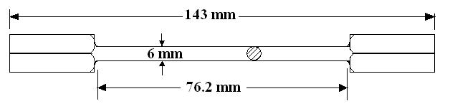

(A)

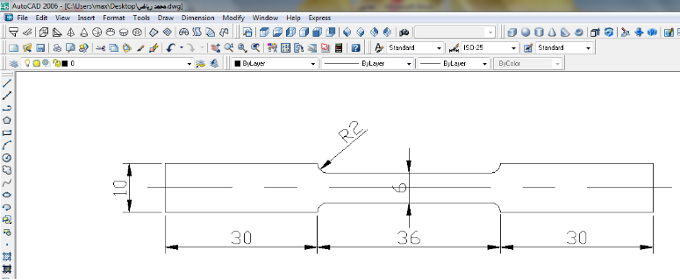

(B)

**Fig. (1):** Testing specimens of Brass C38500,(A) Torsion specimen,(B) Tensile specimen.

|  |
| --- |
|  |
|  |
|  |
|  |
|  |
| **Fig. (2):** The microstructure of all specimens in Table (2). |

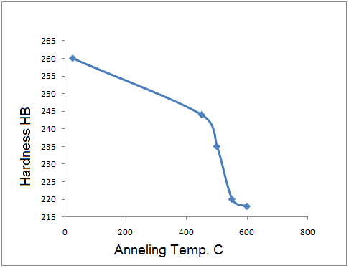

**Fig (3):** the relationship between annealed temperature and hardness.

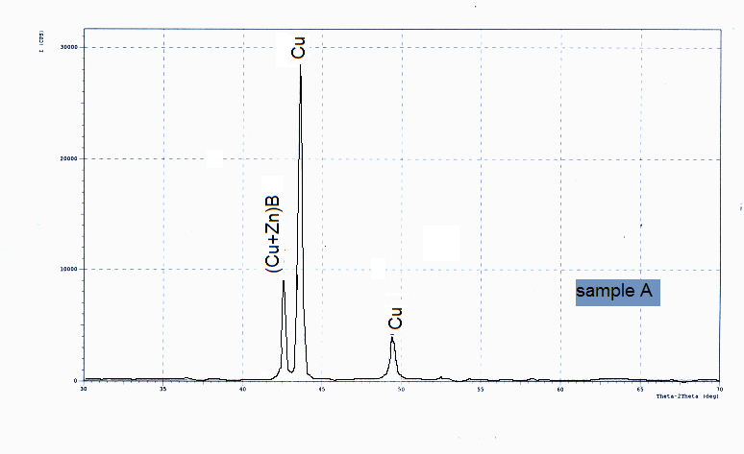

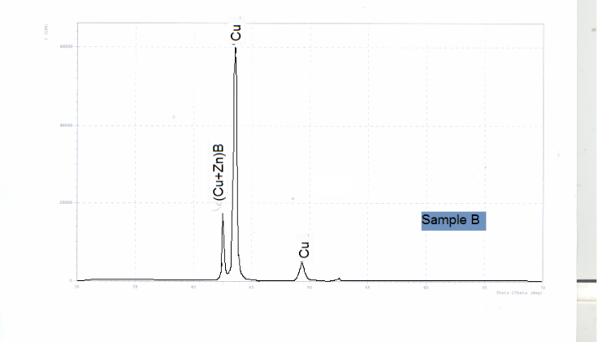

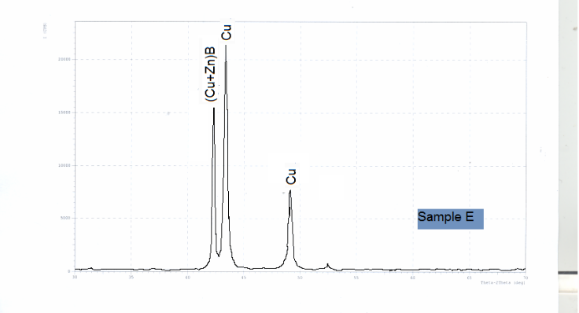

**Fig (4):** phases analysis graphs for specimen for A, B and E.

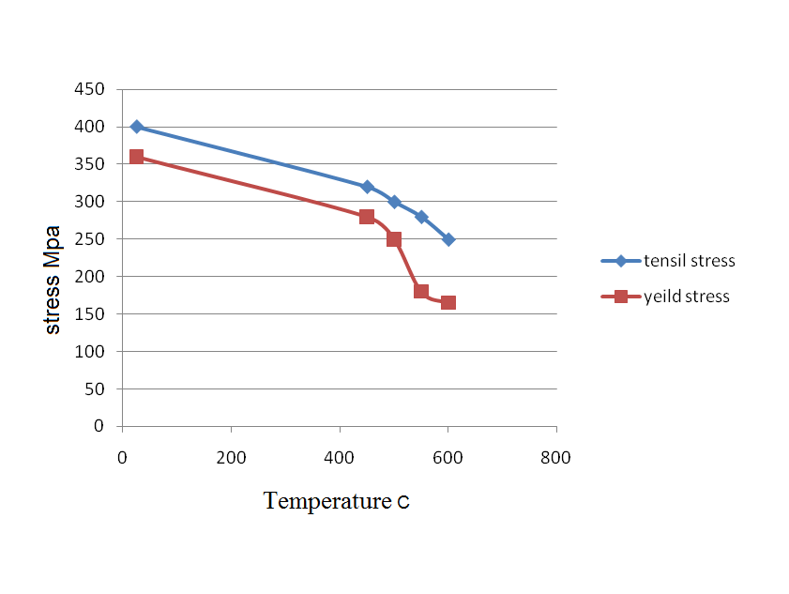

**Fig (5):** the relationship between stress and annealing temperature.

**Fig. (6):** the relationship between shear stress and shear strain.

**Fig. (7):** the relationship between torque and twist angle.

**تأثير عملية التلدين على الخواص الميكانيكية لسبيكة البراصC38500**

**ملخص البحث**

يهدف البحث الى دراسة تأثير عملية التلدين على البنية المجهرية والخواص الميكانيكية لسبيكة البراصC38500. تم تسخين عينات الاختبار في فرن كهربائي إلى درجات حرارة مختلفة 600,550,500,450)) مᵒ لمدة ساعة ثم التبريد البطيء داخل الفرن الى درجة حرارة الغرفة.

تم فحص البنية المجهرية بعد التلدين باستخدام مجهر ضوئي وكذلك الخواص الميكانيكية من (مقاومة الشد و نقطة خضوع والصلادة) إضافة إلى إجراء اختبار الالتواء وقد وجد إن لعملية التلدين تأثير قليل على البنية المجهرية بينما ساهمت في تقليل الخواص الميكانيكية (مقاومة الشد و نقطة خضوع والصلادة) بسبب تقليل ترسيب الأطوار الهشة ولكنه حسّن من مقاومة الالتواء بسبب زيادة القوة اللازمة لمقاومة اللي من خلال زيادة عدد الدورات اللازمة للكسر وقد وجد إن درجة حرارة التخمير (600) م° أعطت أفضل انفعال قص.