ISSN 1999-8716
Diyala Journal
of Engineering Sciences
Printed in Iraq

Vol. 08, No. 01, pp. 42-63, March 2015

CRITICAL AND IMPORTANT FACTORS RELATED WITH ENHANCING WIRELESS COMMUNICATION USING MIMO TECHNOLOGY

Soukaena H. Hashem ¹, Hassan H. Saleh ²
¹ University of technology
² College of Engineering, Diyala University, Iraq
E-mail: soukaena_hassan@yahoo.com ¹, hassan_hadi_saleh@yahoo.com ².
(Received: 16/9/2012; Accepted: 4/6/2013)

ABSTRACT:- This research propose analyze, simulate, test, and determine the optimal performance of cited three critical and important factors related with enhancing wireless communication using MIMO technology, for simulations throughout proposed work will employing Rayleigh flat and Additive White Gaussian Noise (AWGN). Orthogonal Frequency Division Multiplexing (OFDM) was the first factor simulated, to evaluate it is performance relating with the direct parameters presents the base bone of OFDM architecture such as OFDM model, channel types, FFT size, constellation and modulations. Secondly a simulation of channel capacity factor was done to assess the performance of capacity relating with SISO, SIMO, MISO, and MIMO. Finally from single antenna to multiantenna techniques was tested, to evaluate Bit Error Rate (BER) performance by using different receive and transmit diversity techniques have been simulated and tested for SIMO and MISO systems. Furthermore, different diversity techniques based on MIMO system have also been simulated and tested. All of these techniques are compared numerically and graphically with the BER performance of SISO system, in addition to their comparison with each other, by using various numbers of antennas. From proposed analysis, simulation, and testing of these three factors and their related parameters many of recommendations are obtained to set parameters of the three factors to build high performance PHY layer with wireless communication using MIMO technique. The implementation proposal was done under Matlab programming language.
Keywords: MIMO, SISO, SIMO, MISO, EGC, MMSE, ZF, STBC, MRC.

- INTRODUCTION:
MIMO (multiple input, multiple output) is an antenna technology for wireless communications in which multiple antennas are used at both the source (transmitter) and the destination (receiver). MIMO is one of several forms of smart antenna technology, the others being MISO (multiple input, single output), SIMO (single input, multiple output) and SISO (single input, single output) the conventional wireless communications, a single antenna is used at the source, and another single antenna is used at the destination ^{[1, 2, 3]}, see Figure (1).
MIMO technology has aroused interest because of its possible applications in digital television (DTV), wireless local area networks (WLANs), metropolitan area networks (MANs), and mobile communications ^{[4, 5]}. OFDM is a multi-carrier transmission technique employed to reduce the inter-symbol interference (ISI) of wireless systems with small symbol periods. As a result, the capacity in wireless systems is improved. First we will display the block diagram of OFDM performance, as shown in Figure (2). OFDM system, firstly map all input bits using (BPSK) Modulation onto complex word (patterns), then map all complex words to FFT. Each sub-carrier in OFDM will be assigned one baseband symbol to transmit with duration increasing proportionally to the bit interval ^{[6, 7, 8]}. Diversity techniques can be used to improve system performance in fading channels. Instead of transmitting and receiving the desired signal through one channel, we obtain L copies of the desired signal through M different channels ^{[9, 10]}.

- PROPOSAL TO ENHANCE MIMO
The proposal aims to enhance wireless communication using MIMO technique that by analyzing the critical three factors presents the direct effect of MIMO wireless communications. Then trying to optimize the parameters of these effective factors, to reach stable and enhanced wireless communications using MIMO technique. This research aim to develop simulation program with multi interfacing forms has been designed, PHY of IEEE 802.11n, under MATLAB (M-file) programming language environment.
2.1 Enhancement of MIMO Technology
The optimizing of OFDM performance was done under the following cited parameters:
- The system has been tested under, Rayleigh fading channel, in addition to AWGN channel. Assuming that bad channel environment is considered here, which means that the synchronization sometimes is lost. Figure (3) shows the performance of an OFDM. The BER performance of conventional OFDM is simulated here without any channel coding, it is clear that the worse BER is obtained in the case of Rayleigh fading channel, it needs 44 dB of SNR to achieve 10⁻⁵ bit error rate which is difficult for wireless communication.
- Testing of conventional OFDM under various FFT size. The extension of FFT size must increase the synchronization complexity and available bandwidth, however, the performance will degrade by increasing the size of FFT. Figure (3-a) depicts this falling, observe that large size of FFT cause bad performance, although increasing the number of subcarriers supports them against burst error because the symbols that subject to this error is relatively less than that for small size of FFT, but it cannot assure perfect protection from ICI, taking in mind that small bandwidth of subcarriers for large size of FFT, making them susceptible to ICI and ISI. Conversely it can be seen from Figure (3-b) that with availability of perfect synchronization there is steady performance as vary the size of FFT. Figure (3-c) OFDM performance with various FFT size It is better than previous condition by 14dB to achieve 10⁻⁴ BER for a relatively small size of FFT (2⁶), and but it can be said that it is very difficult to approach perfect synchronization especially with urban environments. Thus to improve the performance of an OFDM system in bad condition that it is the actual situation in wireless communication. In previous case the amount of information is increased relative to the size of FFT, for example 60 subcarriers used in 2⁶ FFT, 102 subcarriers in 2⁷ FFT, and so on. But if the length of message is held constant, better performance, is got in this case as FFT size is increased, as depicted in Figure (3-d).
- It can be seen from Figure (3-e) that the lower modulation scheme provides better performance with less SNR. This can be easily visualized if we look at their constellation mapping; larger distance between adjacent points can tolerate larger noise.
- By using modulation in simulation ,the performance of system and channel capacity can increase with use different method such as (BPSK, QPSK, 16QAM, 32QAM, 64QAM) ,BPSK modulation method represent (1 bit) while 64QAM modulation method (6bit), This is clearly shown in Figure (3-f), which presents the increase of CAPACITY with different modulation method.
- As the redundancy of convolution codes increases (lower code rate) the bandwidth expansion must grow for any real-time communication application. However, the benefit of increased redundancy, is the improvement in bit-error performance, as can be seen in Figure (3-g). It is clear that high code gain can be achieved by reducing the code rate. At BER level, the code gain is reducing for code rate of 3/4, 2/3, 1/2, and 1/3, respectively. Choosing optimum relative redundancy must tradeoff between expansion bandwidth and code gain amount. In this subsection we did not use puncturing technique, but here obtaining various code rate relies on changing the input/output lines.

2.2 Proposed Performance Enhancement of Channel Capacity Enhancement
In this research, channel capacity sub form has been designed with multi choice to perform many simulation experiments for all models, to run any model, just click or select on push-button and see the result or modify parameters which need it, or selected from combo box object which contain many options (forms), see figure (4), simulation results and tests of channel capacity for SISO, SIM, MISO, and MIMO systems will be discussed under various assumptions. In addition to that, it should be noted that the transmitted signal bandwidth B_{W} is normalized to be 1Hz for all the above systems.
Channel Capacity of SISO system, the channel capacity of SISO system versus SNR is illustrated in Figure (5-a). From Figure (5-a), it can be seen that the limitation of SISO system is that the capacity increases very slowly with the log of SNR and in general it is low. The capacity of SISO system at SNR = 20 dB is about 6 bit/s/Hz. The SISO capacity curve will also be shown in the next capacity figures for graphical comparison. It should be noted that the capacity simulation results of all the above system will be numerically compared with the other systems.
Channel Capacity of SIMO system, the addition of receive antennas yields a logarithmic increase in capacity in SIMO channels, due to the array gain of the receive antennas. However, knowledge of the channel at the transmitter for this system provides no additional benefit. The channel capacity of SIMO system is shown in Figure (5-b) for M_{R} = 2, 3 and 4. Figure (5-b), it can be seen that SIMO system has a channel capacities at SNR = 20 dB of about 6.4 bit/s/Hz, 7.2 bit/s/Hz, and 7.45 bit/s/Hz for M_{R} = 2, 3, and 4, respectively. The maximum capacity improvement for SIMO system over SISO system was achieved by using 1×4 transmission, which is about 1.45 bit/s/Hz at SNR = 20 dB.
Channel Capacity of MISO system, for MISO system, the transmit power will be equally divided between all the transmit antennas. This yields in a very low capacity improvement over SISO system. From Figure (5-c), it can be seen that, MISO system achieves a capacity improvement over SISO system at SNR = 20 dB by about 1.5 bit/s/Hz and 1.75 bit/s/Hz and 2.4 bit/s/Hz for M_{T} = 2, and 3 , 4, respectively. The maximum capacity improvement for MISO system over SISO system was achieved by using 4×1 transmission, which is about 1.4 bit/s/Hz at SNR = 20 dB. Table (1), presents a numerical results for the achieved capacities by using different numbers of transmit antennas at SNR = 20.
Figure (4.14) SIMO channel capacity

MIMO Capacity with CSI at the Transmitter, when CSI is available at the transmitter, By using multiple transmit and receive antennas, the channel capacity can be much better than the earlier examined systems. This is clearly shown in Figure (5-d), which presents the MIMO channel capacity for the case of CSI at the transmitter. From Figure (5-d), at SNR = 20 dB, the MIMO channel capacities are about, bit/s/Hz, 11.5 bit/s/Hz, 17.2 bit/s/Hz, and 23 bit/s/Hz for transmission schemes of 2×2, 3×3, and 4×4 respectively. The maximum capacity improvement over SISO system is about 17 bit/s/Hz for 4×4 transmission, at SNR = 20 dB, see table (2).
MIMO Capacity comparison with SIMO, performance evaluations of the SIMO and MIMO capacity mentioned above are presented in this section.The comparison of MIMO system capacities and SIMO system are shown in Fig. (5-e), for 1×2, and 1×4 with 2×2 and 4×4 transmission cases. From Figure (5-e), it can be seen that, there is a clear difference in channel capacity between MIMO and SIMO system. MIMO system achieves a capacity improvement over SISO system at SNR = 20 dB by about 7 bit/s/Hz and 16.5 bit/s/Hz for M_{T}× M_{R} = 2×2, and 4×4, respectively, while SIMO system achieves a capacity improvement over SISO system at SNR = 20 dB by about 1.5 bit/s/Hz and 9.3 bit/s/Hz for M_{T}× M_{R} = 1×2, and 1×4, respectively. The maximum capacity improvement for MIMO system over SIMO system was achieved by using 4×4 transmission, which is about 7.2 bit/s/Hz at SNR = 20 dB.
2. 3. Proposal to Enhance MIMO over Diversity Techniques
Bit Error Rate (BER) performance by using different receive and transmit diversity techniques have been simulated and tested for SIMO and MISO systems, respectively. Furthermore, different diversity techniques based on MIMO system have also been simulated and tested. All of these techniques are compared numerically and graphically with the BER performance of SISO system, in addition to their comparison with each other, by using various numbers of antennas, figure (6) show window display these techniques with their implementation. To evaluate the optimal performance of the multiple antennas (SIMO, MISO, and MIMO) systems, must generate SISO channel, the new simulator can also be used directly to generate multiple fading channels for SIMO, MISO, and MIMO systems.
Figure (6) represent sub form program developed to using it in testing many (SIMO, MISO, MIMO) Models, and to evaluate the optimum performance and compare with each other to find best technique, as shown in figure many buttons found in the form which can be select any technique in easy way, all types of techniques grouped in frames, the results of simulation may present in the same form or in another form to modify and select suitable parameters.
Performance of Single Input Single Output (SISO), SISO communication system provides the simplest description of a communication link between one transmit antenna and one receive antenna. This clearly implies that spatial diversity cannot be applied.
Performance of SIMO and MISO Systems, in this section, three different receive diversity combining techniques are tested and simulated for SIMO system, which are, Selection Combining (SC), Equal Gain Combining (EGC), and Maximal Ratio Combining (MRC). For MISO system, Maximal Ratio Transmission (MRT) will be simulated, tested and compared with the performance of Maximal Ratio Combining (MRC) for SIMO system.
Selection Combining (SC) Performance, the received signals have different deep fades, which occur at different random times. The selection diversity combiner selects the branch with the maximum instantaneous SNR, and discards the other branch at any instance of time. As a result, the deep fades can be avoided by using Selection Combining (SC) technique. However, the selection diversity combiner has no array gain, since it takes the advantage of single branch without exploiting the array gain of the other branches. The test for this method is the BER performance. Figure (7) shows an SNR gain over SISO system, at BER=10⁻⁵ by about 21.5 dB, 28.2 dB, and 30.33 dB, for M_{R} = 2, 3, and 4, respectively (i.e., 1×2, 1×3, and 1×4, transmission cases, respectively). From simulation results, it can be seen that, as the number of received antennas increases, the bit error rate decreases.
Equal Gain Combining (EGC) Performance, if the same signals are received by using EGC, the signal level variation at the output of the combiner will appear are co-phased (weighed equally) and added together with equal gain (unity gain) in order to improve SNR at the output. Figure (8) clearly shows that this method can achieve a higher SNR gain than Selection Combining (SC) diversity due to the array gain of EGC, which results in a better performance than selection combining diversity technique. The results of BER performance for M_{R} =2, 3, and 4 are shown in Figure (9). From this figure, it can be seen that a gain of about 21.2 dB, 29.8 dB and 32.7 dB can be obtained for M_{R} = 2, 3, and 4, respectively, at BER=10⁻⁵. As SC situation, the enhancement in performance also increases with increasing the number of the receive antennas.
Maximal Ratio Combining (MRC) Performance, this method achieves the maximum signal to noise ratio at the receiver output by weighting each received replica by the corresponding complex conjugate channel coefficient and then adding the resulted signals to take the array gain advantages of all the diversity branches. From figure, it is clearly seen that this method has a higher SNR gain than SC and EGC, which makes this method to has the best performance than other combining methods. Figure (9) presents the BER performance of MRC, which shows an improvement over SISO system by about 22.02 dB, 30.14 dB and 34.023 dB for M_{R} =2, 3and 4, respectively. The comparisons in BER performance between MRC and MRT is shown in Figure (10) for 2 receive antennas. The results show a very good agreement between the two methods in case of full CSI is avaliable at the transnitter.
Comparison between Diversity Combining Techniques, Performance evaluations of the three receive diversity mentioned above are presented in this section. The performance of error rate for these techniques with M_{R} = 2 and 4 is shown in Figure (11). At BER=10⁻⁵ with M_{R} = 2, it is can be seen that MRC provides the better performance by about 0.62 dB and 1.5 dB as compared with EGC and SC, respectively, This is due to the MRC method of combining, which depends on maximizing the SNR at the output of the combiner. From these graphs it can be concluded that Equal gain combining (EGC) performs very close to the MRC. Unlike the MRC, the estimate of the channel gain is not required in EGC.
MIMO Techniques Performance, MIMO and smart antenna (SIMO, MISO) systems may look the same on first examination: Both employ multiple antennas spaced as far apart as practical. But MIMO and smart antenna systems are fundamentally different. Smart antennas enhance conventional, one-dimensional radio systems. The most common smart antenna systems use transmit diversity to concentrate the signal energy on the main path and receive combining to capture the strongest signal at any given moment. In this section, three efficient MIMO detection techniques. ZF, MMSE, and STBC techniques will be tested and simulated for MIMO system. In addition, these techniques will be compared with each other, graphically and numerically in terms of BER performance, by using different transmission types.
ZF Performance, Figure (12) shows the comparative simulation results for ZF techniques by using M_{T} = 2 and M_{R} = 2, 3, and 4. From Figure (12), it can be seen that the BER performance of ZF with M_{T} = M_{R} = 2 (2×2 transmission case) is the same as SISO system. In fact, ZF combiner perfectly separates the interference of cochannel signals at the cost of noise enhancement, hence, it has a poor BER performance. Furthermore, this result is related with the diversity order of ZF that is given by M_{R} – M_{T} + 1. When M_{R} = M_{T}, the diversity order is 1, which is the same diversity order of SISO system. Hence, ZF reception method, does not offer any diversity advantage over SISO system when, M_{T} = M_{R}. the BER performance improved when M_{R}>M_{T}. For example, at BER=10⁻⁵, there is 22.77 dB and 30.0dB improvement for M_{R} = 3 and 4, respectively. It can also be noted that ZF method with M_{R} > M_{T} has the same BER performance of MRC method. For example, ZF with M_{R} = 3, has the same BER result of MRC method with M_{R} =2 (i.e. diversity order of 2). This similarity in BER performance because that, the two methods depend on multiplying the received signal with the complex conjugate of the channel h*, and the two methods have the same diversity order.
MMSE Performance, the simulated BER performance of MMSE method, is illustrated in Figure (13). The figure clearly shows that the BER performance for M_{T} = M_{R} = 2 is better than SISO system by about 3.18 dB, at BER=10⁻⁵. This improvement in BER performance will be increased when M_{R} > M_{T}, which is by about, 26.66 dB and 30 dB, for M_{R} = 3 and 4, respectively. From the results of Figures (12) and (13), it can be seen that MMSE algorithm has a superior performance over the ZF. The MMSE receiver suppresses both the interference and noise components, whereas the ZF receiver removes only the interference components.
This implies that the mean square error between the transmitted symbols and the estimated symbol at the receiver is minimized. Hence, MMSE is superior to ZF in the presence of noise.
STBC Performance, in this thesis Optimum adaptive algorithms are applied to multicarrier system with Space-Time Block Coding (STBC) scheme over Rayleigh fading channels. This method has been employed in MIMO-OFDM system in order to overcome subchannel interference. A detailed analysis of the performance of 2×2 Multiple Input Multiple Output (MIMO) antenna systems has been carried out by determining the transmit diversity using Almouti Space Time Block Coding (STBC) techniques. Simulation of MIMO-OFDM is done with digital modulation schemes such as BPSK and QPSK in order to evaluate the performance of the designed OFDM system by finding their bit error rate (BER) for different values of signal to noise ratio (SNR). Resultant graphs show that SNR increases with decrease in BER. In this section, simulation results with the BER performance of STBC method are discussed. Furthermore, A developed subform with graphical user interface for this method ,this form contain options for modulation selection and many fields for framelength and number of packet , in addtion to the number of transimeter and reciver and many parameters to use for optimal simulation resualt , figure(14) show subform for STBC Performance with many choices .
For STBC method with M_{T} =2, the received antennas can be M_{R} = 1, 2, 3, and 4, this is because, STBC can be used for both MISO and MIMO systems. The BER performance of STBC is shown in Figure (15). From figure, it can be seen that there is 20 dB, 30.5 dB, 35 dB, and 37.5 dB improvement for M_{R} = 1, 2, 3, and 4, respectively, at BER=10⁻⁵.
Figure (16) shows BER performance comparisons between MRC and STBC methods. It is clear from Figure (16) that STBC for 2×1 tranmission scheme has around 3dB poorer performance than MRC for 1×2 tranmission scheme, at BER=10⁻⁵. This is because the power from the STBC scheme is divided equally between the two transmit antennas (i.e., 3 dB less per antenna than the power from the MRC scheme, which has only one antenna). The 2×2 STBC method, on the other hand, shows a better performance than either of these curves because the order of diversity in this case is 4 (M_{T} M_{R} =2×2 = 4). Extending this logic further, it is to be expected that a 2×2 STBC scheme will be 3 dB poorer than 1×4 MRC scheme, since both have the same diversity order, but there is a 3 dB power loss at the transmitter of the Alamouti scheme due to equal division of power between the transmitting antennas.
Performance Comparison for MIMO Techniques, Figure (17) shows the BER performance comparison of ZF, MMSE and STBC methods with M_{T} = 2 and M_{R} = 2 and 3. From Figure (17), for all methods with M_{T} = 2 and M_{R} = 2, it can be seen that the ZF has the worst performance followed by MMSE and STBC method, which has the better BER performance by about 27.32 dB and 30.50 dB, than MMSE and ZF, respectively, at BER=10⁻⁵. The same logical scinario can be extended for M_{R} = 3 receive antennas.This difference in performane is because the SM of ZF and MMSE is depend on transmitting independent data streams from each of the transmit antennas without coding, to achieve a maximum rate of transmiision. The multiple transmitted data streams will interfere with each others at the receiver, which results in low BER performance.
On the other hand, STBC method, exploit diversity, by sending a redundancy of information bits across space and time to achieve a reliable transmission. However, due to the added redundancy bits, the effective bit rate of the channel is reduced. For more details, Table (3) gives a numerical comparison for the improvement over SISO system, between the three MIMO techniques mentioned above, at BER=10⁻⁵.

- CONCLUSIONS AND RECOMMENDATION
- Although OFDM enhance BER, but the types of channels related with OFDM effect BER.
- Increasing in FFT size will degrade the OFDM performance, but if the length of message is held constant then OFDM performance will enhanced with increasing of FFT size.
- Increasing in modulation level will enhance the capacity, such that 6 bit modulation duplicates six times the capacity of 1 bit modulation.
- SISO capacity very less than other smart antenna SIMO, MISO and MIMO even optimizing OFDM with SISO.
- MIMO is the best at all, even OFDM optimizing was not in it is perfect model.
- With SIMO the SC, EGC and MRC with Rayleigh channel with Mr=4 the best BER is MRC but with highest complexity.
- With MISO the MRT in BER performance with MRC for 2 receive antennas, the results show a very good agreement between the two methods in case of full CSI is avaliable at the transnitter.
- BER performance comparison of ZF, MMSE and STBC methods with M_{T} = 2 and M_{R} = 2 and 3, it can be seen that the ZF has the worst performance followed by MMSE and STBC method.
- The difference in performane is because the SM of ZF and MMSE is depend on transmitting independent data streams from each of the transmit antennas without coding, to achieve a maximum rate of transmiision. The multiple transmitted data streams will interfere with each others at the receiver, which results in low BER performance.
- STBC method, exploit diversity, by sending a redundancy of information bits across space and time to achieve a reliable transmission. The added redundancy bits, the effective bit rate of the channel is reduced.
- Expand work to try improving signals using Multiwavelet with FFT.
- employee evolution techniques and swarm technology in Diversity techniques.

- REFERENCES
- M. L. Riediger, “Techniques for Non coherent Space-Time Communications”, Ph.D. Thesis, University of Manitoba, July 2006.
- P. G Krishnan “Fast Sphere Decoder for MIMO Systems”, University of Missouri - Rolla, 2007.
- V. Kuhn, “Wireless Communications over MIMO Channels”, John Wiley & Sons Ltd, 2006.
- A. Goldsmith, “Capacity Limits of MIMO Channels,” IEEE JSAC, vol. 21, June 2003, pp. 684.
- G. J. Foschini and M. J. Gans, “On limits of wireless communications in a fading environment when using multiple antennas,” Wireless Pers. Commun., vol. 6, pp. 311-335, Mar. 1998
- Nee R., and prasad R., “OFDM for Wireless Multimedia Communications”, Artech House, Boston, London, 2000.
- E. Telatar, “Capacity of multiantenna Gaussian channels,” AT&T Bell Laboratories, Tech. Memo, June 1995.
- H. H. Banaser, “High Performance WLAN Using Smart Antenna”, M.Sc. Thesis, University of Waterloo, Waterloo, Ontario, Canada, September 2007.
- T. S. Pollock, “On Limits of Multi-Antenna Wireless Communications in Spatially Selective Channels”, Ph.D. Thesis, the Australian National University, July 2003.
- B. Vucetic, and J. Yuan, “Space-Time Coding”, John Wiley & Sons Ltd, 2003.

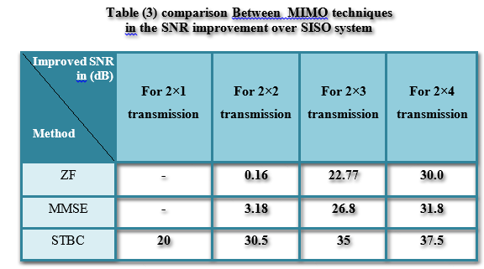

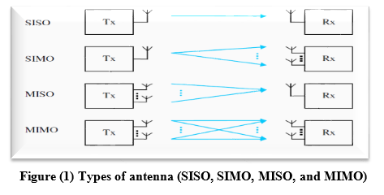

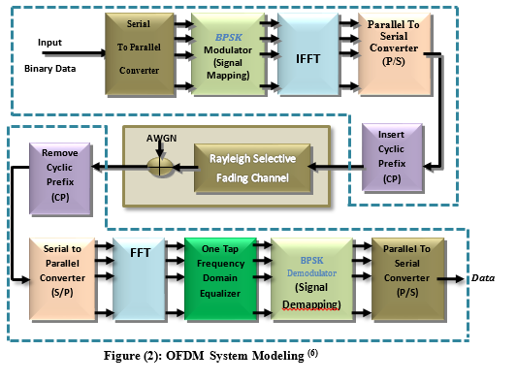

Figure (3-a): The BER performance conventional OFDM over Two channels scenarios.

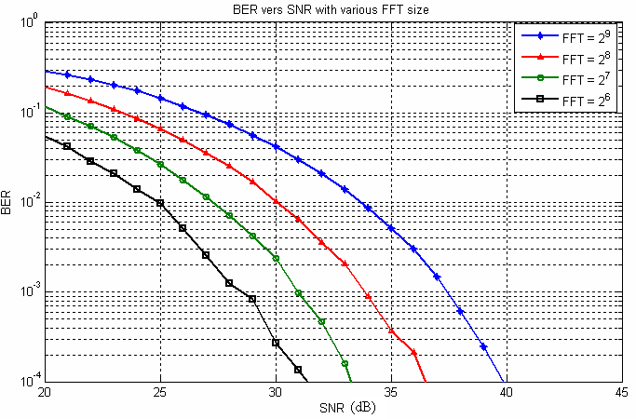

Figure (3-b): OFDM performance under various FFT size

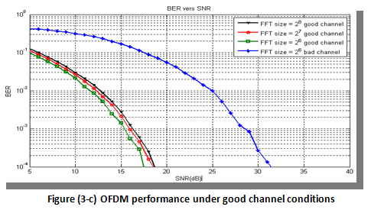

Figure (3-c): OFDM performance under good conditions.

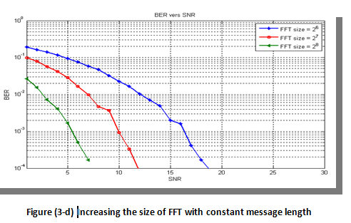

Figure (3-d): Increasing size of FFT with constant message length performance under good.

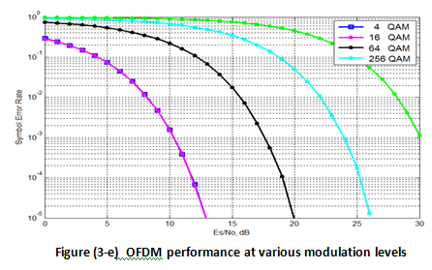

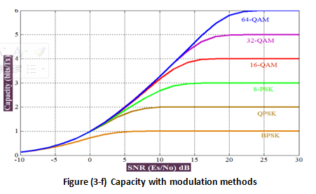

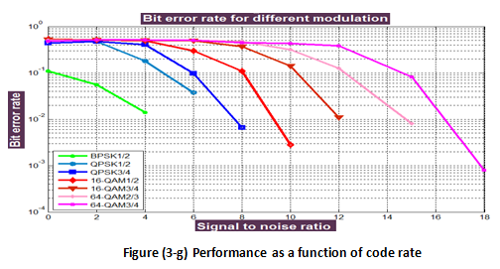

Figure (4): sub form program for Channel Capacity.

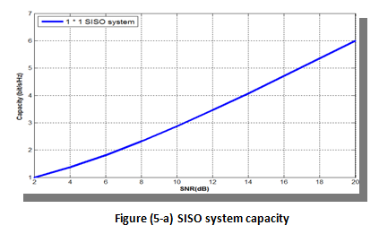

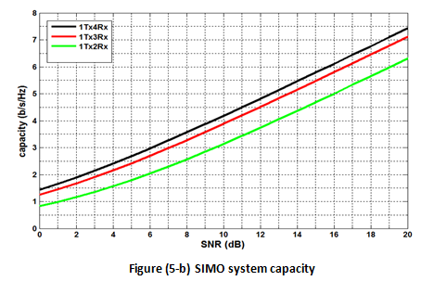

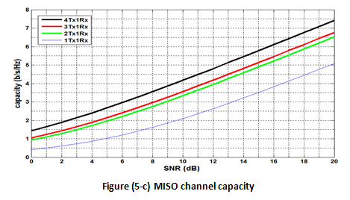

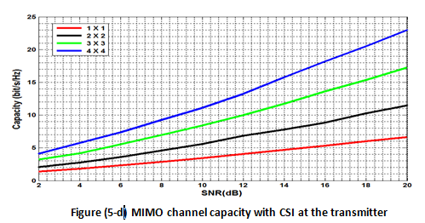

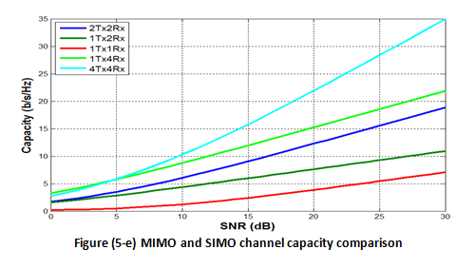

Figure (6): Performance Techniques for SISO, SIMO, MISO, MIMO.

Figure (7): BER of SC with different number of receive antennas.

.

Figure (8): BER of EGC with different number of receive antennas

Figure (9): BER of MRC with different number of receive antennas

Figure (10): BER performance comparison between MRC and MRT

Figure (11): BER performance comparison of SC, EGC and MRC with different number of receive antennas

Figure (12): BER performance of ZF with M_{T} = 2 and M_{R} = 2, 3, and 4

Figure (13): BER performance of MMSE with M_{T} = 2 and M_{R} =2, 3, and 4

Figure (14): Sub form for STBC Performance technique

Figure (15): BER performance of STBC with M_{T} = 2 and M_{R} =1, 2, 3, and 4
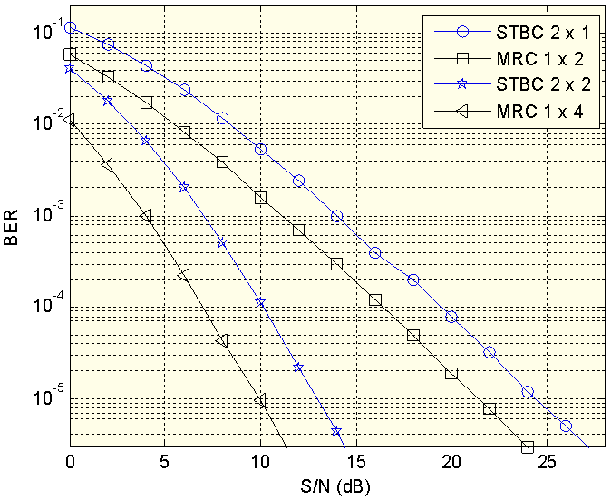

Figure (16): BER performance comparison between STBC and MRC methods

Figure (17): BER performance comparison between ZF,MMSE and STBC methods

العوامل الحرجة والمهمة المتعلقة بتَحسين الاتصالات اللاسلكية باستخدام تقنية هوائيات الارسال والاستقبال المتعدد

أ. م. د سكينة حسن هاشم م. ر. مبرمجين حسن هادي صالح
الجامعة التكنولوجية جامعة ديالى

الخلاصة
هذا البحث يقترح تحليل ومحاكاة واختبار وتحديد الأداء الأمثل من خلال الاستشهاد بثلاثة عوامل حاسمة وهامة ذات الصلة مع تحسين استخدام الاتصالات اللاسلكية المعتمدة مع تقنية MIMO ، لمحاكاة جميع مجالات العمل المقترح سوف نثبت القنوات لنوعين هما Rayleigh و AWGN. العامل الأول محاكاة لتقييم الأداء OFDM بالاعتماد على المعلمات الاساسية له وهي نموذج معمارية OFDM، وأنواع القناة، حجم FFT، وكوكبة التحويرات. ثانيا تم إجراء محاكاة لعامل سعة القناة لتقييم أداء القدرات المتصلة مع SISO، SIMO، MISO، وMIMO. ثم الاختبار الأخير لتقنيات multiantenna، لتقييم نسبة خطأ البت (BER), ومحاكاة واختبار تقنيات مختلفة للتنوع لنظم SIMO MISO. وعلاوة على ذلك، محاكاة واختبار تقنيات مختلفة للتنوع لنظام MIMO أيضا. ثم مقارنة كل هذه التقنيات عدديا وبيانيا مع أداء النظام BER SISO، بالإضافة للمقارنة مع بعضها البعض، وذلك باستخدام أعداد مختلفة من الهوائيات. من التحليل المقترح، والمحاكاة، واختبار هذه العوامل الثلاثة والمعلمات المرتبطة بها تم الحصول على العديد من التوصيات لتحديد معالم العوامل الثلاثة لبناء طبقة عالية الأداء مع PHY الاتصالات اللاسلكية باستخدام تقنية MIMO. وقد تم تنفيذ المقترح تحت لغة البرمجة مات لاب.

