ISSN 1999-8716
Diyala Journal
of Engineering Sciences
Printed in Iraq

Vol. 08, No. 01, pp. 1-15, March 2015

PREPARATION AND ADSORPTION STUDY (MONO AND DI- VALENT IONS) OF SELECTED TYPES OF ZSM-ZEOLITES.

Shahrazad R. Raouf ¹, Moayed G. Jalhoom ², Ramzy S. Hamied ³
¹ Assistant Professor, ³ Engineer, University of Technology.
Ministry of Industry and Metals²
(Received: 17/4/2012; Accepted: 13/11/2012)

ABSTRACT: - Experimental studies have been carried out on three types of crystalline zeolites which were prepared and used as supports catalysts. All were synthesized in the laboratory (ZSM-5, -11, and –23) with SiO₂/Al₂O₃ ratio of 37, 86 and 94 respectively. The adsorption process was investigated to characterize the catalysts performance toward adsorption parameters (percent of extraction and distribution factor). The performance of catalysts was studied over the range of temperature (room, 50 and 80 ºC) for mono and di-valent ions respectively (H⁺, Li⁺, K⁺, Rb⁺, Cs⁺, Sr⁺² and Ba⁺²). The prepared catalysts exhibited that the percent of extraction and distribution factor for both mono and di-valent ions (H⁺, Li⁺, K⁺, Rb⁺, Cs⁺, Sr⁺², and Ba⁺²) used on adsorption increase with increasing temperature and also showed different to the framework structure and type of ions used. The maximum percent of extraction and distribution factor is in the order ZSM-11˃ ZSM-5˃ ZSM-23 respectively.
Keywords: Adsorption, Supports Catalyst, Crystalline Zeolites (ZSM-5, -11, and –23).

1. INTRODUCTION
Adsorption is a phenomenon where molecules in a fluid phase spontaneously concentrate on a solid surface w. Adsorption takes place due to unsatisfied forces in the surface, which attract and hold the molecule of the fluid surrounding the surface ⁽¹⁾.
There are three properties of zeolite on molecular sieves that make them commercially viable: they are selective and strong absorbers, they are selective ion exchangers and, when the cation is a portion, they are super solid acid catalysts ⁽²⁾. Zeolites are also effective in selectively sorbing particular components from a mixture of molecules all individually capable of penetrating the entire zeolite. The surface of adsorption is essentially entirely internal due to the channels and cavities, which uniformly penetrate the entire volume of the adsorbent ⁽³⁾.
A property that has been utilized extensively in characterizing molecular sieve materials is the ability to adsorb selected molecule. Substantial structural information can be discerned about molecular sieve material from adsorption data. The most fundamental characteristic is the pore volume of the individual molecular sieve. Even in molecular sieves that contain a proportionally small quantity of cation occupying sites within the pores, change in the adsorption capacity of a given structure is observed. These changes however are dependent on the probe molecule being adsorbed ⁽⁴⁾.
The versatility of zeolites in the control of adsorption selectivity is by changing the frame work, Si/Al ratio and the cation makes them one of the most practical classes of adsorbents.
Zeolites are high-capacity, selective adsorbent for two reasons:
- They separate molecules based upon the size and configuration of the molecule relative to the size and geometry of the main aperture of the zeolite structure.
- Zeolite adsorbs molecules, in particular these with a permanent dipole moment and which have other interaction effects, with a selectivity not found in other adsorbents ⁽⁵⁾.
The main objectives of the present work are, synthesizing ZSM-5, -11, and –23 zeolites of high Si/Al ratio and calculating the adsorption parameter (percent of extraction and distribution factor) for some mono and di-valent ions at both room and higher temperature such as 80 and 50 ºC respectively, for selected types of zeolites catalysts.
2. EXPERIMENTAL WORK
2.1. Materials and Chemical Compounds
Zeolites ZSM-5, ZSM-11 and ZSM-23 were synthesized in a hydrothermal system containing alumina source, silica source and an organic molecule, such as sulfuric acid, sodium hydroxide ⁽⁶⁾. Other chemicals are listed in Table (1).
2.2 Catalysts and Support
Three different supported types of zeolites, ZSM-5, ZSM-11 and ZSM-23. They were prepared in sodium form., sodium ions were exchanged for adsorption studies by mono-valent ions such as (H⁺, Li⁺, K⁺, Rb⁺, Cs⁺) and di-valent ions such as (St⁺², Ba⁺²).

2.3 Preparation of Zeolites Catalysts
1. Preparation of ZSM-5 Zeolite:
The sodium form of zeolite ZSM-5 was synthesized under conditions described in the literature ⁽⁷⁾. The reaction mixture consisted of indigenous sodium aluminates, silica gel, and water and tetrapropyl ammonium hydroxide as template agent (specific structure-detecting).
A silica gel solution was prepared by dissolution 11.45 gm of SiO₂ in 238 ml (10%) tetrapropyl ammonium hydroxide. A solution of sodium aluminates was prepared by dissolving 1.6 gm of NaAlO₂ in 3 ml of distilled water and was added to the previous gel. The resultant suspension was placed in a stainless steel autoclave as shown in Fig. (1), and heated at 149ºC with stirring for 6 days. The pressure was held constant at 8.7 bars.
The resultant liquor solution was cooled to room temperature, filtered off and the solid washed thoroughly with distilled water. The solid was left to dry at 110 ºC for 24hr and then calcined at 538 ºC for 16 hour.
A portion of this product was subjected to X-ray analysis, which was used to characterize the prepared ZSM-5 zeolite. The identification of this structure was achieved by comparing its XRD pattern with that of the pure-standard ZSM-5. The prepared ZSM-5, which was in powder form was sieved and mixed mechanically with montmorellonite clay (20 %) as a binder.
2. Preparation of ZSM-11 Zeolite:
The sodium form of ZSM-11 was prepared according to described literature condition defined in reference ⁽⁸⁾. The reaction mixture consisted of a silica solution, an acid alumina solution, benzyltrimethyl ammonium chloride and tetra butyl ammonium bromide.
A silicate solution was prepared by dissolving 344 g of sodium silicate in 400 ml of distilled water. An acid alumina solution was made by adding 11.9 g of aluminum sulfate, 35 g of sulfuric acid (100%), 50 g of benzyltrimethyl ammonium bromide and 51.5 g of tetrabutyl ammonium bromide to 500 ml of distilled water. These two solutions were mixed in a stainless steel autoclave as shown in Fig. (1). The resulting gel was whipped for one hour at room temperature with agitation, and then heated at 160 ºC with stirring for 60 hour. The pressure was held constant at 7.5 bars.
The resultant liquor solution was cooled to room temperature, filtered off, and then solid washed thoroughly with distilled water. The solid was left to dry at 110 ºC for 2 hours and then calcined at 538 ºC for 16 hours.
A portion of this product was subjected to x-ray analysis, which was used to characterize the prepared ZSM-11 zeolite. The identification of this structure was achieved by comparing its XRD pattern with that of the pure standard ZSM-11. The prepared ZSM-11, which was in powder form was sieved and mixed mechanically with montmorillonite clay (20 %) as a binder.

3. Preparation of ZSM-23 Zeolite:
The sodium form of ZSM-23 zeolite was synthesized under conditions described in the literature ⁽⁹⁾. The reaction mixture consisted of sodium aluminates, colloidal silica and pyrrolidine.
A solution of 3.3 g of sodium aluminates, solid of 0.68 sodium hydroxide and 59.33 ml of distilled water, then 36.4 g of pyrrolidine were added, followed by addition of 329.5 g of colloidal silica (30 % silica). The resultant suspension was mixed in autoclave as shown in Fig. (1) And heated at 177 ºC with stirring for 2 days. The pressure was held constant at 17 bars.
The resultant liquor solution was cooled to room temperature, filtered off and the solid was washed thoroughly with distilled water. The solid was left in oven to lessen all expected structural water at 110 ºC for 24 hours and then calcined at 538 ºC for 16 hours.
A portion of this product was subjected to x-ray analysis, which was used to characterize the prepared ZSM-23 zeolite. The identification of this structure was achieved by comparing its XRD pattern with that of and pure-standard ZSM-23. The prepared ZSM-23, which was in powder form was sieved and mixed mechanically with montmorillonite clay (20 %) as binder.

2.4 Adsorption Studies of Prepared Zeolites.
The prepared zeolite are studied under different temperatures which are:
2.4.1 At Room Temperature
The prepared zeolites were examined for their ability for the extraction of other mono and di valent metal ions such as H⁺, Li⁺, K⁺, Rb⁺, Cs⁺, Sr⁺² and Ba⁺². Lower concentration (e.g. ~ 0.01 N) of each ion was equilibrated with 1 g of the studied zeolites.
14 ml from each type of above ion nitrate solution was placed in test tube and contacted with 1 g of ZSM-5, -11, -23 and by shaking the test tube and then taking sample every 15 min., centrifuge then read the absorbance at the maximum adsorption using UV-vis-single beam spectrophotometer. Then the sample back to test tube and was repeated the procedure until the absorbance reached almost constant value. The equilibrate sample was analyzed for the remaining extracted salt using atomic absorption technique. Accordingly the percent of extraction for each ion can be determined (10).

2.4.2 At (50 and 80 ºC) Temperatures
The extraction of the above mentioned mono and di-valent metal ions by the prepared zeolites was studied at higher temperatures (at 80 ºC) for the mono-valent and (at 50 ºC) for the di-valent metal ions, as shown in fig (2).
25 ml (0.01 N) of each type of ions (mono and di-valent) nitrate solution was contacted with 2 g of each type of zeolites ZSM-5, -11 and -23 at reflux condition with stirring for 3 hour at 80 ºC for mono-valent and at 50 ºC for di-valent. After this period sample was taken and centrifuged then the concentration was determined using atomic absorption technique. The difference shows the amount of sodium ions replaced or ions adsorbed in three types of zeolites. Accordingly the percent of extraction for each can be calculated (10).

3. CALCULATION:
To calculate the zeolite nadsorption capacity, the percent of extraction and distribution factor must be calculated. The distribution coefficient is calculated from the following equations ⁽¹¹⁾:
(1)
(2) where;
E % = Percent of extraction.
Kd = Distribution coefficient.
C_{or} = concentration ions in the organic solid phase.
C_{aq} = concentration ions of aqueous water phase.
C_{o} = total ion concentration in the mixture before extraction process.
V = volume of aqueous phase in (ml).
W = weight of organic solid phase in (g).

4. RESULTS AND DISCUSSION
1-X-Ray Diffraction of the Prepared Zeolites:
The zeolites of ZSM-5, -11, and –23 are known for its unusually high Si/Al ratio, high degree of thermal and acid stability, and high yield in certain catalytic conversion. All these properties make these types of zeolites suitable and important for industrial applications ⁽¹²⁾.
Figures (3, 4, and 5) show the XRD pattern for the prepared and standard zeolites (ZSM-5, -11, and –23).
The comparison of the heights of the main diffraction peaks to those characterizing best the corresponding pore reference zeolite indicate that the preparation method resulted in a material almost compatible with the crystal structure as ZSM-5, -11, and –23 zeolites. This leads to the conclusion that our preparation method gives an exact synthesized indigenous (ZSM-5, -11, and –23). Analysis of the chemical composition of prepared zeolites and reference is shown in table (2).
Table (2) indicates that SiO₂/Al₂O₃ and Na₂O wt. %. The SiO₂/Al₂O₃ molar ratio was 37.2, 84, and 94 for ZSM-5, -11, and –23 respectively which is typical for such types of zeolites ^{(13),} ⁽¹⁴⁾.

2- Effect of Temperature on Adsorption:
The effect of temperature on adsorption process (percent of Extraction) for mono and di-valent in ZSM-5, -11, and –23 zeolites are shown in Figs. (6) to (11) and (distribution factor) are shown in table (4) and (5).
Data of these Figures shows that adsorption for mono-valent ions on ZSM-5, -11, and -23 catalysts at both (room - 80 ºC). It can be seen that increasing the temperature promotes an increase in the adsorption of both mono and di-valent ions. Partially this can be ascribed to the widening of the channels of zeolites and which make better in diffusion and sodium replacement.
For mono-valent ions, the results have shown that maximum degree of adsorption (percent of extraction and distribution factor) for hydrogen (H⁺) at 80 ºC and minimum value for cesium ion.
In agreement with data of Matel and Rajec [15, 16], cesium, which has big ionic radius, showed lower extraction than the other mono-valent ions H⁺, Li⁺, K⁺ and Rb⁺.
For di-valent maximum (percent of extraction and distribution factor) increasing with increase of temperature and maximum values for Sr⁺² ions at 50 ºC and then for Ba⁺² at the same temperature compared with room temperature and the results shown in figure (9, 10, and 11) and results of (Extraction %) on Table (3). Then the yield order for three types of zeolites namely ZSM-5, -11, and –23 are:
For mono-valent Cs > Rb > K > Li > H
For di-valent Ba⁺² > Sr⁺²
The data obtained in this work prevail that maximum percent of extraction and distribution factors is in the order ZSM-11 > ZSM-5 > ZSM-23. This can be attributed to the difference in the pore structure, pore size and channel system. Since channel system in ZSM-5 has two-dimensional intersecting channel, straight (elliptical) and sinusoidal (circular). While ZSM-11 was two-dimensional intersecting both straight (elliptical). In ZSM-5 the cavities are all equivalent, where as in ZSM-11, there are two types of cavities one which is very nearly the same as that which occurs in ZSM-5, while the other is larger by 30 % volume, which accounts for the greater saturation capacity of ZSM-11 ⁽¹⁷⁾. Channel system in ZSM-23 was one-dimensional none-intersecting (elliptical) channel system. Such a difference in the three types of zeolites ZSM-5, -11 and –23 may explains at least partially the difference in the percent of extraction and the distribution factor.

CONCLUSIONS
Better percent of extraction and distribution factor was obtained at higher temperature; they increase from room temperature to 50 and 80 ºC for both the mono and di-valent ions. On the other hand during extraction, it was observed as the radius for mono and di-valent ions increases the extraction percent and distribution factor decreased in the three studied systems of zeolites ZSM-11, -5 and –23.
X-ray diffraction for ZMS-5, -11 and –23 points to the presence of high degree of crystallinity and surface structure stability. Higher adsorption capacity, represented by percent of extraction and distribution factor, is obtained for mono and di- valent ions, which are obtained by ZSM-11 in both comparison with ZSM-5 and ZSM-23.

NOMENCLATURES
Notation | Definition |  | Units
Conc. | Concentration |  | mole/m³
SiO₂/Al₂O₃ |  | Silica to alumina ratio |  | [-]
T |  | Temperature |  | [ºC]
Wt % |  | Weight percent |  | [-]
XRD |  | X-ray diffraction analysis |  | [-]
ZSM-11 |  | Group of pentasil zeolite number 11 |  | [-]
ZSM-23 |  | Group of pentasil zeolite number 23 |  | [-]
ZSM-5 |  | Group of pentasil zeolite number 5 |  | [-]
REFERENCES
- Szostak R., “Molecular Sieves in Principles of Synthesis and Identifications”, New York (1998).
- Sherman J. D., “Adsoprtion and Ion Exchange Separations”, AIChE Symposium Series, 74, 179 (1978).
- Dessau R. M., “Selective Sorption Properties of Zeolite”, in Flank W. H. (Ed.), Adsorption and Ion Exchange with Synthetic Zeolite, ACS Symposium Series 135 (1980).
- Gabelica Z., and Valange S., J. Microporous and Mesoporous Materials, 330 (1999).
- Breck D. W., “Zeolite Molecular Sieves”, John Wiley and Sons, New York (1974).
- Thomas C. L., “Catalytic Processes and Proven Catalyst”, Academic Press, New York, (1970).
- Argauer R. J., and Landolt G. R., U.S Patent 3,702,886 (1972).
- Vander G. F., Janson J. C., and van Bekkumm H., Proceeding sixth International Zeolite Conference, Reno (1983).
- Plank G.A., Rosinski E.J., and Rubin M.K. U.S. Patent 4,076,842 (1978).
- John S., and Theodore U., “Adsorption and Ion Exchange Progress and Future Prospects”, AIChE J., 80, No. 233 (1984).
- Mohammed D. A., Jalhoom M. G., Khalaf J. S., and Al-Dellal M. J., Basra J. Sci., Vol. 18, No. 2 (2000).
- Ubaidy M. D., “Promote the Selectivity of Pt-Zeolite Catalyst in the Aromatization”, M.Sc. Thesis, University of Technology, Baghdad (1994).
- Elian H. M., “Study the Activity of Platinum and Palladium Zeolites Supported Catalysts for Hydrocrbon Reaction”, M.Sc. Thesis, University of Technology (1998).
- Richardson J. F., Harker J.H., Backhurst J.R., “Chemical Enginerring”, vol (2), John Wiley and Sons, New York (2009).
- Matel L., and Rajec P., “Preliminary Experimnets of Radionuclides Sorption Using Zeolites from Waste Pond Water", 6th International Conference Separation of Ionic Solutes, Piestany Spa, Slovakia, 19 (1995).
- John C.M., Mark E.D., “Conductivity of Mono and Divalent Cations”, J. Phys. Chem. C, Vol. 13 (22), PP (9870 – 9877) (2009).
- Chen L. F., and Lovat V. C., “Temperature-Programmed Desorption of Hydrocarbon from ZSM-5, -11, and Theta-1; Part 1. N-hexane and n-octane”, J. Zeolite, Vol. 8, PP (310 – 316), July (1988).

Table (1): Chemical Components.

No. | Compound | Purity | Company
 | Aluminum oxide | 99% | Brussel-Belgium
 | Hexachloroplatinic acid | 40% | Fluka
 | Cesium nitrate | 99.99% | Fluka
 | Nitric acid | 67% | Fluka
 | Potassium nitrate | 99.9% | Fluka
 | Strontium nitrate | 99.9% | Fluka
 | Tetrapropylammonium hydroxide | 10% | Fluka
 | Tetrabutylammonium bromide | 40% | Fluka
 | Pyrrolidone | >98% | Fluka
 | H₂ gas | 99.98% | Mansour company
 | n-pentane | 99.9% | Merch-Germany
 | Silica gel | 100% | Riedeh-Dehlaen
 | Sodium hydroxide | 99.99% | Riedeh-Dehlaen
 | Sulfuric acid | 99.9% | Riedeh-Dehlaen
 | Lithium nitrate | 99% | Riedeh-Dehlaen
 | Barium nitrate | 99.9% | Riedeh-Dehlaen
 | Benzyltrimethylammonium chloride | 60% | Riedeh-Dehlaen
 | Sodium silicate | 98% | Riedeh-Dehlaen

Table (2): Analysis of the Chemical Composition of Prepared and Reference Zeolites.

Chemical  Composition  Wt% | Prepared | Reference

ZSM-5
Oxide formula | Na₂O.Al₂O₃.5-100 SiO₂. ZH₂O | 0.9±0.2 Na₂O.Al₂O₃.5-100 SiO₂. ZH₂O
SiO₂ | 91.1 | 93.5
Al₂O₃ | 4.16 | 4.9
Na₂O | 1.27 | 1.6

ZSM-11
Oxide formula | Na₂O.Al₂O₃.10-150 SiO₂. ZH₂O | 0.9±0.3 Na₂O.Al₂O₃.10-150 SiO₂. ZH₂O
SiO₂ | 95.52 | 97.96
Al₂O₃ | 1.91 | 2.216
Na₂O | 0.057 | 0.07

ZSM-23
Oxide formula | Na₂O.Al₂O₃.40-250 SiO₂. ZH₂O | 0.5±3.4 Na₂O.Al₂O₃.40-250 SiO₂. ZH₂O
SiO₂ | 94.78 | 96.9
Al₂O₃ | 1.61 | 1.65
Na₂O | 0.19 | 0.27

Table (3): Extraction (%) at T = (Room and 50 ºC) for Di-Valent.
Type of Zeolites |  | ZSM-11  E % |  | ZSM-5  E % |  | ZSM-23  E %
Ions | Diameter (Å) | Room | 50 ºC | Room | 50 ºC | Room | 50 ºC
Sr | 2.26 | 81.82 | 85.46 | 84.6 | 87.15 | 82.96 | 84.6
Ba | 2.7 | 73.52 | 82.7 | 75.8 | 86.3 | 70.56 | 78.64

Table (4): Distribution Factor (kd) at T = (Room and 50 ºC) Di-Valent Ions.
Type of Zeolites |  | ZSM-11  Kd |  | ZSM-5  Kd |  | ZSM-23  Kd
Ions | Diameter (Å) | Room | 50 ºC | Room | 50 ºC | Room | 50 ºC
Sr | 2.26 | 67.53 | 73.47 | 82.63 | 84.75 | 68.64 | 73.04
Ba | 2.7 | 41.65 | 59.77 | 47.03 | 78.8 | 35.78 | 46.04

Table (5): Extraction (%) at T = (Room and 80 ºC) for Mono-Valent.
Type Of Zeolites |  | ZSM-11  E % |  | ZSM-5  E % |  | ZSM-23  E %
Ions | Diameter (Å) | Room | 80 ºC | Room | 80 ºC | Room | 80 ºC
H | 0.46 | 96.98 | 98.09 | 96.45 | 97.1 | 94.37 | 96.2
Li | 1.2 | 96.15 | 97.13 | 95.65 | 96.91 | 93.51 | 95.42
K | 2.66 | 94.93 | 96.34 | 93.26 | 95.69 | 93.103 | 94.18
Rb | 2.96 | 94.67 | 95.9 | 92 | 95.31 | 76.76 | 86.3
Cs | 3.38 | 91 | 91.3 | 86.66 | 90.49 | 63.41 | 82.69

Table (6): Distribution Factor (kd) at T = (Room and 80 ºC) for Mono-Valent Ions.
Type of Zeolites |  | ZSM-11  Kd |  | ZSM-5  Kd |  | ZSM-23  Kd
Ions | Diameter (Å) | Room | 80 ºC | Room | 80 ºC | Room | 80 ºC
H | 0.46 | 481.7 | 643.51 | 407 | 418.9 | 251.74 | 301.5
Li | 1.2 | 425.04 | 452.04 | 330.38 | 356.28 | 216.18 | 260.54
K | 2.66 | 280.85 | 329.03 | 207.52 | 277.55 | 202.48 | 202.32
Rb | 2.96 | 266.81 | 292.61 | 172.5 | 254.02 | 49.55 | 78.73
Cs | 3.38 | 152.68 | 131.28 | 97.46 | 118.85 | 12.5 | 71.7

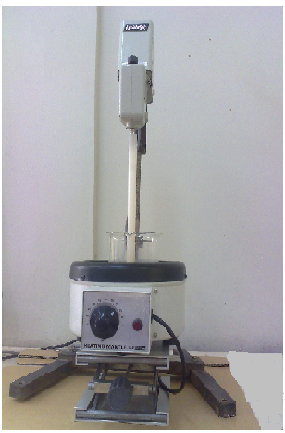
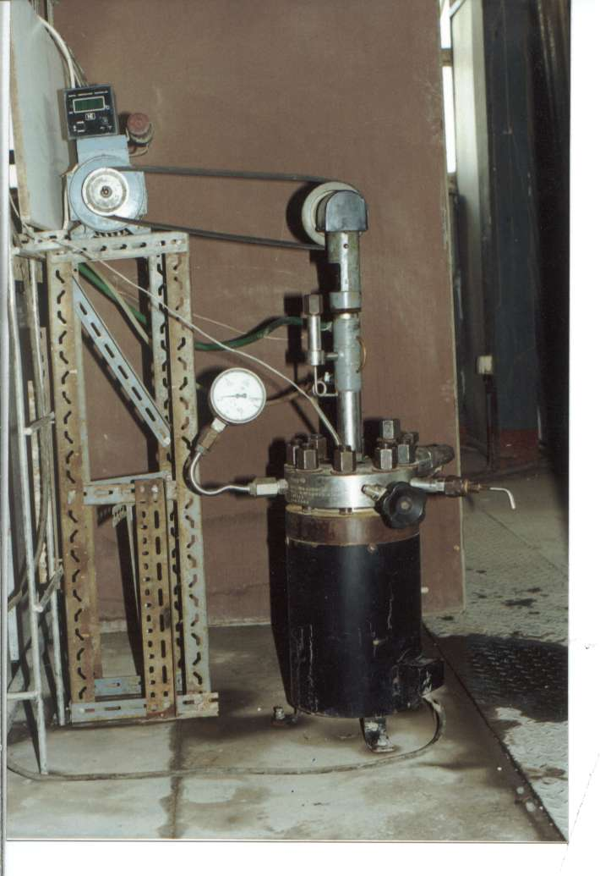

Fig. (1): The Stainless Steel Autoclave.
Fig (2): Mechanical stirrer with controller of temperature of heating path using in catalysts preparation.

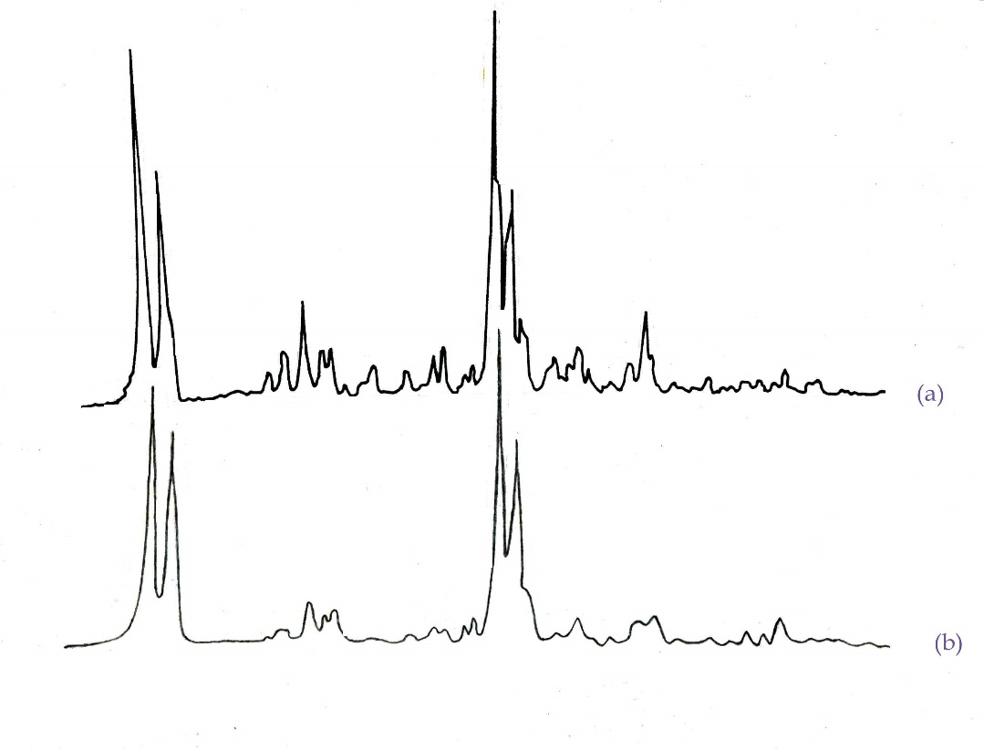

Fig. (3): XRD Pattern of Prepared and Standard Zeolite (ZSM-5)
- Standard and (b) Prepared.

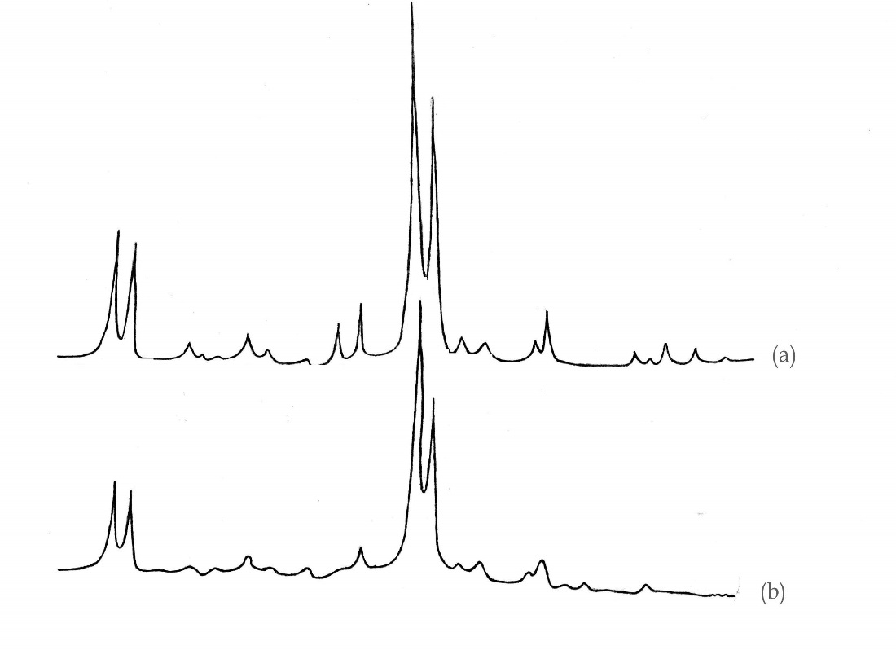

Fig. (4): XRD of Prepared and Standard Zeolite (ZSM-11)
(a)- Standard and (b)- Prepared.

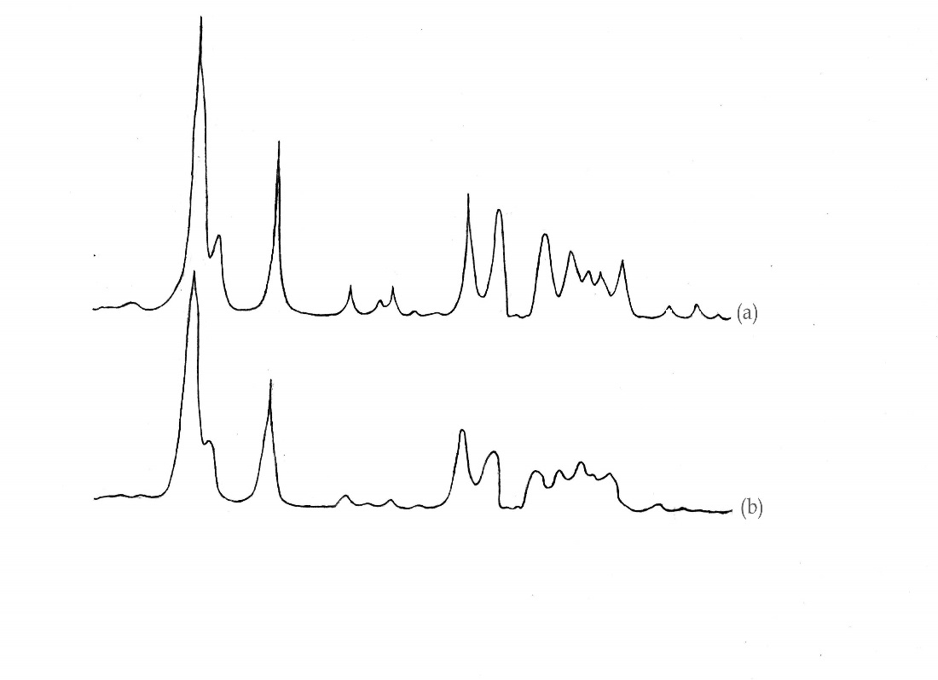

Fig. (5): XRD of Prepared and Standard Zeolite (ZSM-23)
(a)- Standard and (b)- Prepared.

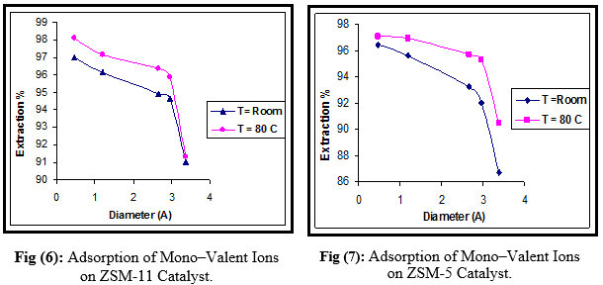
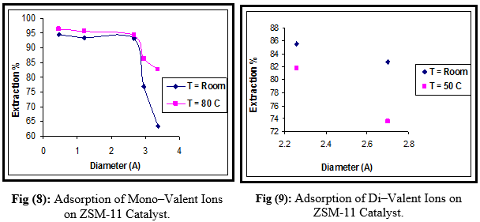
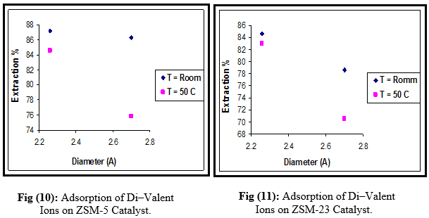

دراسة تحضير وامتصاص (ايونات أحادية وثنائية) لبعض أنواع الزيولايت المنقاة

شهرزاد رفعت رؤوف ¹، مؤيد كاصد جلهوم ²، رمزي صيهود حميد ³
¹ استاذ مساعد، ³ مهندس، الجامعة التكنلوجية
² مدرس، وزارة الصناعة والمعادن

الخلاصة:
تـضمن البحث اعداد دراســة شاملة عمليــة لثلاثة انواع من الزيولايتات واستخدمت كحوامل٬ جميع هذه الانواع تم تحضيرها في المختبر وهي (ZSM-5, -11, and –23) ٬ حيث كانت نسبة السيلكا / الالومينا لهذه الانواع من الزيولايتات هي (94, 86, 37) على التوالي. تم خلال البحث دراســة معاملات الامتصاص (معامل الاستخلاص ومعامل التوزيع للايونات) لعملية الامتصاص للعوامل المساعدة (الزيولايتات) المحضرة. وقد حسبت معاملات الامتصاص (معامل الاستخلاص ومعامل التوزيع للايونات) على مدى درجات حرارة (درجة حرارة الغرفة,50, 80 مº) بالنسبة الى الايونات الاحادية والايونات الثنائية على التوالي وهي (الهيدروجين, الليثيوم, البوتاسيوم, الربديوم, السيزيوم, والسترونيوم, والباريوم). كذلك بينت النتائج أن معامل الاستخلاص والتوزيع للأيونات المستخدمة في عملية الامتصاص كمتغيرات للأمتصاص تختلف تبعا لكل من البناء التركيبي للزيولايت وكذلك نوع الأيون المستخدم. بينت النتائج ان معامل الاستخلاص والتوزيع للايونات المستخدمة في عملية الامتصاص للزيولايتات المستخدمة كانت كالتالي
ZSM-11˃ ZSM-5˃ ZSM-23.
الكلمات المفتاحية: الزيولايت المنقاة، أنواع الزيولايت.

