ISSN 1999-8716

**Diyala Journal**

**of Engineering Sciences**

Printed in Iraq

Vol. 08, No. 01, pp. 98-109, March 2015

**DESIGN AND IMPLEMENTATION OF OP-AMP-RC SINE**

**WAVE OSCILLATOR**

**Khalid Awaad Humood 1, Adham Hadi Saleh 2, Wurod Qasim Mohamed** **3**

1 lecturer, 2 Assistant lecturer, 3 Engineer, College of Engineering, Diyala University

E-mail: humoodkhalid@yahoo.com

(Received: 14/1/2014; Accepted: 2/3/2014)

**ABSTRACT: -** The oscillator is a form of frequency generators which can be generate a sinusoidal wave with constant frequency and amplitude. The frequency oscillator can be considered as a one of basic circuits, which must be existing in most electrical, electronic, communication circuits and systems.

In this paper, a proposed design of sine wave oscillator type RC phase shift has been performed using three approaches. The first approach proposed design is done theoretically using the basic theorems used to generate oscillations, such as the condition of oscillation criteria. Secondly it is done using simulation technique (multisim11). Thirdly the simulated design is implemented practically using single operational amplifier with passive elements such as resistors & capacitors. All the obtained results from the above three approaches (3.800 kHz, 3.510 kHz & 3.600 kHz respectively) are seems to be equal approximately. These obtained results from the designed oscillator were very encouraging.

**Key Word:** RC**,** OP-AMP**,** PhaseShift Oscillator**.**

1. **INTRODUCTION**

Oscillators are circuits that produce specific, periodic waveforms such as square, triangular, saw tooth, and sinusoidal. There are two main classes of oscillator relaxation and sinusoidal. Relaxation oscillator generates the triangular, saw tooth and other non-sinusoidal waveforms. Sinusoidal oscillators consist of amplifiers with external components used to generate oscillation, or crystals that internally generate the oscillation (1). The focus here is on sine wave oscillators, created using the operational amplifiers (Op-Amps).

Sine wave oscillators are used as references or test waveforms by many circuits. A pure sine wave has only a single or fundamental frequency ideally no harmonics are present. (Thus, a sine wave may be the input to a device or circuit, with the output harmonics measured to determine the amount of distortion). The waveforms in relaxation oscillators are generated from sine waves that are summed to provide a specified shape (1, 2). A small signal voltage amplifier is shown in Figure (1a).

The operational amplifier has an extremely high gain under these circumstances and this leads to saturation within the amplifier. As saturation implies working in the non-linear section of the characteristics, harmonics are produced and a ringing pattern may appear inside the chip. Because of this, a square wave output is produced for a sinusoidal input. The amplifier has ceased to amplify and it has become unstable. There are many reasons why an amplifier may become unstable, such as temperature changes or power supply variations, but in this case, the problem is the very high gain of the operational amplifier (3, 4).

Figure (1b) shows how this may be overcome by introducing a feedback network between the output and the input. When feedback is applied to an amplifier, the overall gain can be reduced and controlled so that the operational amplifier can function as a linear amplifier. Note also that the signal feedback has a phase angle, due to the inverting input, which is in opposition to the input signal (V**i**). Negative feedback can therefore be defined as the process whereby a part of the output voltage of an amplifier is fed to the input with a phase angle that opposes the input signal (5, 6).

Negative feedback is used in amplifier circuits in order to give stability and reduced gain. Bandwidth is generally increased, noise reduced and input and output resistances altered. These are all desirable parameters for an amplifier, but if the feedback is overdone then the amplifier becomes unstable and will produce a ringing effect (7).

In order to understand stability, instability and its causes must be considered. From the above discussion, as long as the feedback is negative, the amplifier is stable, but when the signal feedback is inphasewith the input signal then positive feedback exists. Hence, positive feedback occurs when the total phase shift through the operational amplifier (Op-Amp) and the feedback network is 360° (0°). The feedback signal is now in phase with the input signal (V**i**) and oscillations take place (8). There are many types of oscillator circuits depending on the component used in the circuit. These oscillator circuits are RC oscillator, LC oscillator, Colpittes oscillator, Hartley oscillator, Wien bridge oscillator and Crystal oscillator (9). The simplest, form of a negative feedback system is used to demonstrate the requirements for oscillation to occur. Figure (2) shows the block diagram for this system in which V**IN** is the input voltage, V**OUT** is the output voltage from the amplifier gain block (A), and β is the signal, called the feedback factor that is feed back to the summing junction. E represents the error term that is equal to the summation of the feedback factor and the input voltage (10, 11).

**2. GAIN IN THE OSCILLATOR.**

The oscillator gain must be unity at the oscillation frequency. Under normal conditions, the circuit becomes stable when the gain exceeds unity, and oscillations cease. However, when the gain exceeds unity with a phase shift of –180°, the nonlinearity of the active device reduces the gain to unity and the circuit oscillates. The nonlinearity becomes significant when the amplifier swings close to either power rail because cutoff or saturation reduces the active device (transistor) gain. The paradox is that worst-case design practice requires nominal gains exceeding unity for manufacturability, but excess gain causes increased distortion of the output sine wave (12) and distributed among the buffers (13). Most circuit configurations require an auxiliary circuit for gain adjustment when low distortion outputs are desired. Auxiliary circuits range from inserting a nonlinear component in the feedback loop, to automatic gain control (AGC) loops, to limiting by external components such as resistors and diodes. Consideration must also be given to the change in gain resulting from temperature variations and component tolerances, and the level of circuit complexity is determined based onthe required stability of the gain. The more stable the gain, the better the purity of the sine wave output (14, 15).



**3. THEORY OF THE PROPOSED DESIGN.**

unintentionally Op-Amp oscillators are circuits that are unstable not the type that are sometimes designed or created in the lab but ones that are intentionally designed to remain in an unstable or oscillatory state. Oscillators are useful for generating uniform signals that are used as a reference in such applications as audio, function generators, digital systems, and communication system (16).

Op-Amp sine-wave oscillators operate without an externally applied input signal. Instead, some combination of positive and negative feedback is used to drive the op-Amp into an unstable state, causing the output to cycle back and forth between the supply rails at a continuous rate. The frequency and amplitude of oscillation are set by the arrangement of passive and active components around a central Op-Amp (17).

Op-Amp oscillators are restricted to the lower end of the frequency spectrum because op-Amps do not have the required bandwidth to achieve low phase shift at high frequencies. Voltage-feedback Op-Amps are limited to a low kHz range because their dominant, open-loop pole may be as low as 10 Hz. The new current-feedback op-Amps have a much wider bandwidth, but they are very hard to use in oscillator circuits because theyare sensitive to feedback capacitance (18).

In this paper , for the proposed design, RC of feedback components are rearranged as shown in Figure (3) shows the use of an Op-Amp version of this type of oscillator apply in this design. It is clear that the feedback type is voltage series and to obtain the output voltage and the phase shift oscillator the analysis was done as follows:-

From Figure (4), it is clear that the feedback type is voltage series and to obtain the output voltage and the phase shift oscillator the analysis is as follows:-

Loop 1



Loop 2



Loop 3



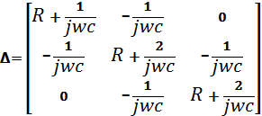









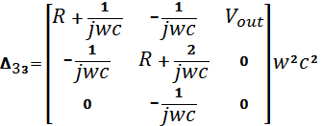



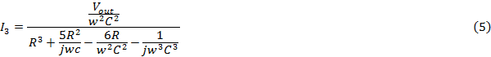

From the circuit shown in Figure (4) it can be obtain:



By substituting Equation (5) in Equation (8), getting that:

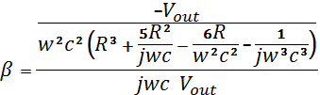

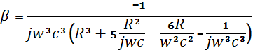



Imaginary part =0







$$w^{2}=\frac{6}{R^{2}C^{2}} so w=\frac{√6}{RC} (9)$$

$$f_{o}=\frac{√6}{2πRC} Oscillator Frquency (10)$$

Substitute for   in Equation (11)



Oscillator condition:





$$A=\frac{1}{β}=-29 (12)$$

The voltage gain of the circuit must have negative gain



**4. SIMULATION OF PROPOSED DESIGN.**

In this paper proposed design of Op-Amp Sine wave oscillator is simulated using multisim technique . The circuit diagram of this design is shown in Figure (5).The output signal which obtained from the operation of this proposed circuit is shown in Figure (6). It obvios that the output of frequency 3.51KH.

As shown in the Figure (5)**,** there are two types of feedback :,negative and positive.The first type is a technique that used to improve the performance of the operated amplifier to obtain high bandwidth, however this reduce the gain . Also it has the following advantages,make the circuit stable , operates without noise and could be able to obtain matching. The positive feedback which has a very important characteristic which make the circuit introduces the oscillation.

**5. PRACTICAL IMPLEMENTAION OF THE PROPOSED DESGIN .**

In this paper, Op-Amp Sine wave Oscillator is implemented practically. The circuit diagram and the output signal of the practical implementation of this design are shown in Figures (7) and (8) respectively.

**6. RESULTS AND CONCLUSIONS.**

This paper presented the design of op-amp sine wave oscillator, which is achieved by three approaches. Firstly, using theory and analysis of basic circuits of oscillation as shown in Figures (3) and (4). Secondly the design was achieved using multisim 11 (electronic simulation technique) as shown in Figures (5) and (6).Thirdly the simulated design is implemented practically as shown in Figures (7) and (8) .The output frequencies for the three approaches are; 3.8kHz, 3.51 kHz and 3.6kHz respectively. The obtained results approximately seem to be constant so that it is very encouraging.

Op-Amp oscillators are restricted to the lower end of the frequency spectrum (the frequency is equal to 3.8 kHz) because they do not have the required bandwidth to achieve low phase shift at high frequencies.

The performance results of the proposed design can be extended as future work for the facts that the bandwidth is an important factor and this was retracted using Op-Amp. So that it can be improved using trans-conductance (gm) instead of Op-Amp. All the presented output results can be improved using current mode technique*.*

**REFERENCES.**

1. Sherr, S., “Generalized Equations for RC Phase Shift Oscillators”, Journal: Proceedings of the IRE ISSN: 00968390: Volume: 42 Issue: 7 Pages: 1169-1172 Provider: IEEE Publisher, 1954.
2. Ron Mancini and Richard Plamer, Book “Sine Wave Oscillator”, Applied Report, Texas Instruments Literature Number SLOA060, March 2001.
3. Graf, Rudolf F., “Oscillator Circuits”, Newnes, 1997.
4. R. Rhea, “Oscillator Design and computer simulations”, Prentice Hall, 1990.
5. G. K. Montress, T. E. Parker, and D. Andress**,** “Review of SAW Oscillator Performance”, Ultrasonic's Symposium Pages: 43-54, Year 1994.
6. Terrel, David L., “OP AMPS, Design, Application and Troubleshooting”, Elsevier Science (USA), 1996.
7. George Clayton and Steve Winder, “Operational Amplifier”, Linacre House, Jordan Hill, Oxford, 2nd edition, 1997.
8. Jung, Water G., “OP AMP Applications Handbook”, Linacre House, Jordan Hill, Oxford UK, 2005.
9. Rhea, Randallw, “Oscillator Design and Computer Simulation”, Noble Publishing Corporation Atlanta, 2nd edition, 1995.
10. Ron Mancini**,** “Design of OP AMP Sine Wave Oscillations”, Application Note, Texas Instruments, Analog and Mixed Signal Products, August, 2000.
11. Guillermo Gonzalez, “Foundations of Oscillator Circuit Design”, Artech House, Inc. 2007.
12. Rhea, Randall W., “Oscillator Design and Computer Simulation”, Nobel publishing Corporation Atlanta, 2nd edition, 1995.
13. Misra, Devendara K**.,** “Radio Frequency Microwave Communication Circuit”, Jhon Wiley and sons, Inc., 2001.
14. Dailey, Denton, J**.,** “Operation Amplifier and Linear Integrated Circuits”, McGraw Hill, 1997.
15. Gottlieb, Irving M., “Practical Oscillator Hand book” Newnes, New Delhi Singapor, 1997.
16. Reza Navid, Thomas H. L and Robert W. Dutton “Minimum Achievable Phase Noise of RC Oscillators”, IEEE Journal of Solid State Circuit, Vol,.40, No.3,pages 630-637,March 2005.
17. Taylor, J. Clarke, C “Improved Harmonic Analysis of RC Active Phase Shift Oscillators” IEEE International Symposium on Circuit and Systems, pages1272-1275, 2008.
18. Taylor, J.**,** “Harmonic Analysis of RC Active Phase Shift Oscillators” IEEE International Conference on Electronics, Circuits and Systems, pages1131-1134, 2008.

**

**Figure (1 a, b):** Operational Amplifier

**

**Figure (2):** Simplest Form of a Feedback System with Positive or Negative Feedback.

**

**Figure (3):** Phase-shift oscillator using an op-Am.



**Figure (4):** the Analysis of the Circuit.

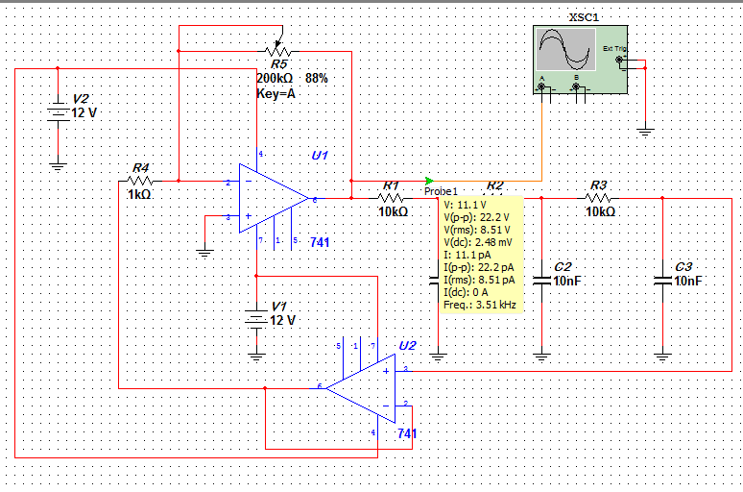

**Figure (5):** Op-Amp sine wave oscillator

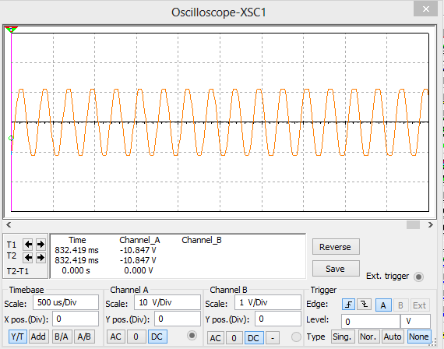

**Figure (6):** Output signal of the Circuit in Figure (5).

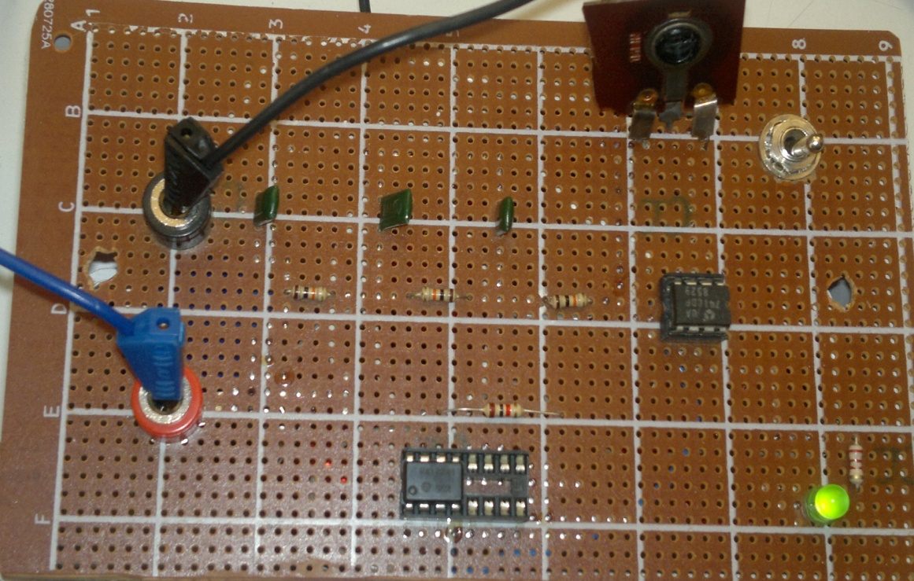

**Figure (7):** the output signal of the practical Circuit.

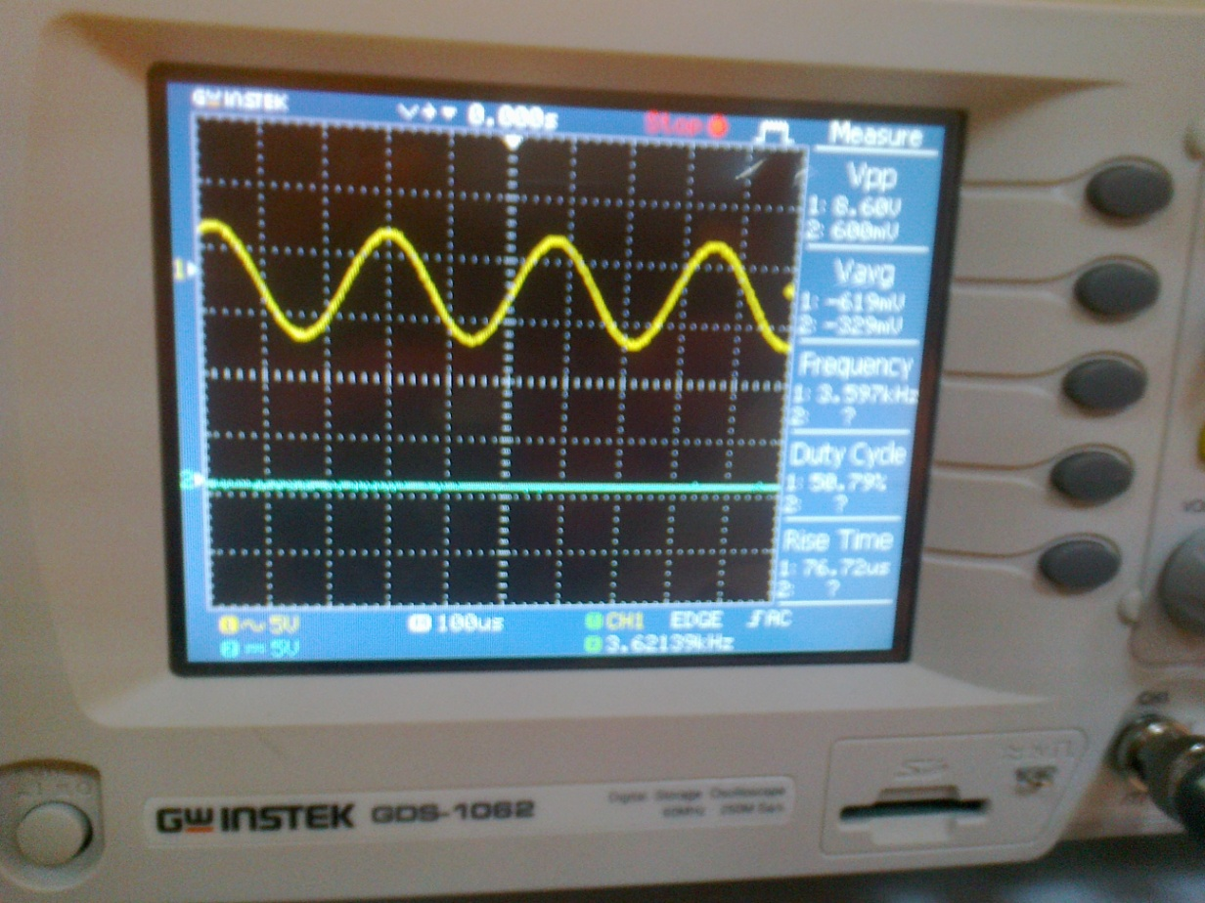

**Figure (8):** the output signal of the practical Circuit.

**تصميم وتنفيذ مذبذب الموجه الجيبية**

**خالد عواد حمود 1، ادهم هادي صالح 2، ورود قاسم محمد 3**

1 مدرس، 2 مدرس مساعد، 3 مهندس/ كلية الهندسة، جامعة ديالى

**الخلاصة:**

المذبذب هواحد انواع مولدات التردد التي يمكن ان تولد موجه جيبية ذات تردد ثابت وسعه ثابته.مولد التردد يمكن ان يعتبراحد الدوائر الاساسية التي يجب ان توجد في اغلب دوائر وانظمة الكهرباء, الالكترونيك والاتصالات.

في هذا البحث التصميم المقترح لمولد الموجه الجيبية نوع:- قد تم انجازه بثلاث اساليب: فرق طور مقاومة متسعة

اولا: تم انجاز التصميم المقترح نظريا بأستخدام نظريات الالكترونيك الاساسية مثل شروط ومعايير التذبذبات (Multism 11)

ثانيا: تم انجاز التصميم بأستخدام تقنية المحاكاة.

ثالثا: التصميم المقترح المنجز بالمحاكاة قد تم تنفيذه عمليا بأستخدام مضخم عمليات مفرد مع العناصر غير الفعالة مثل المتسعات والمقاومات.

جميع النتائج المستحصلة من الاساليب الثلاثه اعلاه (3.8KHZ,3.51KHZ,3.6KHZ) على التوالي والتي تبدو متساوية تقريبا. أن هذه النتائج المستحصله من التصميم المقترح كانت مشجعة جدا.