ISSN 1999-8716

**Diyala Journal**

**of Engineering Sciences**

Printed in Iraq

Vol. 08, No. 01, pp. 110-119, March 2015

**ANODIZING OF MAGNESIUM ALLOY AZ31 BY ALKALINE SOLUTION**

**Basheer Ahmed A.**

Assistant lecturer, Chemical Engineering Dept.-University of Technology

E-mail: [Basheer510@yahoo.com](mailto:Basheer510@yahoo.com)

(Received: 15/1/2014; Accepted: 2/3/2014)

**ABSTRACT: -**Anodizing of AZ 31 Mg alloy was investigate in 3M KOH solution for 10, 20 and 30min. at constant voltage of 5V. Atomic force microscope (AFM) used to investigate the roughness of anodic film formed on the surface while the scanning electron microscope (SEM) was used to determine the morphology of the anodic film, it was found that the roughness of the anodic film is mainly depend on the anodizing time. Coating thickness. Furthermore, the microhardness also increases with the anodizing time.

**Keywords:** anodizing, magnesium alloy, anodic film, alkaline solution.

**INTRODUCTION**

Magnesium alloy are widely used because of their excellent physical and mechanical properties as low density and excellent mechanical strength (1). The other properties of Magnesium represented by its good machinability, high capacity ,ability to be recycled , high creep stress and high impact resistance (2,3). These properties make the Magnesium alloy an excellent choice for a number of application including automobile and computer parts, aerospace components, mobile phone, sporting goods, handheld tools and household equipment (4). In addition Mg and its alloys have been considered as one of potential implant biomaterials due to their closed mechanical properties to natural bone and perfect biocompatibility (5, 6). However, their applications are limited severely for their poor corrosion resistance. It mainly depends on the film formation and varies with the medium to which the specimen is exposed (7, 8). In the past several decades, many surface modification techniques have been developed for the protection of magnesium or magnesium alloys, which include electrochemical plating, conversion coatings, anodizing, laser surface alloying and organic coatings. Among these techniques, anodizing treatment is one of the most promising methods for magnesium alloys (5, 9).

The mechanism of growth as well as the nature of passivating layers formed on magnesium surface during anodizing in aqueous solution is still open to debate (10).

In the previous study, Fei Chen, et.al investigated the corrosion resistance of the oxide layer formed on AZ31 Mg alloy in solution of Na2SiO3, Na2WO4, KOH and Na2EDTA by PEO (11). In another study, Li Wang and colleagues investigated the effect of potassium fluoride on structure and corrosion resistance of plasma electrolytic oxidation films formed on AZ31 magnesium alloy (12). Recently, Cai et al. (13) reported the formation of MgO coating films on magnesium in 6 M KOH solution by an anodic electrodeposition process, an alternative anodization of plasma oxidation. However, there was little information on microstructure and surface morphology of the as-grown MgO passive film.

In current study, the effect of process time on the structural and mechanical behavior of the coating such as roughness, hardness and coating thickness at the same current density was demonstrated.

**2-MECHANISM OF ANODIC FILM FORMATION**

The mechanism of anodizing process could be explained dissolution, and Oxygen evolution. Anions in the electrolyte first need to reach at the anode and then inter into anodic coatings (3).

The general reactions, occurring in the anodizing process for Mg, are as follow:

Mg Mg+2 + 2e-  (1)

4OH- O2 + 2H2O + 4e – (2)

Mg+2 + 2OH Mg (OH) 2 (3)

Mg (OH) 2 MgO + H2O (4)

Fig.1 illustrates the anodizing process in aqueous solutions

**3- EXPERIMENTAL**

The samples for this study were commercial AZ31 magnesium alloy, the standard and actual chemical composition of the commercial AZ31 are listed in table 1 and 2 respectively (in wt %):

Specimens sized 1*2*0.3 cm were mounted in epoxy resin with an exposed area of 2 cm2. After the surface of the alloy was polished up to the No.1000 emery paper followed by 0.05 μm diamond paste , the specimens were carefully cleaned with water, rinsed with acetone and dried under air. SEM (T-Scan-Germany) was used to study the morphology of anodizing film.

The coating thickness was measured by using digital coating thickness gauge (F & NF type CM-8822)

**3-1 Solution**

The solution was prepared at room temperature with deionized water and analytical – grade reagents, 3M KOH was used as an alkaline solution with pH of 13.

**3-2 Anodizing cell**

The anodizing experiment was carried out in 3 M KOH and at 5 V, and 25oC in a two-electrode cell using a DC power supply (5A, 30V). The electrolytes of 1000 ml volume were contained in a glass cell with agitating stirrer. The anode was the Mg alloy specimens while the cathode was a stainless steel. The samples were anodized under constant voltage of 5 V for 10, 20 and 30 min. at room temperature, and the oxide films formed on the surface were rinsed by distilled water and dried in warm air.

The anodized specimens were analyzed with SEM, AFM and coating thickness gauge.

**4- RESULTS AND DISCUSSION**

**4-1 AFM Investigation**

The roughness of surface film before and after anodization process was determined by AFM as shown in Fig. 2. The AFM image revealed that a rough film formed on the magnesium surface after anodizing. The RMS roughness is increases as the time increase due to the anodic layer created on the surface. The types of this layer appear as spherical or semi-spherical. Precipitation process depends on surface cleaning; the presence of a small amount of impurities (especially Fe and Cu) slows down the anodizing process in these sites

The roughness increase by increasing the time of anodizing. Table 3 shows the effect of anodizing time on surface roughness

**4-2 SEM Morphology**

Fig. (3-a) shows the SEM for polished specimen while fig (3-b) shows the microstructure for the specimen.

Figures (4-1), (4-2), (4-3) and (4-4) show microstructure for specimens before anodizing, and after 10, 20, and 30min of anodizing time respectively. These figures show the change in the surface morphology and a new structure was observed.

Figure (4-4) shows SEM micrograph of anodized AZ31 Mg specimen surface. It contains dark spots which indicate that anodizing process deposited the oxide of MgO on the surface of the metal. The anodic film is thickening with increasing anodizing time as shown in figure (4-2, 3 and 4). No cracks were observed on the anodized layer but also a precipitation of oxide layer was found on the surface.

**4-3 Effect of Anodization time on the Coating Thickness**

Fig (5) illustrate that the coating thickness is linearly increase with increasing the anodizing time, the average coating thickness are measured and found to be 9.8, 18.5, and 35 µm corresponding to anodizing time 10, 20 and 30 min. respectively.

Comparison between the coating thickness obtain in this work with previous work (3, 9) indicates a general agreement, but the difference in value are obtained due to the difference in the types of base metal.

Zhang.et.al, found the anodic film on AZ91 Magnesium alloy show that the initially formed anodized film is threadlike and porous, and high potential is essential for the formation of good anodic film with excellent properties. The study also show that the coating thickness is directly proportional to the increase of time (14).

**4-4 Effect of Anodization time on the microhardness**

The results (as shown in table 4) indicate that the microhardness uncrease with increasing in duration time. Figure (6) shows the average micro hardness of as 85, 110, 130, and 170 HV in anodizing time for 10, 20 and 30 min. respectively. This expected as the coat phase include MgO phase, in general, the hardness of the coat phase is higher than of magnesium base

**5- CONCLUSION**

The following conclusions can be drawn from this study:

1. The roughness of anodic film increases with increasing anodizing time period.
2. Coating thickness increase with increasing the anodizing time significantly.
3. Micro hardness increase with increasing anodizing time.
4. The structure of surface layer is changed after anodization process

**Acknowledgments**

The author would like to thank the team in nanotechnology department in University of Technology for their help.

**REFERENCES**

1. Yan Liu, Zhonging Wei, Fuwel Yang, Zhao Zhang, June (2011), "Environmental Friendly Anodizing of AZ91 D Magnesium Alloy in Alkaline Borate – Benzoate Electrolyte", Journal of Alloys and Compounds, Vol.509, Issue 22.2, pp.6440-6446 (IVSL)
2. Salah Abdelghany Salman, Ryoichi Ichino, Masazumi Okido, (2009), "Improvement of Corrosion Resistance of AZ31 Mg Alloy by Anodizing with Co-Precipitation of Cerium Oxide", Transaction of Nonferrous Metals Society of China, Vol.19, pp.883-886.
3. N. A. El Mahallawy, M. A. Shoeib, M. H. Abouelenain, (2011), "AZ91 Magnesium Alloy Anodizing of Using Environmental Friendly Electrolytes", Journal of Surface Engineered Materials and Advanced Technology, 1, 62-72.
4. Xiaolan Liu, Tao Zhang, Yawei Shao, Guozhe Meng , Fuhui Wang, (2009) "Effect of alternating voltage treatment on the corrosion resistance of pure magnesium", Corrosion Science 51, pp. 1772–1779.
5. Ting Lei , Chun Ouyang , Wei Tang, Lian-Feng Li, Le-Shan Zhou, (2010) "Preparation of MgO coatings on magnesium alloys for corrosion protection", Surface & Coatings Technology 204 pp.3798–3803.
6. Yun- Choi, Salah Salman, K. Kuroda, M. Okido, (2012) "Improvement in Corrosion Characteristics of AZ31 Mg Alloy by Square Pulse Anodizing Between Transpassive and Active regions", Corrosion Science, Vol.63,October.pp. 5-11.
7. Xiachum Ma, Yuping Ni, (2010)"research on Anodizing of Magnesium Alloy in Environmental – Friendly Electrolyte with Nano-Al2O3", International Conference on Electrical and Control Engineering. (IVSL).
8. Lei Wang, Bo-Ping Zhang, Tadashi Shinohara, (2010), "Corrosion behavior of AZ91 magnesium alloy in dilute NaCl solutions", Materials and Design, 31, pp.857–863.
9. Salih Durdu, Selin Bayramo_glu, Aysun Demirtas, Metin Usta, A. Hikmet Üçıs, (2013) "Characterization of AZ31 Mg Alloy coated by plasma electrolytic oxidation", Vacuum 88 pp.130-133, (IVSL).
10. M.SENTAMARIA< F. Di Quarto, s. Zanna, P. Marcus, (2011), "The influence of Surface Treatment on the Anodizing of Magnesium in Alkaline Solution", Electrochemical Acta, Vol.56, 25, December pp.10533-10542, (IVSL).
11. Chen F, Zhou H, Yao B, Qin Z, Zhang Q. Surf Coat Tech 2007; 201:4905e8.
12. Wang L, Chen L, Yan Z, Wang H, Peng J. J Alloy Compound 2009;480:469e74.
13. Z.P. Cai, D.S. Lu, W.S. Li, Y. Liang, H.B. Zhou, (2009) " Study on Anodic Oxidation of Magnesium in 6M KOH solution by Alternative Current Impedance", Int. J. Hydrogen Energy 34, 467- 472.
14. L. J. Zhang , J.J. Fan, Z. Zhang, F.H. Cao, J.Q. Zhang, C. N. Cao, (2007) "Study on the anodic film formation process of AZ91D magnesium alloy", Electrochimica Acta 52, 5325–5333

**Table (1):** Chemical Composition of Standard AZ31 Mg Alloy (2)

|  |  |  |  |  |
| --- | --- | --- | --- | --- |
| Standard Chemical Composition of AZ31 Mg Alloy | | | | |
| Mg | Si | Mn | Zn | Al |
| Balance | 0.004 | 0.3 | 1.0 | 3.0 |

**Table (2):** Actual Chemical Composition of AZ31 MG Alloy

|  |  |  |  |  |  |  |  |
| --- | --- | --- | --- | --- | --- | --- | --- |
| Actual Chemical Composition of AZ31 Mg Alloy | | | | | | | |
| Mg | Fe | Ni | Cu | Si | Mn | Zr | Al |
| Balance | 0.001 | <0.001 | 0.003 | 0.002 | 0.333 | 0.897 | 2. 85 |

**Table (3):** Root Mean Square Surface Roughness of anodic layer

|  |  |  |
| --- | --- | --- |
| Run No. | Anodizing time min. | RMS Roughness in nm |
| 1 | 0 | 0.532 |
| 2 | 10 | 1.52 |
| 3 | 20 | 2.78 |
| 4 | 30 | 11 |

**Table (4):** Microhardness of anodic layer

|  |  |  |
| --- | --- | --- |
| Run No. | Anodizing time min. | Microhardness HV |
| 1 | 0 | 85 |
| 2 | 10 | 110 |
| 3 | 20 | 130 |
| 4 | 30 | 170 |



**Fig (1):** Electrode Processes in aqueous solutions (9)

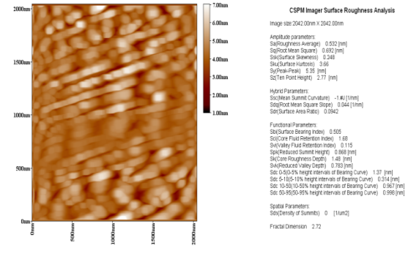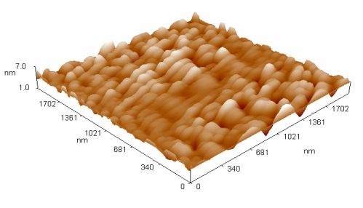

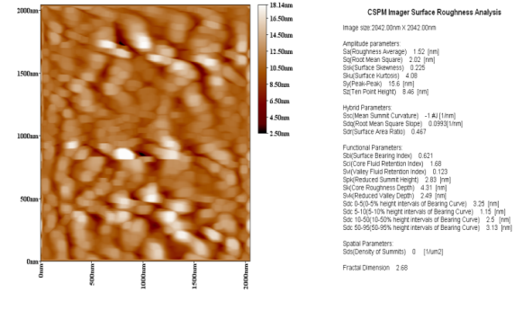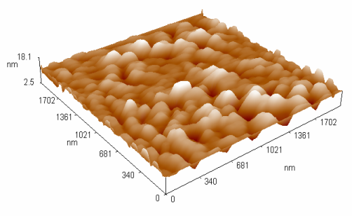

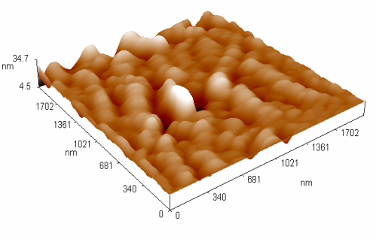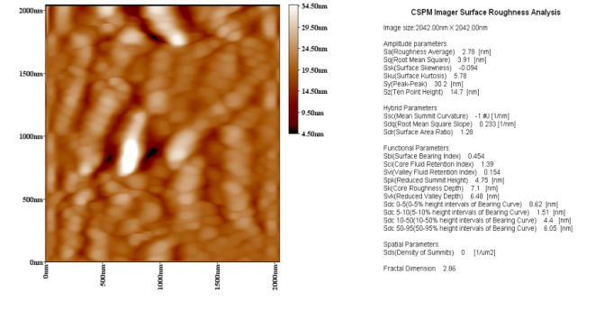

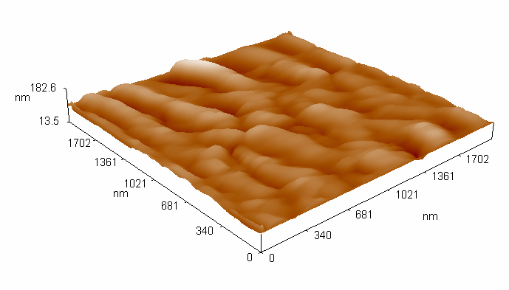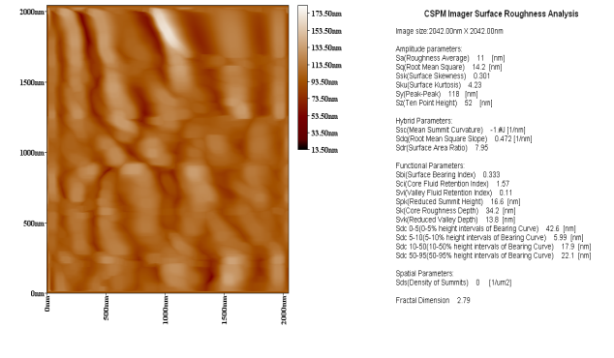

**Fig (2):** 2D and 3D AFM images for Mg AZ31 Alloy (a) polished Surface (b) 10min.Anodizing (c) 20 min. Anodizing (d) 30 min. Anodizing

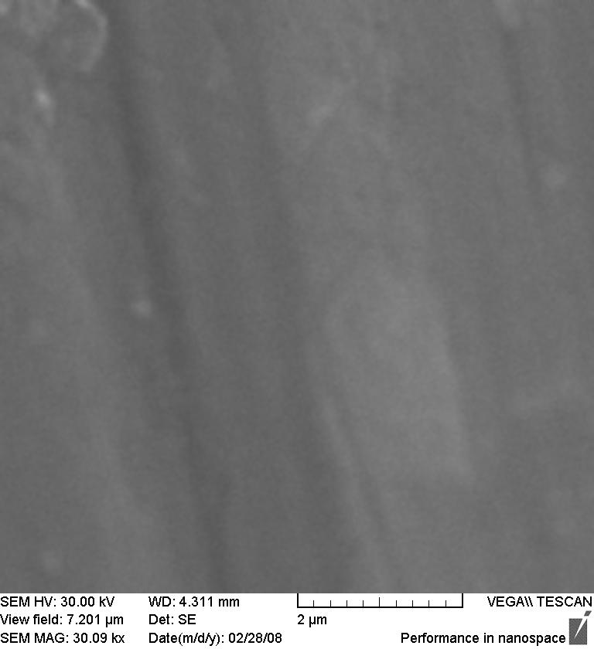

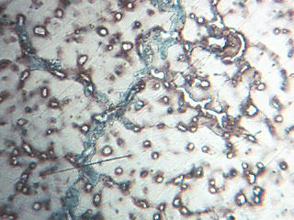

(a)

(b)

**Fig (3):** AZ31 Mg alloy

(a) SEM as polished (b) microstructure (Optical Microscope)

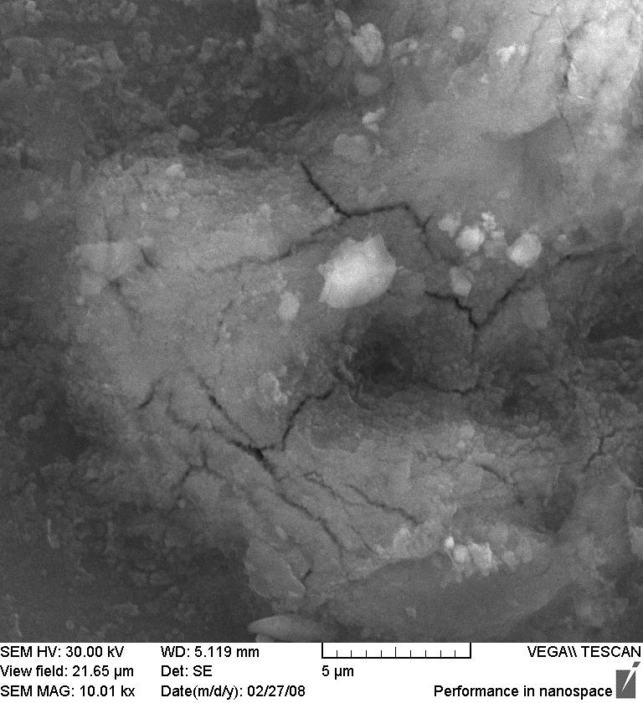

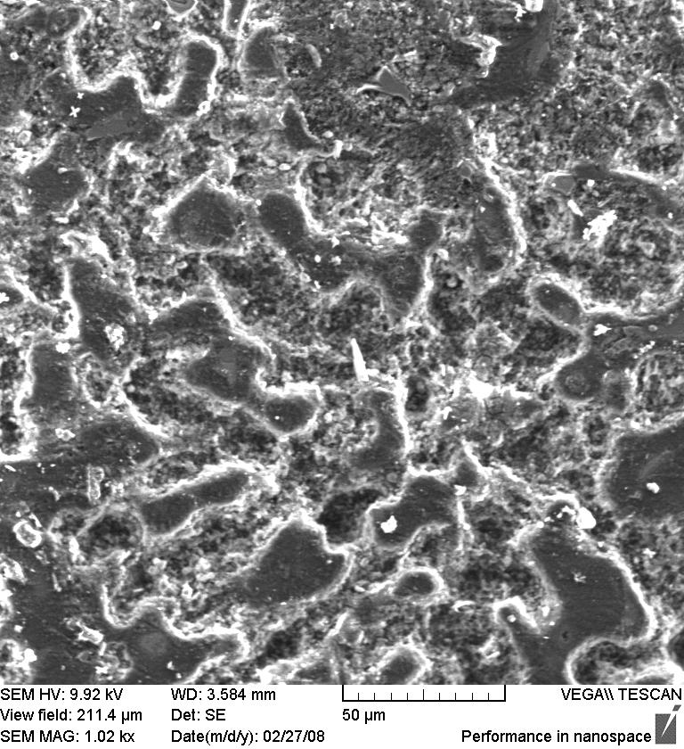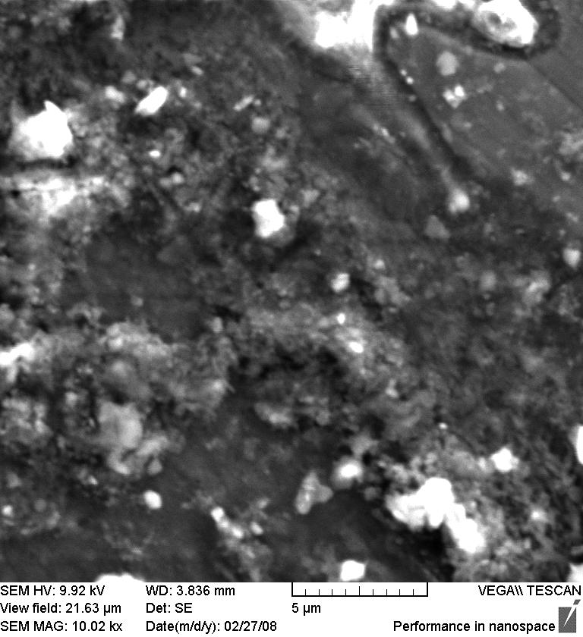

**Fig. (4):** SEM morphology of the anodic surface: (a) polished Surface

(b) 10 min. Anodizing (c) 20min.Anodizing (d) 30min.Anodizing

**Fig (5):** Variation of coating thickness with anodizing time

**Fig (6):** Relation between anodizing time and microhardness of coating layers

**أنودة سبيكة المغنيسيوم (AZ31) بأستخدام محلول قاعدي**

**الخلاصة**

تم في هذا البحث دراسة بناء طبقة من اوكسيد المغنيسيوم على سطح سبيكة المغنيسيوم (AZ31) باستعمال محلول قاعدي (3 مولاري) KOH ولزمن انودة (10،20،30) دقيقة وبثبوت الفولتية عند (5 V). الطبقة المتكونه على سطح السبيكة تم قياس خشونتها بأستخدام (AFM) (مجهر القوى الذرية) كما تم استخدام المجهر الألكتروني الماسح (SEM) لتوضيح البنية المجهرية قبل وبعد عملية الأنودة.

من خلال النتائج التي تم الحصول عليها نلاحظ ان خشونة وسمك وصلادة الطبقة المتكونة على سطح سبيكة المغنيسيوم (AZ31) يعتمد على زمن الأنودة حيث يزداد بزيادة الزمن.