ISSN 1999-8716

**Diyala Journal**

**of Engineering Sciences**

Printed in Iraq

Vol. 08, No. 02, pp. 1-17, June 2015

**DESIGN OF MICROSTRIP ANTENNA USING FRACTAL GEOMETRY AND METAMATERIAL**

**Waleed K. Abd 1, Muneer A. Hashem 2, Israa H. Ali3**

1, 2 Assistant Professor, Department of Electrical Engineering / Collage of Engineering,

Al-Mustansiya University

3Assistant Lecturer, Collage of Engineering, University of Diyala

dewk_2009@yahoo.com 1, muneraboud@yahoo.com 2, [pg_student75@yahoo.com](mailto:pg_student75@yahoo.com) 3

(Received: 4/9/2013; Accepted: 24/2/2014)

**ABSTRACT: -** The performance improvement which was achieved in rectangular patch antenna was made by the use of fractal geometry and Left-Handed Metamaterial (LHM). The two types of fractal geometry used are 1st iteration of Minkoweski and Koch separately, while the 2nd iteration includes (a combination two types of Koch and Minkoweski). The S-Shape Split Ring Resonator (S-SRR) was used to ensure the Left-Handed Metamaterial (LHM), that's mean negative value of permeability and permittivity in the same frequency band. Finally a combination of the designed (fractal antenna and S-Shape SRR) were used together, and the effect of this combination on antenna performance were made. Implementation of fractal geometry leads to the area redaction by 30%, and the implementation of S-SRR leads to the bandwidth improvement by 4% compared to the rectangular patch antenna design. The used program for the antenna design and their performance is CST software (Computer Simulation Technology), CST STUDIO SUITETM 2010**.**

**Keywords:** Microstrip antenna, Fractal Antenna, Left-Handed Metamaterial, negative permittivity, negative permeability**..**.

**1. INTRODUCTION**

With the tremendous advancements in wireless communications, there is an increasing demand for miniature, low-cost, easy-to- fabricate, multiband and wideband antennas for use in commercial communications systems. As a part of an effort to further enhance modern communications systems technology, researchers have been studying different approaches for creating novel and innovative antennas. The approach adopted in this paper combines fractal geometry and left-handed metamaterial in order to achieve an antenna design suitable for several wireless applications.

The antennas should also be well-suited in terms of cost, size, radiation patterns, gain and ease of integration in the circuit boards of communication devices. To meet these constraints, we use a rectangular patch with a microstrip-line feed.

Due to the concept of self-similarity, infinite complexities and detail in their geometrical properties, fractal antennas allow smaller, multiband and broadband antenna design (1). A Koch and Minkoweski fractal geometry are introduced in the patch and they are used to increase the antenna's electrical length. These will help obtain a resonance at a lower frequency without increasing the overall antenna dimensions. Then, a dynamic technique which achieves selectivity in frequency is used.

The possibility of obtaining media with simultaneously negative permeability and permittivity was hypothesized by Veselago in the late 1960s (2). In spite of the interesting properties presented by such media, it was not used until 2000 that the first experimental evidence of a medium with simultaneously negative permeability and permittivity was demonstrated Pendry and Smith. Duo to their unique electromagnetic properties, LHMs have great potential application values at microwave. A great variety of metamaterials have been envisioned and fabricated. Similar to the working principle of SRR/Wire metamaterial, dielectric-metallic LHM unit cells, like S-shaped, Ω-shaped, coplanar magnetic and electric resonator unit cells, have been proposed (3). Chen et al., proposed an S-shaped SRR structure (S-SRR) which, without the need of additional rods, produces an electric and magnetic response within the same frequency range, thus realizing simultaneously a negative permittivity and a negative permeability, i.e., a left-handed metamaterial (4).

In this paper we propose a design rectangular patch antenna with combination fractal geometry and S-Shape SRR metamaterial, at frequency operating equal to 1.8 GHz.

**2- DESIGN OF ANTENNA**

This paper consists of three parts of the designs as be seen:

**(a) DESIGN OF RECTANGULAR PATCH ANTENNA**

The design of the proposed antenna is shown in Figure (1).

There are several techniques available to feed or transmit electromagnetic energy to a microstrip patch antenna. The role of feeding is very important in case of efficient operation of antenna to improve the antenna input impedance matching. There are main four types of feeding (Microstrip Line, Coaxial Cable, Aperture Coupling and Proximity Coupling) which were tasted, and the Microstrip Transmission Line feed is chosen because easy to fabricate and good performance.

Figure 1 shows the microstrip rectangular patch antenna with a microstrip transmission line insert feed. The required frequency (fo) of the lower patch is chosen to be around 1.8 GHz. The substrate used for the antenna is FR-4 with dielectric constant, εr = 4.3, loss tangent 0.019 and the thickness is 3.5 mm. The thickness of the ground (copper) material is 0.1 mm. The size of the feed line is adjusted to make sure that the impedance of the antenna is 50 Ω. The width (W) and the length (L) of antenna are calculated from conventional equations(5):

(1)

The actual length is obtained from equation (2) as using:

$L= L_{eff}-2∆L$ (2)

Equation (3) gives the length extension (ΔL) as:

$∆L$ = $0.412 h \frac{\left(Ɛ_{reff}+0.3\right)\left(\frac{w}{h}+0.264\right)}{\left(Ɛ_{reff}-0.258\right)\left(\frac{w}{h}+0.8\right)}$ (3)

Effective dielectric constant (εreff) is given in equation (4):

$Ɛ_{reff}=\frac{\left(Ɛ_{r}+1\right)}{2}+\frac{\left(Ɛ_{r}-1\right)}{2 } {\left[1+12\frac{h}{w}\right]}^{\frac{-1}{ 2}}$ (4)

$L_{eff= } \frac{c}{2f_{r} \sqrt{Ɛ_{reff}}}$ (5)

Where Leff = Effective length of the patch

Equation (6) and (7) gives the width (Wg) and the length (Lg) of the ground plane:

$W_{g}=6h+W$ (6)

$L_{g}=6h+L$ (7)

The length and width of the microstrip patch antenna are 39 mm and 52 mm respectively, the length and width of ground plane are 60 mm and 73 mm respectively.

To calculate the notch width for microstrip line feed as follow (5):

(8)

**(b) DESIGN OF FRACTAL ANTENNA**

In this paper, we apply the combination of triangular Koch and Minkowski fractal geometries on the sides of a rectangular patch antenna. The fractal geometry is generated by an initiator and then generators are used for two types combinations (6). Type I, uses first the Minkowski fractal then Koch triangular fractal as shown in Figure 2(a). Type II, employs the reverse order as shown in Figure 2(b). In both types, the scale factor is approximately equal to 0.21.When are used microstrip patch antenna with microstrip transmission line. The fractal are applied on three sides of the inset-fed patch and the fourth side was designed to impedance matching of the proposed fractal antenna (7), the design would be as shown Figure 3(a) and (b).

**(c) DESIGN OF S- SHAPE SPLIT RING RESONATOR (S-SRR)**

A periodic array of S-SRR structures is shown in Figure 4(a), where each unit cell is composed of two reversed S-shaped metallic strips printed facing each-other. Where the solid line indicates the front ‘S’ pattern, and the dashed line indicates the back ‘S’ pattern, yielding an eight like pattern when viewed from top are shown in Figure 4(b). Thus, besides the two capacitances Cs between the top and bottom metallic strips, there is another capacitance Cm between the center of the metallic strips. The dimensions of a unit cell are (15 x7.5 x 0.25) mm, while the dimensions of the S-SRR are w= 13 mm, h= 7 mm, c= 1mm, and the dielectric constant of the substrate is 4.3.

When a time-varying external magnetic field is applied, the total electromotive force around the circumference of the figure-eight pattern (composed of the two opposite S rings) is zero, and the capacitance Cm does not exist or is very small, it can be treated as an open circuit. Because the magnetic flux in the top half and bottom-half area of the figure-eight-pattern structure always cancel each other. If the Cm is large and equal to C, so that the existence of Cm enables the current to flow in each half ring, the capacitance between the two metallic strips can be calculated as (4):

)9)

And an inductance L of each half ring directly proportional to the area enclosed by each ring (4):

)10)

If the fractional volume of the cell occupied by the top and bottom loop of the ‘8’ pattern is equal then the effective permeability that was defined in (8):

(11)

Where:

$X={(ωμ_{0}F S)}^{2} \left(1-\frac{1}{ωμ_{0}F S} \frac{l}{C_{s}} \right)$

$D\left(σ\right)=\frac{A\left(σ\right)}{X}$ (12)

$E\left(σ\right)=\frac{B\left(σ\right)}{X}$

$G\left(σ\right)= C(σ)/X$

The electrical properties of the S-SSR are in fact very similar to those of an array of cut rods.

The generic form of the effective permittivity for the rods array has been shown to be (8):

(13)

**3- SIMULATION RESULTS AND ANALYSIS**

1. **Rectangular Patch Antenna with Microstrip Transmission Line (MPTL)**

Figure (5) shown the reflection coefficient S11, it depicts that the designed antenna ensures the multiband operation including the required operating frequency 1.8 GHz with bandwidth 83MHz and return loss -25 dB.

**(b) Fractal Antenna**

The linear polarization of radiation is obtained by placing similar fractal shapes on the edges of rectangular patch, so that their electrical lengths are identical. The rectangular patch fractal types I and II, with Minkowski and triangular Koch (with two iterations) seen Figures 6 and 7. It observed that the resonance frequencies of 1st and 2nd iteration of type I and II fractals are lower than that of the simple patch antenna by (1.595, 1.717, 1.574 and 1.662) GHz respectively instead of 1.8 GHz. So the miniaturization of the fractal antenna dimensions is needed to cover the resonant frequency at 1.8 GHz.

To obtain the required frequency $f_{r}$ at 1.8 GHz, would be varying the dimensions of the fractal antenna and it's feeding. The Figures 8 and 9 shown these design of fractal antenna.

Table 1 illustrates the antenna parameters and the area after miniaturization. It is observed that the operating frequency considers with the required frequency, and the obtained area reduction is about 35%, a better performance in bandwidth, gain and beam width with respect to the antenna combination before miniaturization

**(c) S-Shape SRR Metamaterial**

Figure 10 (a) and (b) show the reflection and transmission coefficients, while the Figure 11 (a) and (b) are depicts the phase in S11, S21 respectively.

The LHM is obtained, since the dip in the phase of S11 and S21, indicates the presence of negative index band at the designed frequency.

**(d)** **S- Shape SRR with MPTL and Fractals**

The final design are combined an array of S-SRR with rectangular patch antenna and with the fractal types antenna miniaturization in the back of patch antenna. The Figures 12, 13, 14, 15, 16 present the final design. And the Figures 17, 18, 19, 20 are shown the return loss and radiation pattern for these design.

From Table 2 is shown that increasing the number of unit cells the numbers of unit cell leads to enhancement of the directive properties.

1st type and 2nd type combination of fractal antenna with and without metamaterial has the same performance approximately. The designed antenna with metamaterial give BW 4% batter than the designs antenna without metamaterial. 1st iteration Koch fractal antenna's parameters gives a better performance in than 1st iteration Minkoweski antenna.

**4. CONCLUSION:**

The final designs of antenna refers to the linear polarization in E-plane, where the beam width is approximated more than ${95}^{°}$, the VSWR is around less than 1.6, the directivity is altered 6 dBi, the permeability and permittivity are obtained in negative value at in same band 1.8 GHz without need the rods, that’s mean the LHM is achieved. The area reduction by 30% and the bandwidth improvement by 4%.

**REFERENCES:**

* 1. Yogesh Kumar Choukiker and S. K. Behera: “Design of Wideband Fractal Antenna with Combination of Fractal Geometries”, IEEE Trans. on Antenna and Propagation, vol. 48, pp. 978-1-4577, 2011.
  2. V. G. VESELAGO: “The Electrodynamics of substances with simultaneously negative valuo of Ɛ and μ”, Soviet Physics Uspekhi, vol.10, No. 4, 1968.
  3. Iman Ben Issa and Mohamed Essaaidi, “*Simultaneous Gain and Bandwidth Enhancement of a Circularly Polarized Microstrip Patch Antenna Using a Coupled Square-shape Split Ring Resonators Metamaterial Superstrate*”, IEEE Trans. Antennas Propag., vol. AP-33, no. 9, 2012.
  4. Hongsheng Chen, Lixin Ran, Jiangtao Huangfu, Xianmin Zhang, and Kangsheng Chen: “Left-Handed Materials Composed of only S-Shaped Resonators”, American Physical Society, 70 057605-1, 2004.
  5. M A MATIN, A. I. SAYEED: “A Design Rule for Inset-fed Rectangular Microstrip Patch Antenna”, WSEAS Transactions on Communications, Issue 1, Volume 9, January 2010.
  6. Z.-W. Yu, G.-M. Wang, X.-J. Gao, and K. Lu: “A Novel Small-Size Single Patch Microstrip Antenna Based on Koch and Sierpinski Fractal-Shapes”, Progress In Electromagnetics Research Letters, Vol. 17, 95-103, 2010
  7. Elder Eldervitch Carneiro de Oliveira, Antonio Luiz Pereira de Siqueira Campos and Paulo Henrique da Fonseca Silva: “Quasi-fractal Koch Triangular Antenna”, SBMO/IEEE MTT-S International Microwave & Optoelectronics Conference (IMOC), 2009.
  8. H. S. Chen, L. X. Ran, J. T. Huangfu, X. M. Zhang, and K. S. Chen: “Magnetic Properties of S-Shaped Split-Ring Resonators”, Progress In Electromagnetics Research, PIER 51, 231–247, 2005

**Table )1:(** Comparison between the miniaturization fractal types & the obtained parameters of designed antenna

|  |  |  |  |  |  |  |  |
| --- | --- | --- | --- | --- | --- | --- | --- |
| Antenna  parameters  Types of  design antenna | BW MHz  ($f_{L}-f_{H}$) | Gain dB | Dir. dBi | VSWR | Return Loss dB | Beamwidth  (-3dB)  deg. w.r.t E-plane | Area $${mm}^{2}$$ |
| 1st iteration Minkowski | 55  (1772-1827) | 1.6 | 5.7 | 1.04 | -34.3 | 101.1 | 1081.8 |
| 1st iteration Koch | 65  (1783-1848) | 2.4 | 5.8 | 1.45 | -18.8 | 99.7 | 1424.12 |
| 2nd iteration  Combination I | 60  (1793-1853) | 3.3 | 5.8 | 1.48 | -21.7 | 100.6 | 1248.93 |
| 2nd iteration  Combination II | 67  (1745-1812) | 3 | 5.9 | 1.5 | -17.8 | 99.7 | 1354 |

**Table (2):** Comparison between the fractal antenna parameters with and without metamaterial

|  |  |  |  |  |  |  |  |
| --- | --- | --- | --- | --- | --- | --- | --- |
| Beamwidth  (-3dB)  degree w.r.t E-plane | Return loss  dB | VSWR | Dir.  dBi | Gain  dB | BW MHz  ($f_{L}-f_{H}$) | Antenna parameters    Types  of antenna design | |
| 98.4 | -25 | 1.113 | 6 | 3.3 | 83  (1762-1845) | without metamaterial | Rectangular patch antenna |
| 94.1 | -28.8 | 1.19 | 6.1 | 3.4 | 87.5  (1772-1859.5) | with metamaterial |
| 101.1 | -34.3 | 1.04 | 5.7 | 1.6 | 55  (1772-1827) | without metamaterial | Minkoweski 1st iteration fractal antenna |
| 95.9 | -32 | 1.05 | 5.9 | 1.7 | 57  (1772-1830) | with metamaterial |
| 99.7 | -18.8 | 1.27 | 5.8 | 2.4 | 65  (1783-1848) | without metamaterial | Koch 1st iteration fractal antenna |
| 99 | -20 | 1.58 | 5.8 | 2.7 | 72.3  (1785-1857.3) | with metamaterial |
| 100.6 | -21.7 | 1.48 | 5.8 | 3.3 | 60  (1793-1853) | without metamaterial | 2nd iteration combination type I fractal antenna |
| 96 | -20 | 1.2 | 6 | 3.4 | 66  (1761-1827) | with metamaterial |
| 99.7 | -17.8 | 1.5 | 5.9 | 3 | 67  (1745-1812) | without metamaterial | 2nd iteration combination type II fractal antenna |
| 96 | -17.5 | 1.48 | 6.2 | 3 | 74.2  (1749.2-1825.4) | with metamaterial |

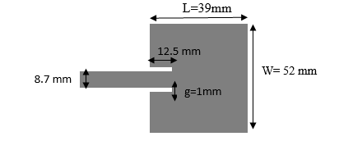

**Figure (1):** Rectangular patch antenna.



(a)



(b)

**Figure (2):** Procedure for the generation of fractals (a) Type I (b) Type II.



(a)



(b)

**Figure (3):** Combined fractal patch antennas with microstrip line feed (a) Type I (b) Type II.

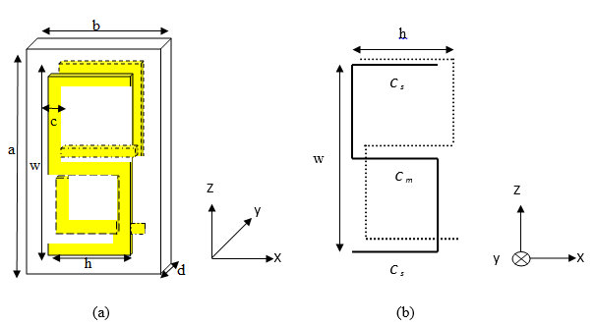**Figure (4):** S-shaped SRR (a) plot of 3-D, (b) in x-z plane

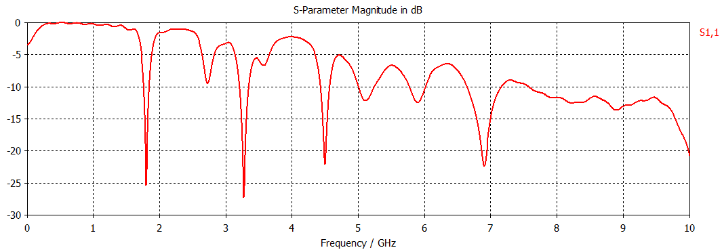

**Figure (5):** Reflection coefficient S11 for rectangular patch antenna with (MPTL)

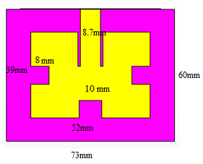 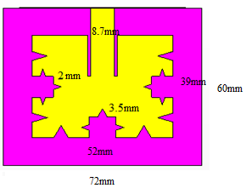

**Figure (6)**: 1st and 2nd iteration combination fractal type I

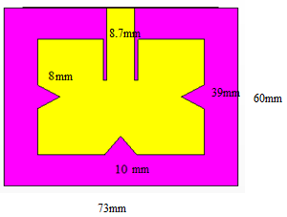 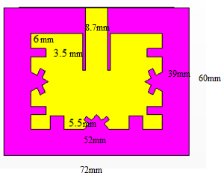

**Figure (7):**1st and 2nd iteration combination fractal type II

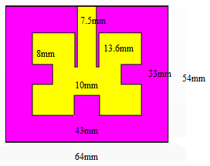 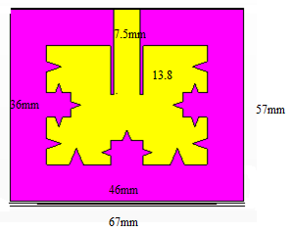

**Figure (8):** 1st and 2nd iteration combination fractal miniaturization type I

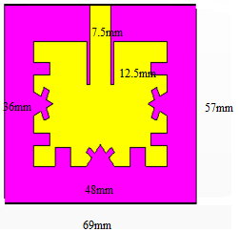 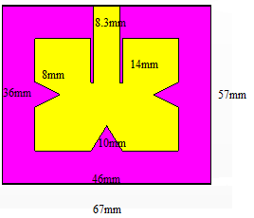

**Figure (9):** 1st and 2nd iteration combination fractal miniaturization type II

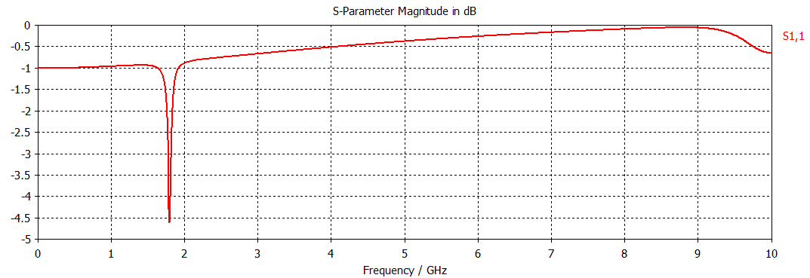

(a)

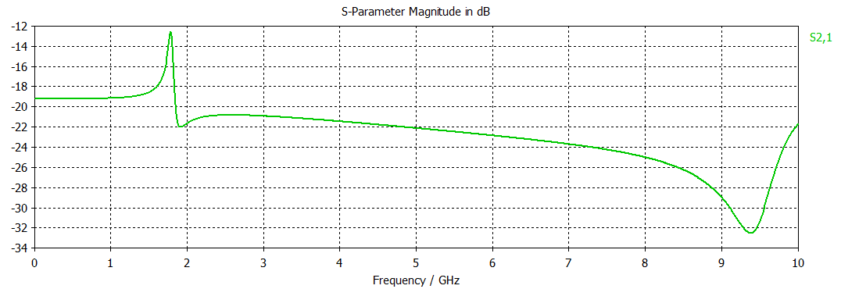

(b)

**Figure (10):** S-Shape SRR (a) Reflection coefficient S11 (b) Transmission coefficient S21

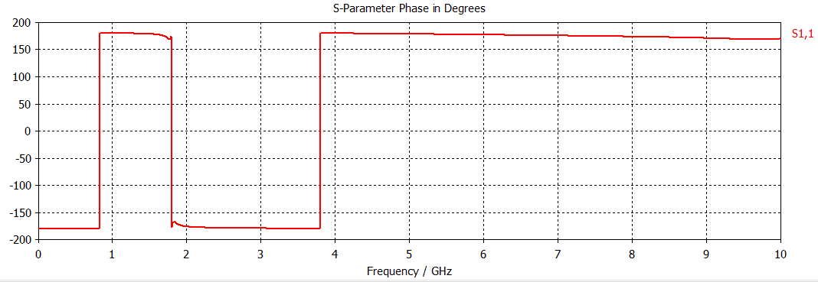

(a)

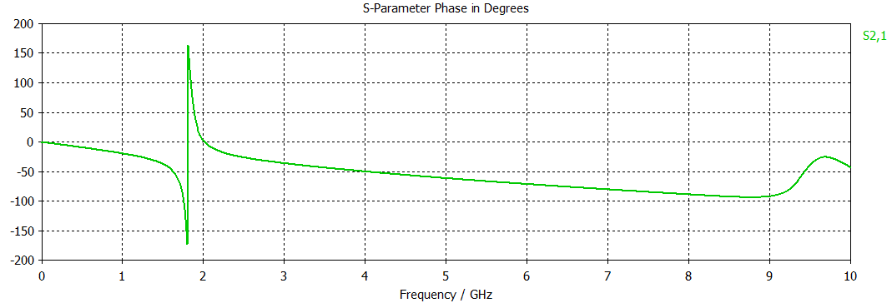

(b)

**Figure (11):** Phase for S-Shape SRR (a) reflection coefficient S11 (b) transmission coefficient S21

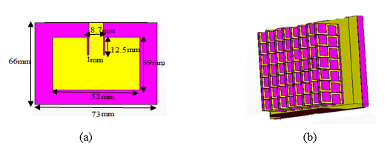

**Figure (12):** MPTL with S-Shape SRR (a) front view (b) side view.

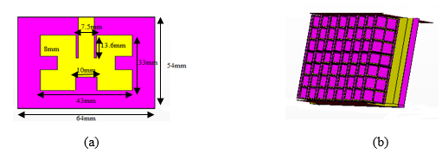

**Figure (13):** 1st iteration Minkowski fractal with S-Shape SRR (a) front view (b) side view

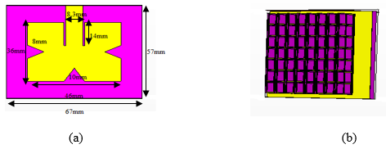

**Figure (14):** 1st iteration Koch fractal with S-Shape SRR (a) front view (b) side view.

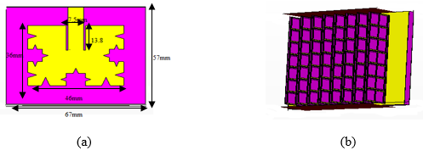

**Figure (15):** 2nd iteration combination I fractal with S-Shape SRR (a) front view (b) side view

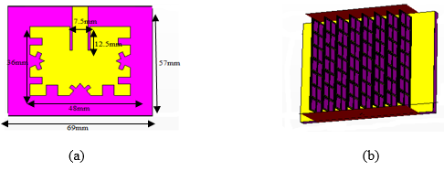

**Figure (16):** 2nd iteration combination II fractal with S-Shape SRR (a) front view (b) side view.

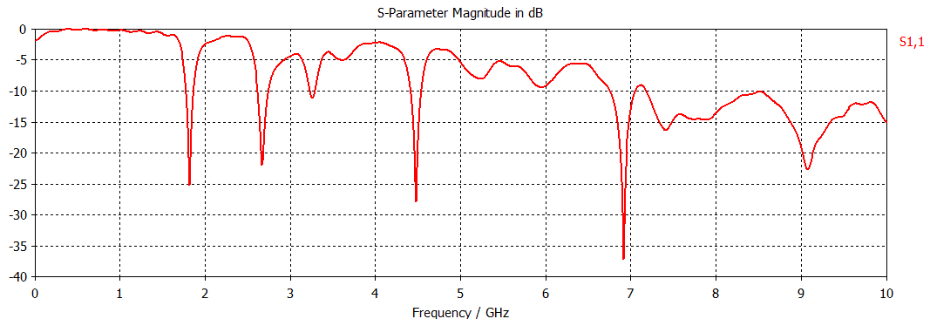

**Figure (17):** S11 for MPTL.

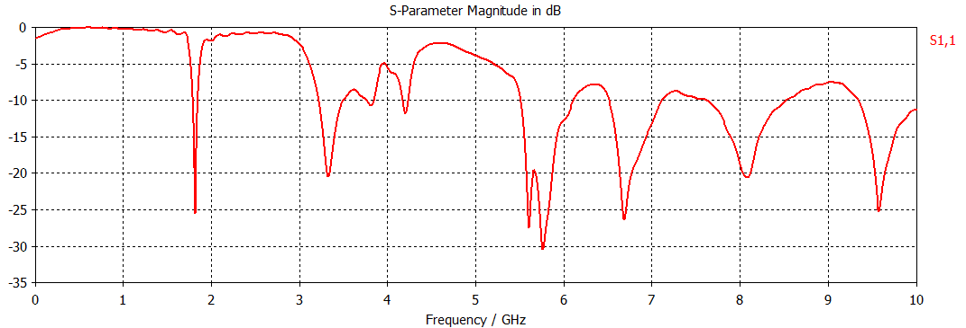

(a)

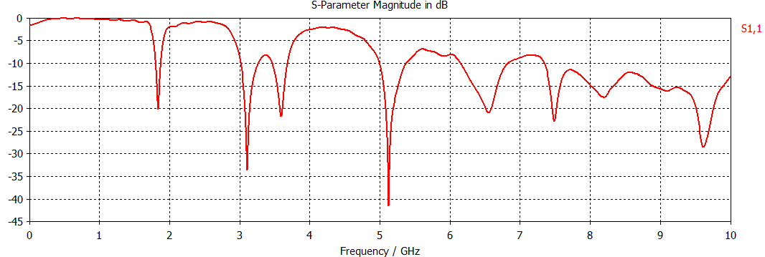

(b)

**Figure (18):** S11 for 1st iteration fractal (a) Minkoweski (b) Koch.



(a)

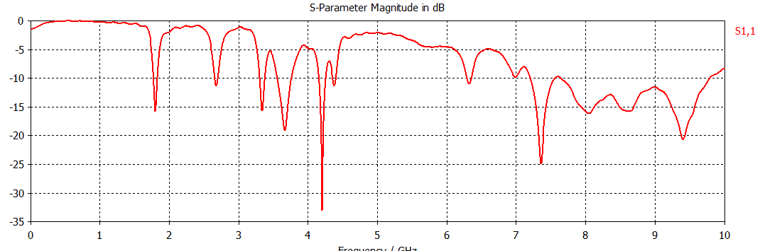  
(b)

**Figure (19):** S11 for 2nd iteration combination fractal (a) type I (b) type II.

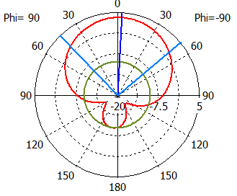

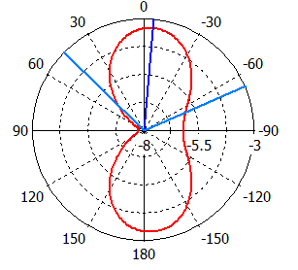  
 (a)

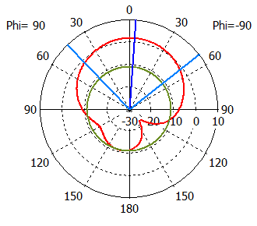 (b) 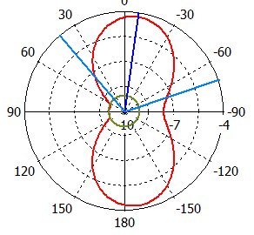

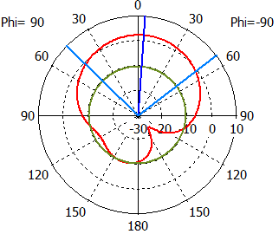 (c) 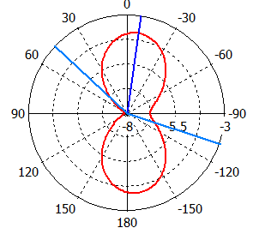

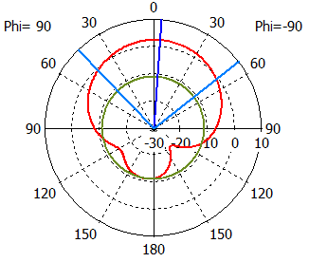

(d) 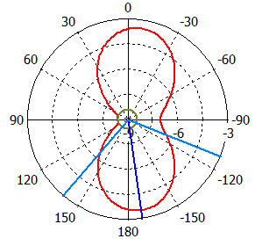

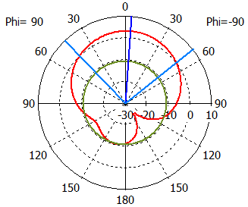 (e) 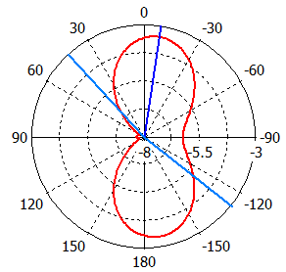

E-plane H-plane

**Figure 20:** Radiation pattern at E-plane and H-plane with S-SRR (a) MPTL (b) 1st iteration Minkoweski, (c) 1st iteration Koch, (d) 2nd iteration combination type I and (e) 2nd iteration combination type II.

**تصميم هوائي الوصلة الدقيقة باستخدام الهندسة الجزيئية والمواد ذات معامل الانكسار السالب**

**وليد خالد عبد 1، منير عبود هاشم 2، اسراء حازم علي 3**

1، 2 استاذ مساعد، كلية الهندسة، الجامعة المستنصرية

3 مدرس مساعد، كلية الهندسة جامعة، ديالى

**الخلاصة**

تم إجراء تحسينات على هوائي الرقعة المستطيلة باستخدام الهندسة الجزيئية و(LHM) Left-Handed Metamaterial.استعملنا نوعين من الهندسة الجزيئية، في التكرار الأول استخدمنا منكوفسكي وكوخ بشكل منفصل بينما في التكرار الثاني جمعنا النوعين منكوفسكي وكوخ.تم استخدام الحلقة الرنينية على شكل حرف S لتحقيق LHM وهذا يعني قيمة سالبة من النفاذية والسماحية في نطاق التردد نفسه. وأخيرا" تم تصميم هوائي من دمج الهندسة الجزيئية والحلقة الرنينية على شكل حرف S, وعلاقة هذا الدمج على أداء الهوائي. فعند استخدام الهندسة الجزيئية انخفضت المساحة بنسبة 30% وباستخدام الحلقة الرنينية على شكل حرفS ازدادت حزمة الترددات بنسبة 4% مقارنة بهوائي الرقعة المستطيلة المصمم. البرنامج المستخدم لتصميم الهوائي وأداؤه هو برنامج CST STUDIO SUITETM 2010 (تقنية محاكاة الحاسوب(.