ISSN 1999-8716

**Diyala Journal**

**of Engineering Sciences**

Printed in Iraq

Vol. 08, No. 02, pp. 18-27, June 2015

**NEW DESIGN OF SYMMETRICAL FED CIRCULAR PATCH ANTENNA BASED ON CURVE-SHAPE GROUND SLOT FOR ULTRA-WIDEBAND APPLICATIONS**

**Adheed H. Sallomi 1, Zaid A. Abed AL-Husain 2, Amir A. Osman 3**

1, 2 Lecturer, 3Assistant Lecturer, Department of Electrical Engineering,

Collage of Engineering, Al-Mustansiriya University

(Received: 27/5/2012; Accepted: 6/12/2012)

**ABSTRACT**

A new single layer, symmetrical microstrip fed compact circular patch with open-ended curve-shape slot ground is demonstrated and designed for Ultra-Wideband (UWB) applications. With the open-ended curve-shaped slot and circular patch fed by the micro-strip line, multiple resonant frequencies are excited and merged to form a measured widen operating bandwidth of 1.73 to 5.92 GHz with -10 dB return loss. Finite element simulations have been carried out to evaluate the performance of the modeled antenna using the HFSS v.11 electromagnetic (EM) simulator, from Ansoft. The proposed antenna is simulated with different ground slot width in order to study its effect on the bandwidth. In addition, the proposed slot antenna exhibits a small size of 30 × 30 mm. The simulated results show that, the proposed antenna has very good performance in impedance bandwidth with accepted radiation pattern, which makes it an excellent candidate in many ultra-wide band applications. The antenna is candidate to operate in Global System Mobile (GSM) and Wireless Local Area Communications (WLAN) 2.45 GHz and 5.8 GHz systems.

**INTRODUCTION**

The accelerating progress of the wireless communication and the ever increasing number of communication and navigation services such as cellular phones (GSM, GPRS, WCDMA), Global Positioning System (GPS), ground penetrating radars, high data rate short wireless local area communications (WLAN), parking radars, and other applications in the last few years, has created an ever-growing demand for multi systems application. To cover many or all of these services by one system, it’s required a very high bandwidth antenna or as called ultra-wideband (UWB) antenna with compact size and adequate performance that can be exploited in wireless communication systems. There is an important relation between antenna dimensions and wavelength. This relation states: if antenna size is less than the quarter of the wavelength (*λ/*4) then the antenna is not efficient because radiation resistance, gain and bandwidth is reduced and therefore antenna size is increased. Fractal geometry (1, 2, 3) is a very good solution for this problem. These structures are recognized by their self-similarity properties and fractional dimension. In the recent years, the geometrical properties of self-similar and space ﬁlling nature has motivated antenna design engineers to adopt this geometry a viable alternative to meet the target of multi, Broad-band as well as ultra-wideband operation. T. Kikkawa, K. Kimoto and S. Watanabe was modified the characteristics of Sierpinski carpet fractal antenna for UWB operation. The antenna are fabricated on silicon substrates with the resistivities of (2290, 79.6, and 10Ω) (4). New fractal geometry for microstrip antennas is presented by A. Azari and J. Rowhani. This fractal structure is implemented on hexagonal and several iterations are applied on initial shape. This antenna successfully demonstrated (UWB) characteristics (from 0.1GHz to 24GHz) (5). S. N. Khan, J. Hu, J. Xiong, and S. He introduce circular ultra-wideband fractal monopole antenna based on descartes circle theorem (DCT) with elliptical iterations. Their design is optimized for return loss below (−15 dB) (6). G. M. Yang, R. H. Jin, G. B. Xiao, C. Vittoria, V. G. Harris, and N. X. Sun design Novel ultra wideband (UWB) antennas with multi resonant split-ring loops and with coplanar waveguide (CPW) feed [7]. A. Aggarwal and M. V. Kartikeyan show the design of a fractal patch antenna, which uses a unique fractal geometry known as Pythagoras tree with co-planer waveguide (CPW) feeding. The antenna has been designed for dual band operation at the WLAN/WiMAX (2.4GHz) and WiMAX (3.5GHz) for ultra-wide bandwidth applications (8). K. Song, Y.-Z. Yin, B. Chen, and S.-T. Fan, introduced novel compact microstrip fed ultra-wideband (UWB) step-slot antenna with a rotated patch. The antenna has effective combination of the step-slot and rotated patch and proper dimensions bandwidth enhancement for UWB operation is obtained (9).

In this paper, a symmetrical microstrip patch antenna with curve-shape ground slot is used to design UWB antenna. The characteristics of the proposed antenna structure has been predicated using Finite element simulations have been carried out to evaluate the performance of the modeled antenna using the HFSS v.11 EM simulator, from Ansoft (10).

**ANTENNA DEISGN**

By combining open-ended curve-shaped ground slot and symmetrical circular patch fed by the microstrip line, a compact UWB slot antenna is designed. The geometry of the wide-band curve-slot patch antenna is shown in Figure (1).

The proposed UWB antenna is 30×30 mm size. It is designed on a substrate with a thickness of 0.8 mm and a relative permittivity εr of 4.5. The circular patch diameter is 12 mm, and is fed by a 50 Ω micro-strip line. The feeding strip that is connected to the patch is 1.5 mm width, and 8.35 mm length. The ground gap width is 4.5 mm. Air dielectric is used between the patch and the ground. The dimensions of the designed antenna shown in Figure 2 are all given in millimeters.

**ANTENNA PERFORMANCE EVALUATION**

According to Figure 2, the Ref. Antenna has been modeled. The antenna exhibits an ultra-wide band response impedance bandwidth 110.44% (from 1.73 to 5.92 GHz, for S11 ≤ 10 dB). This band is candied to operate in GSM, DCS and WLAN 2.45 GHz and 5.8 GHz systems. The proposed antenna has suitable return loss in these bands to satisfy these applications. An interesting parametric study has been conducted to demonstrate the effects of the variations of the ground space (g) on its performance (matching) in terms of the S11 response. Figure 3 shows this effect. Antenna matching has been occurs when the gap space around 6 mm which offers maximum bandwidth, while no matching (S11 ≥ 10 dB) when there is no gap space (continuous ground plane). Figure 4 shows the S11 frequency response for the antenna dimensions shown in figure (2) and gap space g=6mm.

It can be noticed that increasing the ground gap (g) can result in a wider bandwidth. By carefully selecting suitable values of the length of the micro-strip feed line, and the width of the open-end curve-slot, an optimum wideband can be obtained as illustrated in Figure 4(at g=6mm) which is butter than those that have been shown in Figure 4.

The simulated 2&3D-far-field radiation patterns of proposed wide-band Microstrip single-layer patch antenna at frequencies of 1.8 GHz, 2.45 GHz, and 5.8 GHz are shown in Figure 5 and 6 respectively. It can be seen that the designed UWB antenna has the asymmetric radiation characteristics at H-plane because of its inherent asymmetric structure.

At the surface of the modeled antenna, current surface has been presented at the three resonance frequencies is shown in Figure 7. It can be seen largest values of the surface currents have been found to take place along the circumference of antenna structure

**CONCLUSION**

In this paper, a proposed compact open-ended curve-shaped slot antenna with circular patch for bandwidth enhancement is designed and simulated. Using the simple open-ended curve-shaped slot and the circular patch fed by the 50 Ω Microstrip line, the proposed antenna can enhance the operating bandwidth of 1.73 – 5.92 GHz***.*** The curve-shaped slot of the antenna shows significant reduction of return losses. The designed UWB slot antenna exhibits a small area of 30 *×* 30 mm2. The simulation results show that this antenna is an excellent candidate for UWB applications, as the used geometry eliminates the need for the parasitic elements and the dielectric substrate. The possibility to employ this antenna that fit in smaller volumes, and an efficient performance can be seen in many applications, and especially those involving mobile terminals, as the reduction of the antenna size is an ultimate goal.

**REFERENCES**

1. D. H. Werner and S. Gangul, “An overview of Fractal Antenna Engineering Research”, IEEE Antennas and Propagation Magazine Vol.45, No.1, February 2003.
2. K. Falconer, “Fractal Geometry; Mathematical Foundations and applications”, 2nd Edition, John Wiley and Sons, 2003.
3. J. Guterman, A.A. Hoofer and C. Peixeiro, “Microstrip Fractal Antenna for Multistandard Terminals”, IEEE Antenna and Propagation Wireless Letters, Vol.3, pp. 351-354, 2004.
4. T. Kikkawa, K. Kimoto and S. Watanabe “Ultra wideband Characteristics of Fractal Dipole Antennas Integrated on Si for ULSI Wireless Interconnects”, IEEE Electron Device Letters, VOL. 26, NO. 10, OCTOBER 2005.
5. A. Azari and J. Rowhani, “ULTRA WIDEBAND FRACTAL MICROSTRIP ANTENNA DESIGN”, Progress In Electromagnetics Research C, Vol. 2, 7–12, 2008.
6. S. N. Khan, J. Hu, J. Xiong, and S. He, “CIRCULAR FRACTAL MONOPOLE ANTENNA FOR LOW VSWR UWB APPLICATIONS”, Progress In Electromagnetics Research Letters, Vol. 1, 19–25, 2008.
7. G. M. Yang, R. H. Jin, G. B. Xiao, C. Vittoria, V. G. Harris, and N. X. Sun” Ultra wideband (UWB) Antennas With Multiresonant Split-Ring Loops”, IEEE TRANSACTIONS ON ANTENNAS AND PROPAGATION, VOL. 57, NO. 1, JANUARY 2009.
8. A. Aggarwal and M. V. Kartikeyan, “PYTHAGORAS TREE: A FRACTAL PATCH ANTENNA FOR MULTI-FREQUENCY AND ULTRAWIDE BAND-WIDTH OPERATIONS”, Progress In Electromagnetics Research C, Vol. 16, 25-35, 2010.
9. K. Song, Y.-Z. Yin, B. Chen, and S.-T. Fan “BANDWIDTH ENHANCEMENT DESIGN OF COMPACT UWB STEP-SLOT ANTENNA WITH ROTATED PATCH”, Progress in Electromagnetics Research Letters, Vol. 22, 39-45, 2011.
10. HFSS version 11.0, Ansoft Software Inc., 2007.

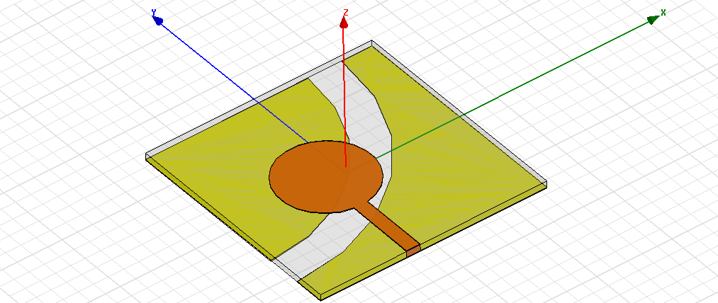

**Figure (1):** The proposed wide-band Microstrip antenna

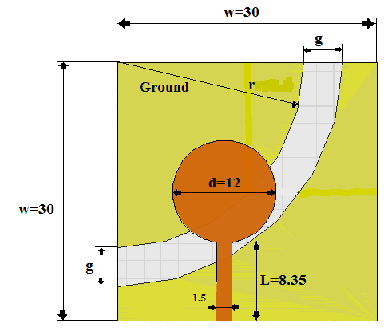

**Figure (2):** All Antenna dimensions in mm, g (Ground gap), d diameter of patch, L is length of strip line feeding.

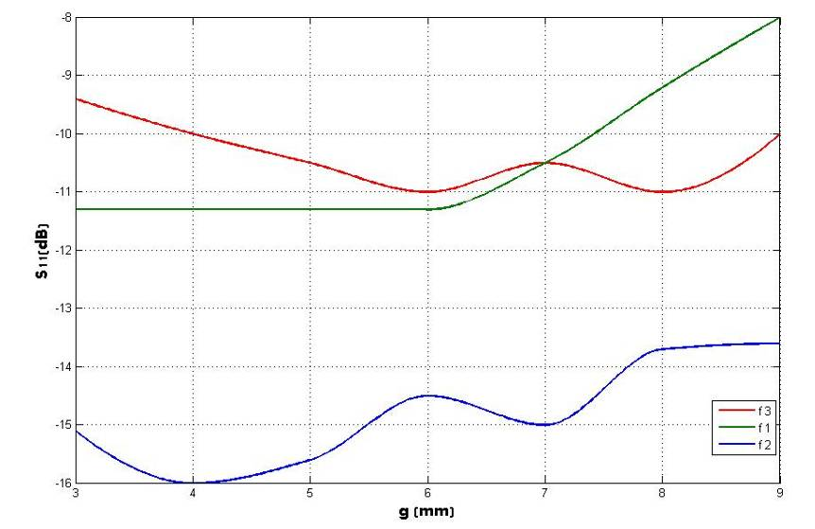

**Figure (3):** resonance bands (f1=1.8, f2=2.45 and f3=5.8 GHz) variation in term of S11 with gap space (g)



g = 4 mm

g = 5 mm

g = 6 mm

g = 7 mm

g = 8 mm

g = 9 mm

**Figure. (4):** The return losses with different curve- slot width (g).



At f=2.45 GHz At f=1.8 GHz



At f=5.8 GHz

**Figure (5):** far-field radiation patterns (Red line represent H_Plane and dark line E_ plane)

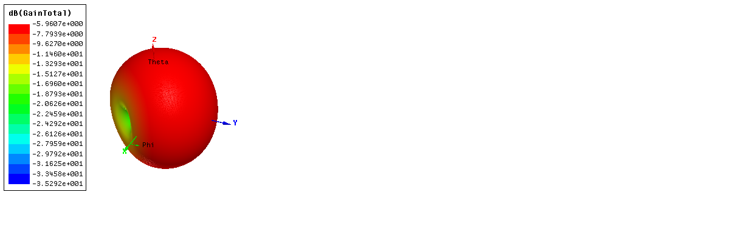

At f=1.8 GHz

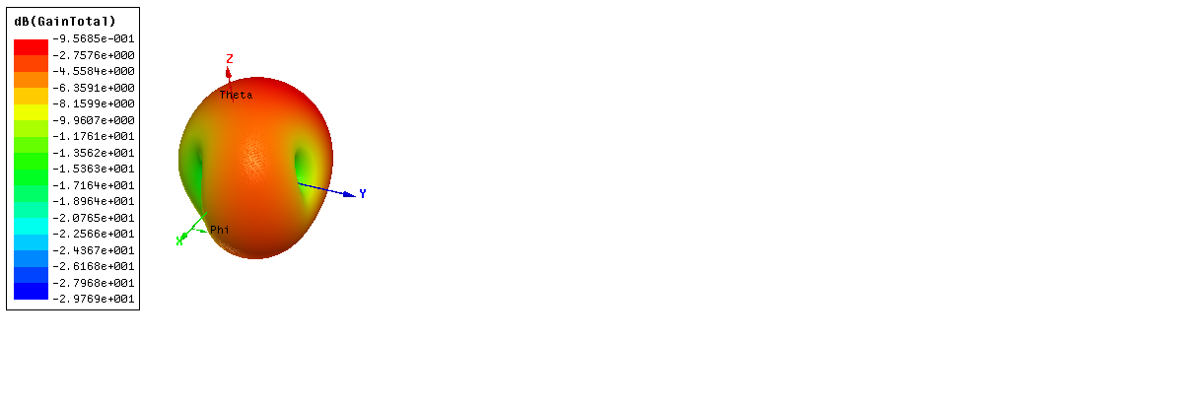

At f=2.45 GHz

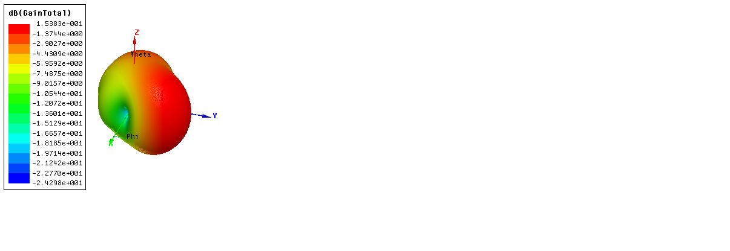

At f=5.8 GHz

**Figure (6):** 3D far-field radiation patterns

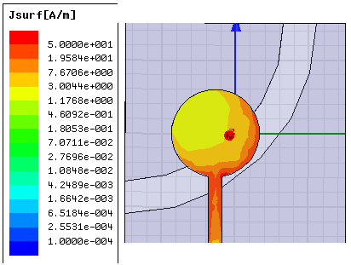

At f=1.8 GHz

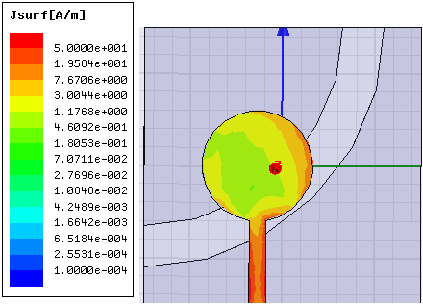

At f=2.45 GHz.

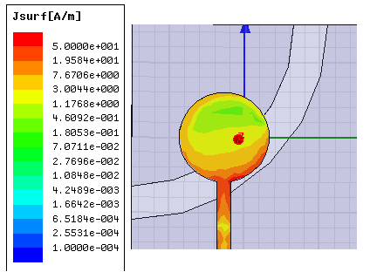

At f=5.8 GHz

**Figure (7):** current surface (J) distributions

**تصميم جديد لهوائي الرقعة الدائرية متناظر التغذية المستند إلى شق على شكل منحنى في ارضيته لاغراض تطبيقات النطاق الترددي الواسع جدا**

**الخلاصة**

هوائي جديد بطبقة واحدة ذو تغذية دقيقة متناظرة الدمج مع رقعة دائرية الشكل ومزود بشق ذو شكل منحني ذا نهايتين مفتوحتين في الطبقة الارضية للهوائي. لقد انجز وصمم هذا الهوائي لاغراض تطبيقات الحزم الترددية الواسعة جدا. ومع هذا الشق على شكل منحنى مفتوح النهايتين والرقعة الدائرية المتغذية بواسطة خط التغذية الدقيق ادى الى بروز واندماج عدد من الترددات الرنينية بحيث تشكل عرض نطاق ترددي واسع بمقياس تشغيل من 1.73غيغا هيرتز الى 5.92غيغا هيرتز مع -10 ديسيبل فقدان عودة. وقد أجريت محاكاة بطريقة العناصر المحدودة رياضيا باستخدام المحاكي HFSS V.11 لبناء النظم الميكانيكية الكهربائية للتطبيقات الكهرومغناطيسية (EM) لتقييم أداء الهوائي. على غرار ذلك تمت محاكات الهوائي المقترح مع مختلف عرض لفتحة الشق لطبقة الهوائي الارضية لدراسة تأثيرها على عرض النطاق الترددي. بالاضافة الى ذلك يتمتع الهوائي المقترح ذو الشق المنحني بحجم صغير ذا قياس (30×30) ملم. نتائج المحاكاة تبين أن، الهوائي المقترح لديه أداء جيد جدا مع مقاومة عرض النطاق الترددي وبنمط اشعاعي مقبول مما يجعل هذا الهوائي مرشح ممتاز في العديد من تطبيقات واسعة جدا. يعتبر هذا الهوائي هو الهوائي المرشح للعمل في GSM وWLAN غيغاهرتز 2.45 و 5.8 غيغاهرتز أنظمة.