SN 1999-8716 ISSN 1999-8716

**Diyala Journal**

**of Engineering Sciences**

Printed in Iraq

Vol. 08, No. 02, pp. 38-46, June 2015

**STUDYING SURFACE ROUGHNESS IN ABRASIVE FLOW MACHINING BY USING SiC**

**Abbas Fadhil Ibrahim**

Lecturer, Production and metallurgy engineering / University of Technology

(Received: 4/2/2014; Accepted: 10/4/2014)

**ABSTRACT: -** Finishing of complex, miniaturized parts, especially of internal recesses is very difficult and time consuming process. Abrasive Flow Machining (AFM) is an appropriate finishing process for such finishing requirements. It uses abrasives laden polymeric putty with other ingredients to polish the surfaces. This medium is extruded back-and-forth over the surface employing the hydraulic pressure system through the aluminum alloy 1060 as the work piece and SiC as abrasive material. Using the Taguchi method, the main parameters is length of stroke, extrusion pressure and number of cycles have been analyzed for the better signal-to-noise ratio for the surface roughness. Taguchi’s experimental design based on L9 orthogonal array has been taken for the experimentation and on the basis of maximum Signal-to-Noise (S/N) ratio. The R Square pieces (the ability of the independent values to predict the dependent values) is 94.4% for mean. The optimal parametric combination for minimum Ra at 120 mm length of stroke, 8 Mpa extrusion pressure, 30 cycles.

**1. INTRODUCTION**

Aluminum alloys, with their advantages of good corrosion and fatigue resistance, high strength to weight ratio and ease of fabrication, are increasing their popularity in automotive, marine and aircraft industries. Thus, the welding and machinability studies are becoming increasingly important (1).Abrasive flow machining (AFM) is a non-conventional finishing process, which is being used for deburring, polishing, radiusing, removing recast layers, and producing compressive residual stresses on difficult to reach surfaces. AFM has three major elements, namely, the machine, work piece fixture (tooling), and media. The machine in a typical two-way AFM flow process hydraulically clamps the work holding fixtures between two vertically opposed media cylinder. These cylinders extrude abrasive laden semisolid pliable substance known as the media back and forth through the workpiece (s). Two strokes are obtained, one from the lower cylinder and the other from the upper cylinder, making up one process cycle (2). In AFM, the media determines the aggressiveness of the action of abrasives, which is resilient enough to act as a self-deforming grinding stone when forced through a passageway (3). Production of extremely thin chips allows fine surface finish, closer tolerances, and generation of more intricate surface texture. Recently, diesel injector nozzles, microchannels, and spring collets have been finished by abrasive flow finishing (AFF) process, and the researchers claim that the AFF process directly improved the performance of their systems. Monolithic materials from soft aluminum to tough nickel alloys, ceramics, and carbides can be successfully micromachined by this process (4).

This technique uses a liquid polymer containing abrasive particles as grinding media. This media is also known as an abrasive laden medium, not-so-silly putty (5), or a liquid file. The abrasive media is extruded through the passages formed by the work-piece and tooling with the help of hydraulic pressure system employing hydraulic actuators. Abrasion occurs wherever the medium enters and passes through the most restrictive passages. The media act as a self-modulation abrasive medium with good fluidity and viscosity so the cutting tools are flexible (6). Consequently, the medium abrade the work-piece in the work holder and fixture.

It has been reported in a number of studies that abrasion is more pronounced in some initial cycles after which improvement in the surface finish stabilize or reduce in some cases (7, 8). Abrahamson et al. (9) showed the effect of initial surface finish on the wear of sliding surfaces. Jain and Jain (10) analyzed and simulated the profile of the finished surface by the interaction of abrasive grains with the workpiece in abrasive flow machining process. Jain et al. (7) developed a surface roughness model of the workpiece, which has uniform profile without statistical distribution. They observed that surface roughness value decreases with an increase in piston velocity, piston pressure, percentage concentration of abrasives and grain mesh size for a specified number of cycles. After a certain value of velocity and pressure, surface roughness starts deteriorating due to an increase in depth of indentation. Taguchi method has been widely used in engineering analysis, and is a powerful tool to design a high quality system. Moreover, Taguchi method employs a special design of orthogonal array to investigate the effects of the entire machining parameters through small number of experiments. The array forces all experimenters to design almost identical experiments (11). This study was focused to study length of stroke, extrusion pressure and number of cycles on the surface roughness for internal hole to aluminum alloy in abrasive flow machine.

**2. EXPERIMENTAL DESIGN**

**2.1 Experimental Material**

In the present investigation, aluminum alloy 1060 as work-piece material was used. The internal cavity to be machined in the test specimen was prepared by drilling operation followed by boring to the required size. Initial surface roughness of the specimens is in the range of 0.8 to 1.7 micron. The work-piece is a hollow cylindrical piece with I.D. 19mm, O.D. 46 mm and Length 40 mm. Figure 1 show the Schematic diagram of workpiece and layer of the abrasive.

**2.2** **Experimental Set-up**

An indigenously developed, hydraulically powered experimental machine for AFM process has been designed and fabricated as shown in Fig. (2).This set-up has been designed keeping in view the fundamental mechanism of the process and basic functional requirements of different types of parts. The AFM set-up consists of upper and lower media cylinders with pistons, workpiece fixture, hydraulic drive and supporting frame. The primary function of the abrasive media cylinders is to contain required quantity of AFM media and to guide the piston during up and down reciprocating motion for extruding the abrasive media. This setup has been designed for the maximum extrusion pressure of 25 N/mm². It employs two hydraulic actuators for the extrusion of media from one media cylinder to the other, through the work-piece during the forward stroke.

**2.3 Polishing Fluid:**

One of the major processes of abrasive flow polishing is to allocate abrasive materials. The media is composed of silicone gel, silicone carrier oil, and silicon carbide (150μm) as abrasive grains. Silicon oil was used in order to preserve the properties of the media as a result of the high temperatures during operation. The mixture of silicone gel and silicone oil is mixed 50% with abrasive grains.

**2.4 Process parameters:**

The machining parameters, such as length of stroke, Extrusion pressure and number of cycles were varied to determine their effects on the surface roughness. The experiments were designed to study the effect of these on response characteristics of AFM process. Table (1). shows the various levels of process parameters.

**2.5 Experimental design based on Taguchi Method:**

The experimental design was according to an orthogonal array (OA) based on the Taguchi method as the total degrees of freedom associated with the three parameters at three levels each (without interaction) is 7, which is less than 8, total degrees of freedom of L9 OA. The levels of each machining parameter were set in accordance with the L9 orthogonal array, based on the Taguchi experimental method.

**3- ANALYSIS BY TAGUCHI METHOD:**

The experiments were planned by using the parametric approach of the Taguchi’s Method. The response characteristic data is provided in Table 2. The standard procedure to analyze the data based on S/N ratio, as suggested by Taguchi, is employed. The average values of the S/N Ratio of the quality/response characteristics for each parameter at different levels are calculated from experimental data. The response parameters (surface roughness), are of “smaller the better” type of machining quality characteristics, hence the S/N ratio for these types of responses is given below [1].

; *i*=1, 2,………*n* …………….. (1)

Where n: number of reading test.

*y*i: output variable value (Ra).

**3. RESULTS & DISCUSSION**

Table (2) represents the experimental results of abrasive flow finishing of Al alloy according to Taguchi L9 mixed orthogonal array. Various response characteristics, namely, Ra in micrometers. The average (mean) of these characteristics and S/N ratio (in decibels) is shown for each characteristic. The R Square pieces (the ability of the independent values to predict the dependent values) is 94.4% for mean (surface roughness).

The main purpose of the analysis of variance (ANOVA) is to investigate the designed parameters and to indicate parameters, which significantly affect the quality characteristic. In the analysis, the sum of the square deviation is calculated from the value of S/N ratio by separating the total variability of S/N ratio for each control parameter.

This analysis helps to find out the relative contribution of finishing parameter in controlling the response of the AFM process. The “P%” value in Tables (3 and 4) shows the effectiveness of each parameter toward influencing the related response characteristics within the specified range.

From Table (3), it is concluded that the extrusion pressure (parameter B) is the most significant parameter for minimum Ra. Number of cycle (parameter C) is next significant parameter for minimum Ra. Figure3 shows the graph of effects Plot for means. It is clear that the optimal parametric combination for minimum Ra is A3 B3 C3, i.e., at 120 mm length of stroke, 8 Mpa extrusion pressure, 30 cycles. It is suggested that the parametric combination within the considered range as mentioned above gives lowest surface roughness height Ra for finishing of Aluminum cylindrical alloy workpiece

From Table (4), it is concluded that the number of cycle (parameter C) is the most significant parameter for maximum S/N ratio. Extrusion pressure (parameter B) is next significant parameter for maximum S/N ratio.

**5-CONCLUSION**

The main conclusions which can be deduced from the present work can be summarized as follows:

1. The R Square pieces (the ability of the independent values to predict the dependent values) is 94.4% for mean.
2. The extrusion pressure (parameter B) is the most significant parameter for minimum Ra.
3. The number of cycle (parameter C) is the most significant parameter for maximum S/N ratio.
4. The optimal parametric combination for minimum Ra is A3 B3 C3, i.e., at 120 mm length of stroke, 8 Mpa extrusion pressure, 30 cycles.

The optimal parametric combination for S/N is A3 B3 C3, i.e., at 120 mm length of stroke, 8 Mpa extrusion pressure, 30 cycles

**REFERENCES:**

1. Ahmet Murat Pinar, Optimization of Process Parameters with Minimum Surface Roughness in the Pocket Machining of AA5083 Aluminum Alloy via Taguchi Method, Arab J Sci. Eng. (2013) 38:705–714.
2. Jain VK Advanced machining processes. Allied Pub Pvt Ltd (2002), 58–76.
3. Rhoades L Abrasive flow machining: a case study. J Mater Process Technol (1991) 28:107–116.
4. 4- Harlal Singh Mali & Alakesh Manna, Optimum selection of abrasive flow machining conditions during fine finishing of Al/15 wt% SiC-MMC using Taguchi method, Int J Adv Manuf Technol (2010) 50:1013–1024.
5. Rhoades L.J. “Abrasive flow machining with not-so-silly putty”, Met Finish, July (1987), 27–29.
6. Tzeng, Yan, Hsu and Lin, “Self-modulating abrasive medium and its application to abrasive flow machining for finishing micro channel surfaces”, International Journal of Advanced Manufacturing Technology, (2007) 32: 1163–1169.
7. Jain R.K., Jain V.K. and Dixit P.M., “Modelling of material removal and surface roughness in abrasive flow machining process”, Int. J. of Machine Tool and Manufacture (1999), Vol. 39, pp. 1903-1923.
8. Shan H.S., and Dubey A.K. “Micro machining by flow of abrasives”, Proceedings 17th AIMTDR Conference, Warangal, India (1997), pp. 269-275.
9. Abrahamson EP II, Jahanmir S, Suh NP The effect of surface finish on the wear of sliding surfaces. Ann CIRP (1975) 24 (1):513–514
10. Jain RK, Jain VK Simulation of surface generated in abrasive flow machining process. Robot Comput-Integr Manuf. (1999) 15:403–412.
11. Brar B.S., Walia R.S., Singh V.P., Singh Mandeep , Development of a robust abrasive flow machining process setup. National Conference on Advancements and Futuristic Trends in Mechanical and Materials Engineering (2011).

**Table (1):** Process Parameters and their Values at Different Levels

|  |  |  |  |
| --- | --- | --- | --- |
| **No.** | **Length of stroke (mm) A** | **Extrusion pressure(MPa) B** | **No. of Cycle**  C |
| **1** | 40 | 4 | 10 |
| **2** | 80 | 6 | 20 |
| **3** | 120 | 8 | 30 |

**Table (2):** The L9 (34) OA (Parameters Assigned) with experimental results of various response Characteristics.

|  |  |  |  |  |  |  |  |  |
| --- | --- | --- | --- | --- | --- | --- | --- | --- |
| **No.** | **A** | **B** | **C** | **Ra1** | **Ra2** | **Ra3** | **S/N** | **Ra Mean** |
| 1 | 40 | 4 | 10 | 0.734 | 0.701 | 0.401 | 4.01225 | 0.612 |
| 2 | 40 | 6 | 20 | 0.334 | 0.738 | 0.500 | 5.19897 | 0.524 |
| 3 | 40 | 8 | 30 | 0.432 | 0.302 | 0.244 | 9.49023 | 0.326 |
| 4 | 80 | 4 | 20 | 0.446 | 0.826 | 0.489 | 4.27782 | 0.587 |
| 5 | 80 | 6 | 30 | 0.424 | 0.531 | 0.572 | 5.80088 | 0.509 |
| 6 | 80 | 8 | 10 | 0.587 | 0.542 | 0.560 | 4.98515 | 0.563 |
| 7 | 120 | 4 | 30 | 0.429 | 0.368 | 0.388 | 8.05015 | 0.395 |
| 8 | 120 | 6 | 10 | 0.398 | 0.438 | 0.430 | 7.48647 | 0.422 |
| 9 | 120 | 8 | 20 | 0.346 | 0.354 | 0.389 | 8.79039 | 0.363 |

**Table (3):** Analysis of Variance for mean Taguchi Orthogonal Array (TOA)

|  |  |  |  |  |  |  |
| --- | --- | --- | --- | --- | --- | --- |
| Source | DF | Seq. SS | Adj. SS | Adj. MS | F | P |
| A | 2 | 0.038642 | 0.038642 | 0.019321 | 7.94 | 0.112 |
| B | 2 | 0.019722 | 0.019722 | 0.009861 | 4.05 | 0.198 |
| C | 2 | 0.023262 | 0.023262 | 0.011631 | 4.78 | 0.173 |
| Residual Error | 2 | 0.004868 | 0.004868 | 0.002434 |  |  |
| Total | 8 | 0.086493 |  |  |  |  |

**Table (4):** Analysis of Variance for SN ratios Taguchi Orthogonal Array (TOA)

|  |  |  |  |  |  |  |
| --- | --- | --- | --- | --- | --- | --- |
| Source | DF | Seq. SS | Adj. SS | Adj. MS | F | P |
| A | 2 | 379.93 | 379.93 | 189.964 | 23.72 | 0.040 |
| B | 2 | 127.87 | 127.87 | 63.935 | 7.98 | 0.111 |
| C | 2 | 73.21 | 73.21 | 36.607 | 4.57 | 0.180 |
| Residual Error | 2 | 16.02 | 16.02 | 8.009 |  |  |
| Total | 8 | 597.03 |  |  |  |  |

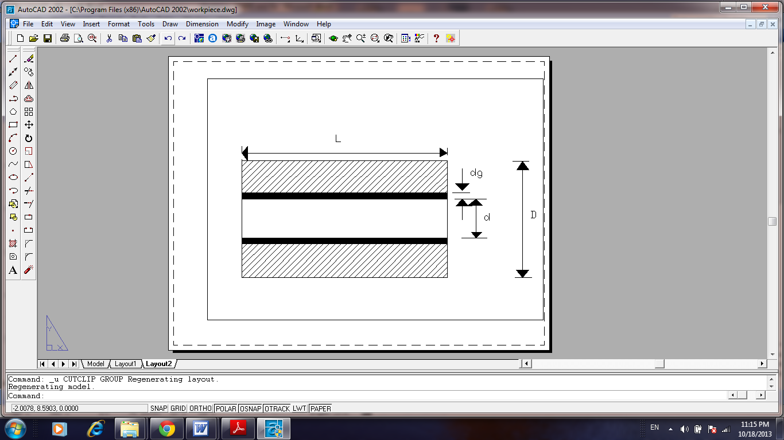

**Fig. (1):** Schematic diagram of work piece and layer of the abrasive media (L=40mm, D=45mm, d=19 mm).

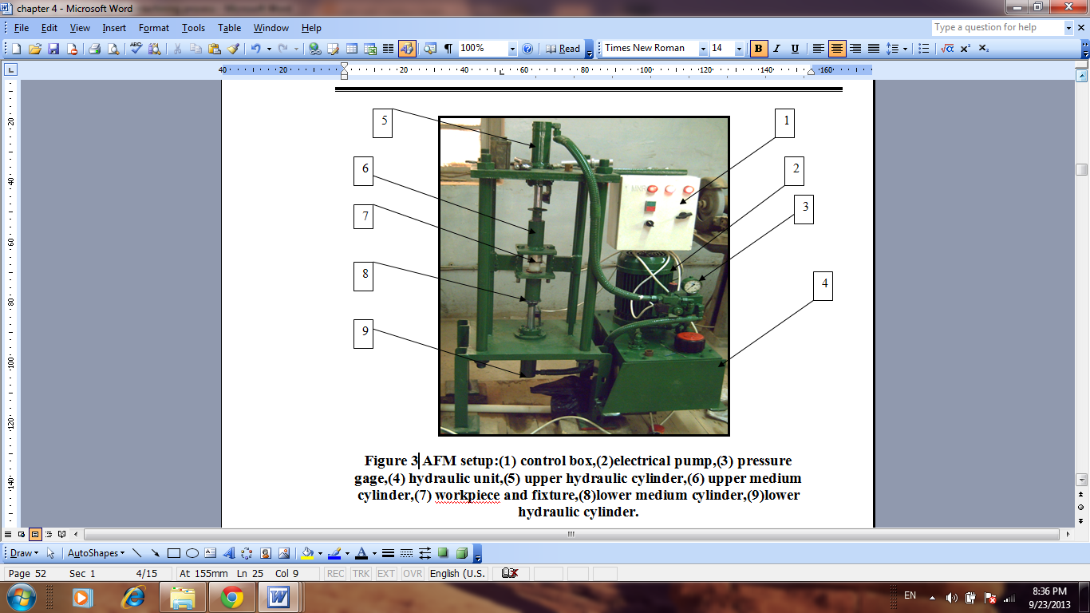

**Figure (2):** AFM setup :(1) control box, (2)electrical pump, (3) pressure gage, (4) hydraulic unit, (5) upper hydraulic cylinder, (6) upper media cylinder, (7) workpiece and fixture,(8) lower media cylinder, (9)lower hydraulic cylinder

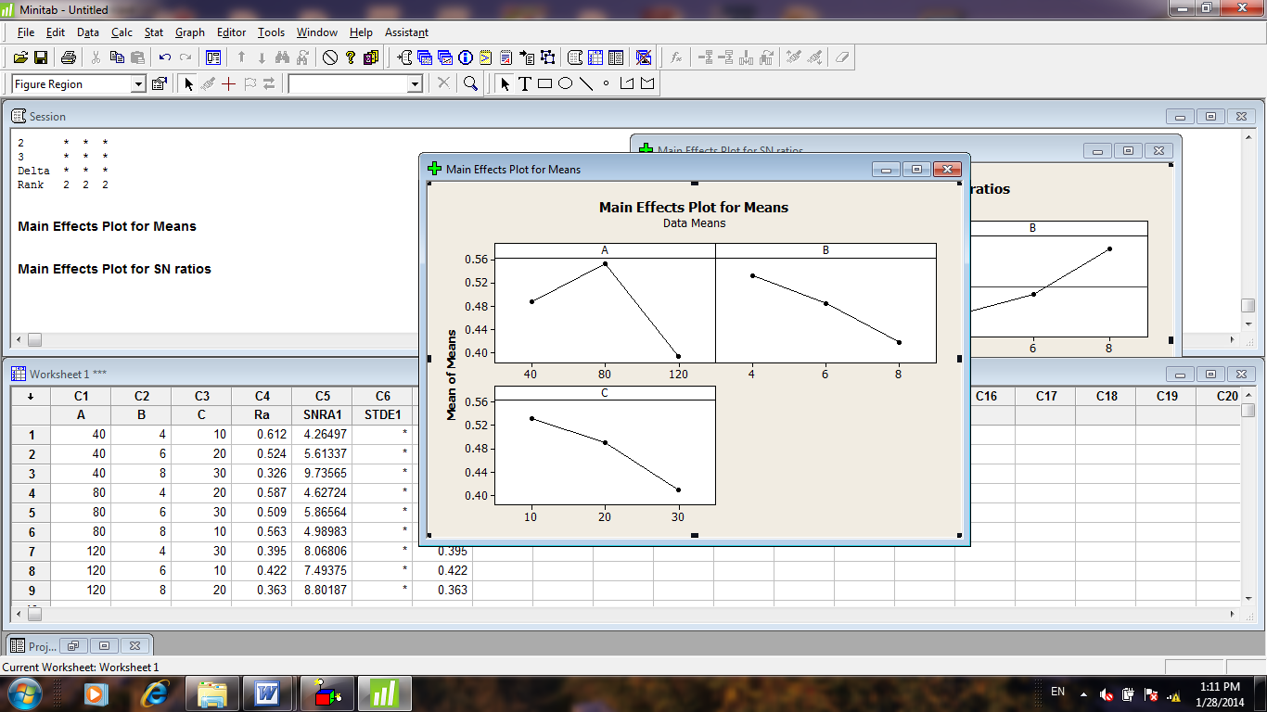

**Figure (3):** Main effects Plot for means

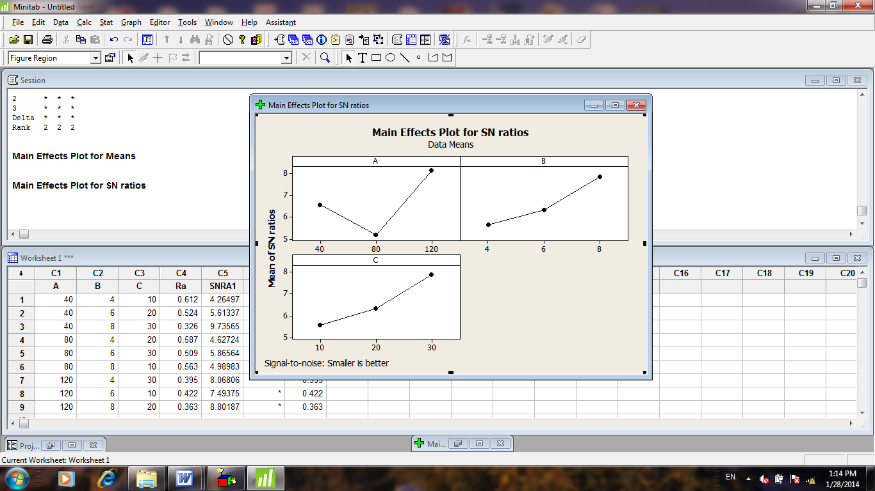

**Figure (4):** Main effects Plot for signal to noise ratios

**دراسة الخشونة السطحية في عملية انسياب المادة الحاكة بأستخدام كربيد السيلكون**

**عباس فاضل ابراهيم**

مدرس، قسم هندسة الانتاج والمعادن / الجامعة التكنلوجية

**الخلاصة:**

تعتبر عملية الانهاء للاجزاء المعقدة والمنمنمة خصوصا الداخلية هي صعبة جدا" وتتطلب وقت طويل. ان عملية التشغيل بأنسياب المادة الحاكة تقوم بعملية الانهاء المطلوبة فهي تستخدم حبيبات حاكة محمولة على عجين بوليمري مع مكونات اخرى لتلميع الاسطح حيث ان الوسط ينبثق للخلف والامام خلال المشغولة المستخدمة بواسطة منظومة ضغط هيدوليكية حيث تم في هذا البحث استخدام سبيكة المنيوم 1060 كمشغولة للعمل وكاربيد السيلكون كمادة حاكة. بأستخدام طريقة تاكوجي المتغيرات الرئيسية هي طول الشوط، ضغط البثق وعدد الدورات تم تحليلها لافضل نسبة اشارة / ضوضاء للخشونة السطحية. اختبارات تاكوجي صممت بالاعتماد 9L مجموعة متعامدة والتي تم اعتمادها للاختبار وعلى اساس اكبر نسبة اشارة / ضوضاء. ان قابلية القيم المستقلة للتنبؤ بالقيم المعتمدة كانت 94.4%، وان المتغيرات المثلى للحصول على اقل خشونة سطحية كانت عند طول شوط يساوي120ملم، ضغط بثق 8 ميكاباسكال وعند 30 دورة.