ISSN 1999-8716
Diyala Journal
of Engineering Sciences
Printed in Iraq

Vol. 08, No. 02, pp. 84-98, June 2015

2D-FEM FOR ASSESSMENT OF SLOPE STABILITY

Jasim M Abbas
Lecturer, Civil Engineering Department/ College of Engineering / University of Diyala
E-mail: jasimalshamary@yahoo.com
(Received: 27/1/2014; Accepted: 15/6/2014)

ABSTRACT: - The main objective of this paper is to evaluate the influence of soil types on the slope stability in specific soil slope case. The soils used have been included sandy, clayey, peat, fill, loam, deep clay and deep sand. The soil specification for both sandy and clayey soil type has been changed to estimate the influence of soil properties on the soil stability issue for these most common types of soils. To achieve the objective of this research, 2D finite element method has been used with Mohr-Columb soil model. It has been concluded that the soil types are largely effect on the slope stability issues. In addition the high factor of safety obtained in case of stabile soil type.
Keywords: Soil stability, Soil types, 2D FEM, Failure surface, FOS
1. INTRODUCTION
In fact, the stability of soil either from natural or manmade are usually one of the challenges to any researchers and the field engineering. In field, instability possibly results because of bad weather such as heavy rainfall and some time when groundwater table rise and this absolutely effect in stress conditions. Correspondingly, natural slopes and during the construction, the slope rapidly fail even if it is stable from long time ago. (Abramson et al. 2002). In addition the source of slope failure possibly resulted from earthquakes (Tayler & Burns, 2005) and many other reasons that effected on the slope stability.
In general the slope stability issues has been simulated using 2D finite element methods and classically contain plane-strain failure mechanisms. This is due to simplicity and the results can be used to estimate the failure zone (Michalowski and Dreschwe 2009). Among the existing approaches of analysis are the limit equilibrium methods of slices, boundary element methods (Jiang, 1990), finite element methods (Matsui and San, 1992), and neural network methods (Jaritngam et al, 2001). In addition number of researchers have also been studied the slope stability problem such as (Wenxi Fu, Yi Liao. 2010, Gavin, K and Jian feng Xue. 2010, Leong, E.C. and Rahardjo H. 2012 and Abbas, J M. 2014). According to author, these researches and other was not covered enough the influence of soil types and properties on the slope stability problems. This issue is very important to evaluate all probable risks that may occurred during the slope failure.
Therefore, more researches are needed to evaluate the influence of wide range from soils to the slope stability cases. Accordingly, this paper deals with slope stability evaluations carried out by commonly used finite element (FE) methods. Another important contribution of this study has been the investigations of the different slope angle for the case study slopes.

DESCRIPTION OF CASE STUDY
This part includes all descriptions and geometrical conditions in this case study. The slope angle is changed during this study by fixing H1 by 5m and then increases the value of H2 by (8m, 10m and 14m). Over all width for this case is 60m, the middle part of slope is taken as 20m, both sides extend for equal value of the middle part, because of this extension is suitable for this type of analysis and will not change the results as illustrated in Figure 1. The water table is taken at 5m above the bottom of case study. Three soil profile conditions have been used in this study, the first one was one soil layer, the second was horizontal three layers and the third case was three inclined layers.

2. ANALYSIS METHODOLOGY AND LAYOUT
The main objective of this study is to study of slope behavior when take into account the soil conditions using finite element method. The soil profile includes one layer soil condition with different soil specification. In addition three layers soil profile with and without inclination. These cases have been used to estimate the extreme soil displacement and strain, extreme stresses as well as factor of safety. This evaluation provided by adopting 15-node triangular elements for finite element simulation with Mohr-Columb elasto-plastic model to represent the surrounded soil. This study was also representing the soil in drained condition. The baseline soil parameters used for the analysis of slope stability are illustrated in table 1.
The investigation was achieved with PLAXIS 2D program, Two-dimensional (2D), plane strain FE modeling has been used to simulate the whole geotechnical system as illustrated in in next sections. All dimensions are in meters as usual cases. The bottom boundary condition is fixed of the slope system, which means no deformation occurred in boundary. In addition only vertical deformation can be occurred on both sides of this case study. There are no any external load applied in this case, that means the assessment is depend only on the gravity force of the soil. As a result of FEM, the whole system is divided into a number of triangular elements; all elements include number of nodes with certain degree of freedom.
In the analysis of slope stability problems it is important to consider the final stability. It is interesting to evaluate the global safety factor in the case. A more appropriate definition of the factor of safety is therefore: safety factor is equal to S (maximum available) to S (need for equilibrium), where S represent the shear strength.

3. RESULTS & DISCUSSION
This part includes the results of finite element simulation of slope cases. This included three cases. (1) slope stability with one layer and different soil conditions, (2) slope stability with three horizontal layers and different soil conditions, and (3) slope stability with three inclined layers and different soil conditions. Different soil properties have been used as shown in Table (1). As results, this study can be used to estimate the expected performance of slope cases in different conditions. These conditions are usually representing the real case of slope stability and can be compared each other and predict the behavior of slopes. The analysis includes the study of side slope stability (i.e the collapse of the soil at the critical zone of the slope, safety analysis and displacement) under specific condition.

Case Study 1: Assessments of slope stability with one layer and different soil conditions
In this case study the influence of soil types and condition on the performance of slope was included and is only containing the one layer of soil profile with different soil types. The finite element mesh for this case was illustrated in Figure 2. In this case the soil take into account as one types and this means the case represented the deep layer. It seems that the sandy soils observed high displacement compared with clayey soils. This is possibly due to high soil resistance for the case of clayey soils. It can be observed that for deep sand and deep clay resisted more than the normal soils like sandy soil and clayey soil, respectively as shown in Figure (3a). In general, the slope angle less than 12 degree obtain less displacement compared with angles more than these values. This is probably due to influence of slope angle which can conduct the small angle is usually represent high stability.
In addition, the extreme total stresses verses slope angle is shown in Figure 3b. It can be concluded that the total stresses are similar for all soil types until reached to 12 degree. This value of slope angle obtained a lower magnitude of total stresses. It can be used for design process in comparable case studies. In the other hand, the extreme total strain versus slope angle is illustrated in Figure (3c). It can be shown that the total strain is slightly increased from lower values to maximum magnitude in two case (i.e. deep sand and deep clay). While the performance of sandy soil and clayey soil included two parts, the lower part included all results until 10 degree from slope angle and then the values up to 10 degree in both cases of sandy and clayey soils. This is possibly due to high resistance of deep sand and clay.

Case Study 2: Assessments of slope stability with three horizontal layers and different soil conditions
In this case study, soils with three layers have two categories. The first is (SCD) represent sand layer at top and middle clayey layer then deep clay at the bottom. The second is (CSD) represent clay layer at top and middle sandy layer then deep sand at the bottom. These layers include 5m for bottom layer and then the other is distributed by equal distances in y-direction. For this case there is only one value of H2 of 14m is taken into account. Two dimensional finite element mesh for case study 2 is shown in Figure 4.
It can be observed that the SCD obtained high displacement compared with CSD as shown in Figure 5a. This is possibly due to the influence of layer interaction between soil layers. In both cases, the displacement increased with increased the angle of slope with little differences. Moreover, the total stresses versus slope angle for both SCD and CSD is illustrated in Figure 5b. It can be seen that there is little effect of soil layers on the total stresses. This may be due to no change in geostatic load has been observed in both cases. Correspondingly, the total strain versus slope angle is detailed in Figure (5c). As previous, there is little influence of soil layer on the total strain and for same reason.

Case Study 3: Assessments of slope stability with three inclined layers and different soil conditions.
Also in this case study, soils with three layers have two categories as case 2 for the case of SCD and CSD. In this case there are two values of H2 of 14m and 20m. The inclinations of soil layer are 3⁰, 4.2⁰, 5.7⁰ and 7.1⁰ for the case of H2=14m. Consequently, the inclinations of soil layer are 3⁰, 5.7⁰, 8.5⁰ and 11.3⁰ for the case of H2=20m. Figure (6) shows two dimensional finite element mesh for case study 3.
Figure 7a shown the influence of layer inclination on the total displacement in case of H2=14m. It can be concluded that the SCD has more displacement compared with CSD and this is means that the SCD has little resistance compared with CSD. This is possibly due to little resistance of SCD for this soil profile. In addition, the influence of layer inclination on the total stresses has been observed for this kind of soil profile as shown in Figure (7b). In this case, little influence of layer inclination on the total stresses was observed. The effect of layer inclination on the total strain is shown in Figure 7c. It can be seen that the soil profile of CSD obtained high strain compared to SCD. Consequently, Figure 8a shown the influence of layer inclination on the total displacement in case of H2=20m. It seems also, that the SCD has more displacement compared with CSD and this is means that the SCD has little resistance compared with CSD. This is probably due to small strength of SCD for this soil profile. Furthermore, the effect of layer inclination on the total stresses has been detected for this category of soil profile as presented in Figure 8b. In this situation, little effect of layer inclination on the total stresses was observed. The effect of layer inclination on the total strain is shown in Figure 8c. It can be seen that the soil profile for both CSD and to SCD have little influence for this case.

NUMERICAL METHOD RESULTS
Results from PLAXIS program was listed in this part and also the deformation mesh, total displacement direction, and total displacement was included. It has taken H2=14m as case for this part. Figure 9 shows the results of slope stability for case study (Case 1) for one soil layer. In addition, the results of slope stability for case study (Case 2) for three soil layers are illustrated in Figure 10. Finally, the results of slope stability for case study (Case 3) for three soil layers and with layer inclination are detailed in Figure 11.

PREDICTION OF SAFETY FACTOR
The prediction of factor of safety results from finite element simulation was discussed in this part. Figure 12 shows the FOS versus slope angle for the first case study. It seems that the deep sand obtained high FOS compared with other types of soils. This means the overall stability of this case study started from high stability slope in case of deep sand, clayey soil, deep clay and finally sandy soil. In addition, the FOS observed from second case study verses slope angle is shown in Figure 13. It can be seems that the observed from CSD is little higher than these observed from SCD.
Figure 14 shows the FOS observed from third case study and H2=14m versus layer inclination. It can be observed that the FOS that calculated from CSD is usually higher than those observed from SCD. Finally, the FOS predicted from third case study and H2=20m versus layer inclination is illustrated in Figure 15. It can be seems that the FOS observed from SCD is higher than those obtained from CSD. After that, the FOS for both cases had been equal values when the layer inclination reaches to 8 degree. Then the FOS observed from CSD is higher than those obtained from SCD. This is possible the high resistance of layered soil profile in case of SCD for low inclination. While this issue changed when increase the inclination of soil layers.
CONCLUSIONS
- For case of one layer soil profile (case 1), the sandy soils observed high displacement compared with clayey soils. The deep sand and deep clay resisted more than the normal soils like sandy soil and clayey soil. The total stresses are similar for all soil types until reached to 12 degree. The total strain is slightly increased from lower values to maximum magnitude in two case (i.e. deep sand and deep clay). The deep sand obtained high FOS compared with other types of soils.
- For case of three layer soil profile (case 2), the SCD obtained high displacement compared with CSD. The displacement increased with increased the angle of slope with little differences. There is little effect of soil layers on the total stresses. Also, there is little influence of soil layer on the total strain. The FOS that calculated from CSD is usually higher than those observed from SCD.
- For case of three layer soil profile with inclination (case 3), the SCD has more displacement compared with CSD. Little influence of layer inclination on the total stresses. The soil profile of CSD obtained high strain compared to SCD. The SCD has more displacement compared with CSD. Little effect of layer inclination on the total stresses. Also the soil profiles for both CSD and to SCD are little influence for this case. Usually the FOS is highly influenced by the soil layer inclination.
REFERENCES
- Michalowski, R. L. 2002. Stability Charts for Uniform Slopes, Journal of Geotechnical and Geoenvironmental Engineering, ASCE, 128(4): 351–355.
- Michalowski, R. L. and Dreschwe, A. 2009. "Three-dimensional stability of slopes and excavation. Geotechnique, 59 (10): 839-850.
- Griffiths, D. V. and Marquez, R. M. 2007. Three-dimensional slope stability analysis by elasto-plastic finite elements. Geotechnique. 57(6): 537-546.
- Silvestri, V. 2006. A three-dimensional slope stability problem in clay. Canadian Geotechnical Journal. 43(2): 224-238.
- Abramson, L., Lee, T., Sharma, S., Boyce, G., 2002. Slope Stability Concepts. Slope Stabilization and Stabilization Methods, 2nd ed., John Willey & Sons, UK.
- Swan C. C and Seo Y. K. 1999. Limit state analysis of earthen slopes using dual continuum/FEM approach. International Journal of Analytical and Numerical Method in Geomechanics. 23(12): 1359-1371.
- Zhang, H. Tham L.G. Liu D.F. 2006. On two definitions of the factor of safety commonly used finite element slope stability analysis. Computer and Geotechnics. 33: 188-195
- Abbas, J M. 2014. Slope Stability Analysis Using Numerical Method. Journal of Applied Sciences, 14: 846-859.
- Leong, E.C. and Rahardjo H. 2012. Two and three-dimensional slope stability reanalysis of Bukit Batok slope. Computers and Geotechnics 42 (2012) 81–88
- Wenxi Fu, Yi Liao. 2010. Non-linear shear strength reduction technique in slope stability calculation. Computers and Geotechnics 37 (2010) 288–298
- Gavin, K and Jian feng Xue. 2010. Design Charts for the Stability Analysis of Unsaturated Soil Slopes. Geotech GeolEng 28:79–90

Table (1): soil parameters for analysis of slope stability
 | γ_{unsat}  kN/m³ | γ_{sat}  kN/m³ | E  kN/m² | v | c  kN/m² | φ
Sandy soil (Soil1) | 17 | 20 | 1300 | 0.3 | 1 | 31
Clayey soil (Soil2) | 16 | 18 | 10000 | 0.35 | 5 | 25
Deep Clay (Soil14) | 16 | 18 | 100000 | 0.33 | 4 | 25
Deep Sand (Soil15) | 17 | 21 | 120000 | 0.3 | 1 | 33

Slope angle
W.T.

Figure (1): profile view of slope stability problem.

Figure (2): Two Dimensional Finite Element mesh for case study 1

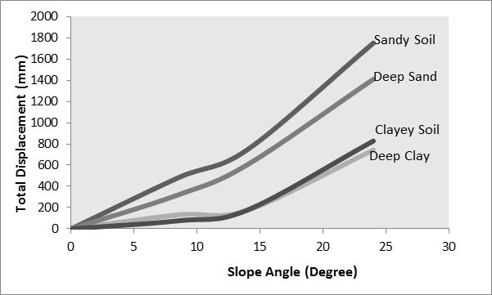
(a)

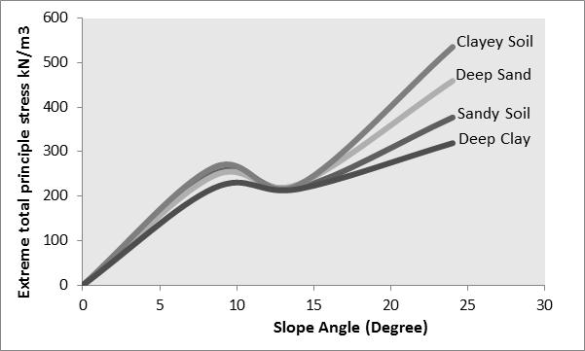
(b)

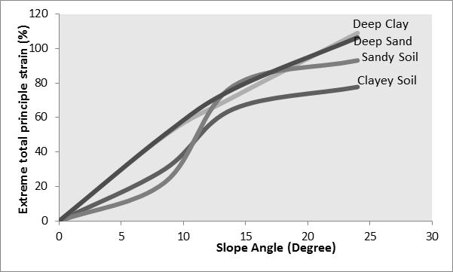
(c)
Figure (3): Assessments of slope stability with one layer (Case 1), (a) Total displacement vs. slope angle, (b) Extreme total principle stress vs. slope angle and (c) Extreme total principle strain vs. slope angle

Figure (4): Two Dimensional Finite Element mesh for case study 2

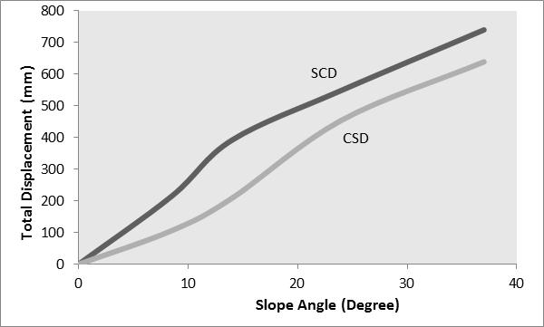
(a)

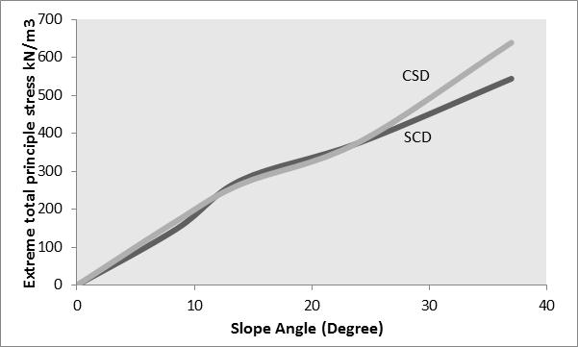
(b)

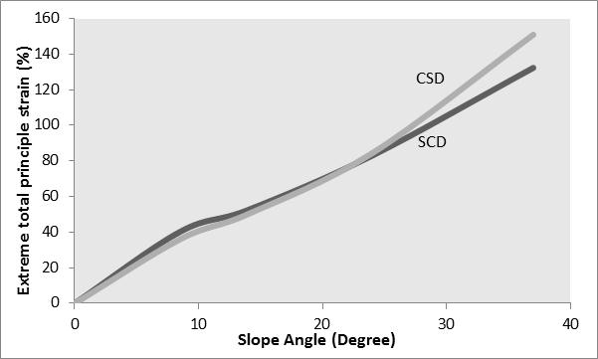
(C)
Figure (5) Assessments of slope stability with three horizontal layers (Case 2), (a) Total displacement vs. slope angle, (b) Extreme total principle stress vs. slope angle and (c) Extreme total principle strain vs. slope angle

Figure (6): Two Dimensional Finite Element mesh for case study 3

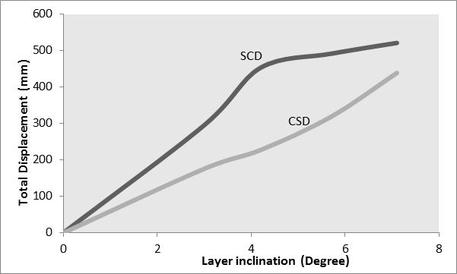
(a)

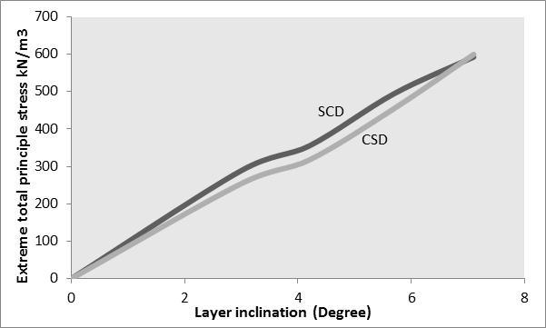
(b)

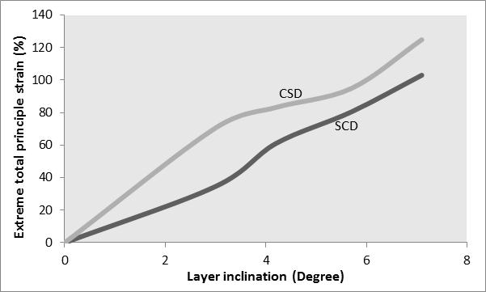
(c)
Figure (7): Assessments of slope stability with three inclined layers (Case 3) and (H2=14m), (a) Total displacement vs. slope angle, (b) Extreme total principle stress vs. slope angle and (c) Extreme total principle strain vs. slope angle

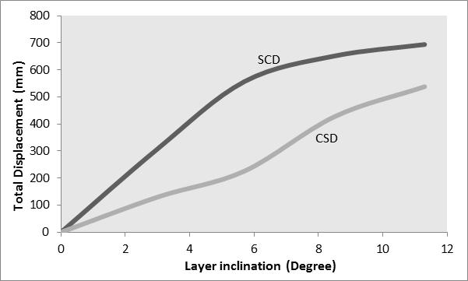
(a)

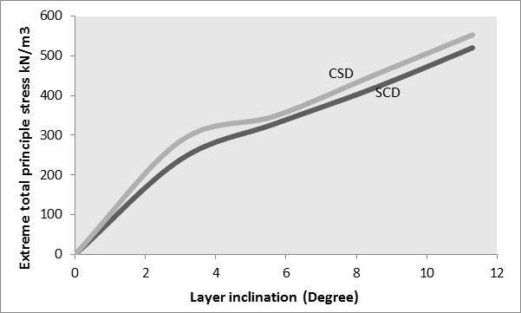
(b)

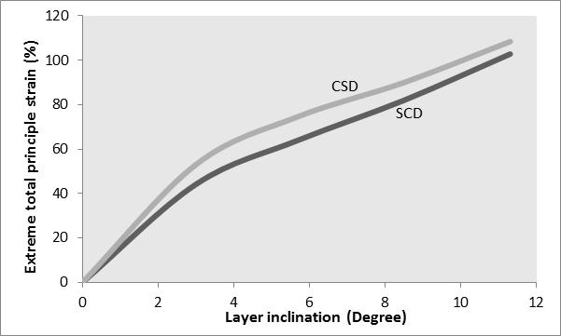
(C)
Figure (8): Assessments of slope stability with three inclined layers (Case 3) and (H2=20m), (a) Total displacement vs. slope angle, (b) Extreme total principle stress vs. slope angle and (c) Extreme total principle strain vs. slope angle.

(a) | (b)
(c)
Figure (9): Numerical method results of slope stability case study (Case 1) and (H2=14m), (a) deformation mesh, (b) total displacement direction and (c) total displacement
(a) | (b)
(c)
Figure (10):Numerical method results of slope stability case study (Case 2) and (H2=14m), (a) deformation mesh, (b) total displacement direction and (c) total displacement

(a) | (b)
(c)
Figure (11): Numerical method results of slope stability case study (Case 3) and (H2=14m), (a) deformation mesh, (b) total displacement direction and (c) total displacement

Figure (12): factor of safety predicted from Case 1.

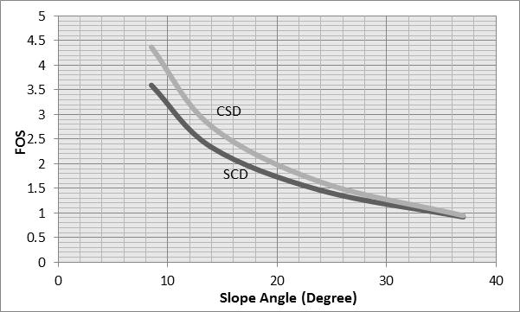
Figure (13): factor of safety predicted from Case 2

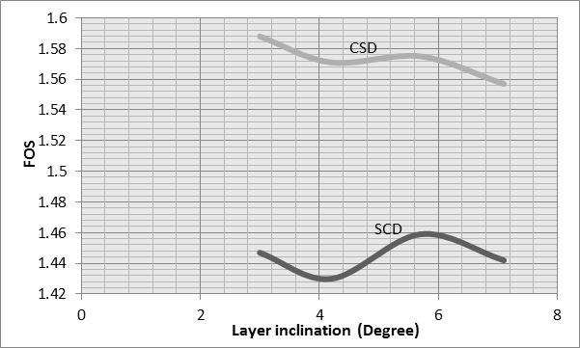
Figure (14): factor of safety predicted from Case 3 (H2=14m)

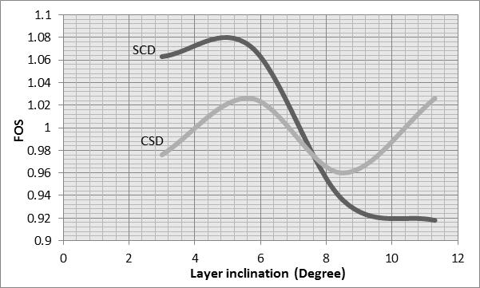

Figure (15): factor of safety predicted from Case 3 (H2=20m)

تقييم ميول المنحدرات بواسطة طريقة العناصر المحدد

جاسم محمد عباس
مدرس، كلية الهندسة، جامعة ديالى

الخلاصة
ان الهدف الاساسي من هذا البحث هو لتقييم ميول المنحدرات في حال وجود تغيرات في خواص التربة او طبقاتها. ان التربة المستخدمة في هذه الدراسة تحتوي على ترب طيبنية و اخرى رملية وترب مشتقة من هاذين النوعين. ان خواص هذه الترب قد تم تغييرها خلال عملية التحليل لغرض معرفة تاثير هذه التغييرات على تصرف المنحدرات ومقاربتها للطبيعة. ولغرض تحقيق اهدافالبحث فقد تم استخدام طريقة العناصر المحددة و التي اعتمدت على نمذجة التربة بواسطة (Mohr-Columb). وقد ثبت من خلال هذه الدراسة ان نوعية التربة و ميل الطبقات تؤثر بشكل كبير وملموس على تصرف الميول اضافة الى ذلك فانها تؤثر بشكل كبير على معامل الامان المحسوب من هذه النتائج.

