ISSN 1999-8716

**Diyala Journal**

**of Engineering Sciences**

Printed in Iraq

Vol. 08, No. 02, pp. 151-162, June 2015

**DESIGN MATHEMATICAL MODEL TO EVALUATE EFFECT OF WEATHER RELATION ON OPTICAL INTERFEROMETER MODULATOR**

**Sadeq Adnan Hbeeb**

Assistant Lecturer, College of Engineering, Diyala University

E-mail: Sadeq.Hbeeb@yahoo.com

(Received: 18/9/2011; Accepted: 4/9/2014)

**ABSTRACT:-** In this research a mathematical model is proposed to show the environmental effects on the visibility of the optical interferometer by using matlab program version (7), too, it can be use the variables values for the temperatures within Iraqi weather under the condition to the value of visibility can be improved. The visibility of optical interferometer has variables values due to the pressure and strain under effect the temperature.

**Keywords:** Laser source**,** Mach-Zehnder interferometer modulator (MZIM), Fiber optic sensor for pressure, temperature, and strain.

1. **INTRODUCTION** **:**

Interferometers, such as the Mach-Zehnder interferometer modulator (MZIM), )1, 2( play a decisive role in the foundation of physics. They allow to assess and quantify the wave nature of light and matter by probing the complex amplitude of the field.)3(, the most simple interferometers are so-called two-path interferometers, of which the MZIM figure (1) is a particular symmetric one. Two-path interferometers employ a well collimated incident beam of light or matter wave generated by source (1), which is then split by a partially transmitting mirror A (beam splitter)with transmission probability TA and reflection probability RA=1−TA into two partial beams. After following two different paths in space, the partial beams are recollected together by a second half mirror B forming two output beams that are measured at detectors 2 and 3. Due to the particle conservation, the two detectors measure complementary intensities. It therefore suffices to consider one detector signal. In case of a fully coherent classical wave with frequency ω, the measured intensity of the output beam is a periodic function of the difference τ in propagation time along the two paths. In the ideal case, the intensity oscillates between zero and a maximum value, in which case one refers to a visibility of 100%. In recent years, interferometers (the use of interference phenomena) provides wide opportunities for measurements in various areas of physics )1(, particularly in optics and in modulation techniques for the optical fiber communication systems (2, 4, 5, 6).

Figure (1.a) Illustration of a MZIM with mirrors A and B, which are characterized by their transmission probabilities TA and TB. In the electronic version, a potential Vmg at the modulation gate changes the area enclosed by the two partial beams, leading to a phase modulation through the Aharonov-Bohm effect (7).

Figure (1.b) Due to the consequent constructive and destructive interference, the current intensities I2, 3 at the detector contacts 2 and 3 oscillate as a function of Vmg. Thus, is measure the differential transmission probability dIi2/dIi1 of the current in the outer edge state (i) and define the visibility $(υ)$ as its peak-to-peak modulation as indicated by the solid lines in (b) (8).

1. **MATHEMATICAL MODULE:**

If an electric field is applied during a certain length to one arm, a phase difference Δφ between the light propagation through the two waveguides will be introduced see figure (2). This result an intensity modulation at the optical interferometer modulator output, which can be written as equation (1) (9):

If a laser diode source is used, the fringe visibility ($v$) is:



$$∴v=\frac{E_{1}E_{2}}{{2E}_{1}^{2}+{2E}_{1}+1}$$

Where:

% $$E_{1}=Electric field of first arm for MZI \left(V\right)$$



$$E_{2}=Electric field of second arm for MZI \left(V\right)$$

$$∵E_{2}=\left(1-E_{1}\right)$$

$=E_{1}^{2}+\left(1-E_{1}\right)\left(1-E_{1}\right)+\left({2E}_{1}-{2E}_{1}^{2}\right)\cos{Δϕ}$

$\frac{2I-I_{o}}{I_{o}}={2E}_{1}\left[\left(E_{1}-1\right)+\left(1-E_{1}\right)\cos{Δϕ}\right]$

Substituting Eq. (3), into Eq. (4) is resulted:



The mathematical expression of visibility $(v)$ for Mach-Zhender interferometer modulator (MZIM) is shown in Eq. (5).

$$v=\frac{{2E}_{1}I_{o}-{2E}_{1}^{2}I_{o}-I_{o}+2I}{\left({4E}_{1}^{2}I_{o}+{4E}_{1}I_{o}+{2I}_{o}\right)\cos{∆∅}} (5)$$

Equation (5) explains the relationship between the visibility $\left(v\right)$ and the phase difference $∆∅$. Also, the equation (6) which shows the environmental effects is (9):



Where:

,



K = wave number

$λ=$ free space wavelength of the laser in ( nm)

L= length of the fiber in the sensor in (μm)

n= Refractive index (unit less)

$ΔT=$ Temperature difference in (k)

S11= axial strain (unit less), S12= radial strain (unit less), $ρ_{11}and ρ_{12}$ = pocket coefficient

$$\frac{∆∅}{∅∆T}=\frac{\left(\frac{1}{n}\right)\left(\frac{∂n}{∂T}\right)ΔT+S_{11}-\left(\frac{n^{2}}{2}\right)\left[\left(ρ_{11}+ρ_{12}\right)S_{12}+ρ_{12}S_{11}\right]}{ΔT}$$

The strain S11 and S12 are related by:



Substituting Eq. (7), into Eq. (8) yields:



The final mathematical expression of phase difference with respect (temperature, pressure, and strain) for Mach-Zhender interferometer modulator (MZIM) is shown in Eq. (9).



$Δϕ=∅\left[\left(\frac{1}{n}\right)\left(\frac{∂n}{∂T}\right)ΔT+S_{11}\left[1-\left(\frac{n^{2}}{2}\right)\left[\left(ρ_{11}+ρ_{12}\right)-μ+ρ_{12}\right]\right]\right] (9)$

Where:

P = Pressure (Paskal)

G=Young's module (70 MPa)

Substituting Eq. (9), into Eq. (5) is resulted $:$



The equation (11) is the fundamental design equation for many interferometers fiber optic sensor and optical communication systems .Also, this equation show the relationship between visibility $\left(v\right)$, and environmental effects.

1. **SIMULATION VARIABLES:**

The following is a list of the parameters that will be varied in the simulations to determine visibility efficiency of MZIM. These variables and the motives for including them as such, as well as the specific values chosen for the simulations are discussed in previous sections. The denotation of each parameter given in parentheses below will be used in the next section in which the simulation results are presented

* Free space wavelength of the laser (λ) = 1550 nm.
* Fiber arm length (L) = 80 μm.
* Electric field (E) = 1V.
* Young's modules (G) = 70 Mpa.
* Refractive index (n) = 1.468.
* Pocket coefficient ( $ρ_{11},ρ_{12}$) = 0.12, and 0.72 respectively.
* Thermo optic coefficient of the optical fiber) = 8.6 *10^-6 K-1.
* Poisson’s Ratio $(μ)$ = 0.17.

1. **RESULTS & DISCUSSION**

The objective of the simulation is presents to evaluate MZIM performance by analysis the environmental effects which it effects on the visibility of the optical modulator so the simulation established by using the equation (11).

**4.1: The effect of the temperature:**

From the equation (11), and the figure (3), the visibility ($v$) is decreased in to (75%), when the temperature is increases into (323K). Large temperature corresponds to very poor Mach-Zhender interferometer modulator (MZIM) performance. Thus, enhancement of the MZIM performance is achieved by using the cooling techniques. This technique is considered in this research when is used the temperature within (233 K), which results in higher visibility is arrived into ($v$ >98%). Addition to the figure (3) is show the cooling operation when the temperature of cooling is decreased into (253K) the visibility is arrived into ( $v$ <98%).

**4.2: The effect of the Strain:**

From the equation (11), and the figure (4),When the range of strain lies in the range((10-55 με) which has been applied within temperature is arrived into (333 K), it has been noticed from that work when the strain is increased over(10 με), the visibility of MZIM it decreases to arrive into (92%).From the figure(5),with the decreasing the temperature to arrive into (293K), the visibility is increased into (100%). Figure (6), is shown the cooling techniques is effect on the visibility efficiency, when the temperature is decreased into (258K) the visibility is arrived into (98%).Thus, this techniques is consider disadvantage for the visibility of MZIM .

**4.3: The effect of the pressure:**

From the equation (11), when applying the pressure range (0-40 Kpa), within temperature is arrived into (323 K). An increase could be noticed the visibility to arrive approximately about (98%) when the pressure is decreasing into (0 Kpa) this is considered is ideal case see figure(7). Figures [(8), (9), and (10)], are explain the visibility efficiency of MZIM is increased into ( $v$ >98%) with the decreased the temperature to (T<293 K). From this result is can be noticed the low temperature with applied pressure can be considered this work to prevent the effecting the applied pressure and to enhancement the visibility of MZIM.

**5. CONCLUSION:**

1. In this research, it enhances efficiency and the stability of MZIM, so, this technique depends on the controlling on the visibility for MZIM. When the temperature is arrived into (T 330 K), that efficiency of visibility it reaches (75%). Also, the visibility can reach to the better efficiency ( >98%) when use the cooling technique which leads to that temperature is arrived to (T 233 K).



1. It concludes when strain is increased over (10 με) with temperature reaches into (323 K), the visibility decreases gradually until it reaches to (91%). Thus, in order to improve the efficiency of visibility it must be the temperature degree less than (323 K), to reach (T293 K), but the visibility of the efficiency rang arrived into (88%) because off the strain .Otherwise, if the temperature degree is down to (T258 K), with strain rang the visibility is decreased gradually until reach to a lower efficiency and this is considered a disadvantage of visibility for MZIM performance.



1. So, it has been applied pressure (0-40 Kpa), within temperature degree reaches into (T298 K), the visibility operates efficiently better and arrives to (100%). So, it concludes the visibility of MZIM can be work with a better performance when the temperature degrees reach to a lower it levels in order to the effecting of pressure is approximately negligible .



**REFERENCES:**

1. Masato Suzuki, Tomokazu Takahashi, Seiji Aoyagi, Yoshiteru Amemiya, Masataka Fukuyama, and Shin Yokoyama “A Study of Mach–Zehnder Interferometer Type Optical Modulator Applicable to an Accelerometer” DOI: 10.1143/JJAP.50.04DG14, Japanese Journal of Applied Physics 50 (2011).
2. M. Born and E. Wolf, Principles of Optics (Cambridge University Press, Cambridge, England, 1999).
3. A. Zeilinger, Rev. Mod. Phys. 71, S288 (1999).
4. T. Elsarnagawy, “Monitoring of Environmental Effects using Optical-Fibers” Ph.D. Helwan University July (2002).
5. LN Binh and Itzhak Shraga “An Optical Fiber Dispersion Measurement Technique and System” Technical Report MECSE-14- (2005).
6. Matthew Streshinsky, Ran Ding, Yang Liu, Ari Novack, Yisu Yang, Yangjin Ma, Xiaoguang Tu, Edward Koh Sing Chee, Andy Eu-Jin Lim, Patrick Guo-Qiang Lo, Tom Baehr-Jones, and Michael Hochberg “Low power 50 Gb/s silicon traveling wave Mach-Zehnder modulator near 1300 nm” Optical Society of America (2013).
7. A. E. Hansen, A. Kristensen, S. Pedersen, C. B. Sorensen, and P. E. Lindelof, Phys. Rev. B 64, 045327 (2001).
8. E. Bieri, 1 M. Weiss, 1 O. Göktas, 2 M. Hauser, 2 C. Schönenberger, 1, and S. Oberholzer “Finite-bias visibility dependence in an electronic Mach-Zehnder interferometer” PHYSICAL REVIEW. B 79, 245324 (2009).
9. Wei-Chih Wang “Phase modulation” Southern Taiwan University of Technology.

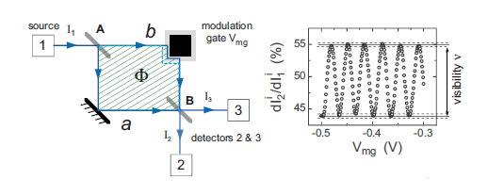

**(b) (a)**

**Fig. (1):** (a) Illustration of a MZIM with mirrors A and B

(b) Illustration visibility of a MZIM.

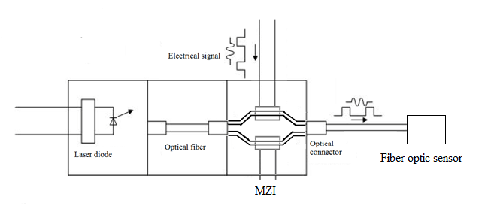

**Fig. (2):** Illustration visibility of a MZIM with fiber optic sensor to monitoring environmental

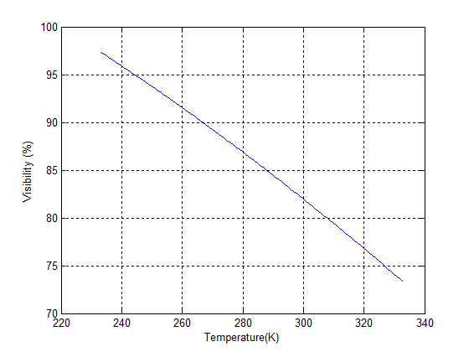

**Fig. (3):** The effect temperature on the visibility of MZIM (233 – 333) K

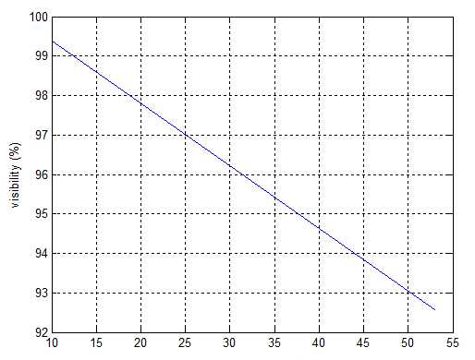

**Fig. (4):** The effect strain on the visibility of MZIM (333 K) (10 - 55 με)

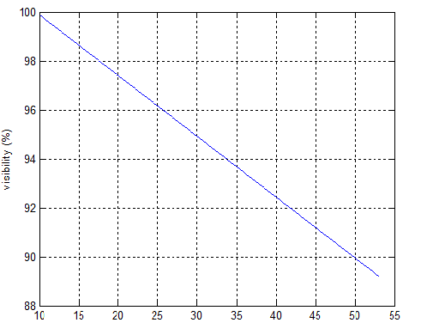

**Fig. (5):** The effect strain on the visibility of MZIM (293) K (10 - 55 με)

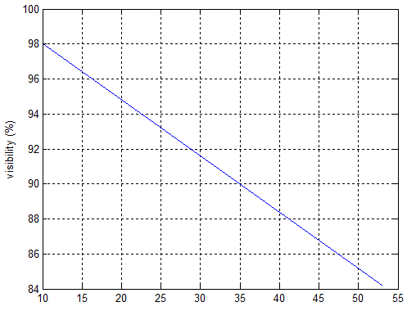

**Fig. (6):** The effect strain on the visibility of MZIM (258 K) (10 - 55 με)

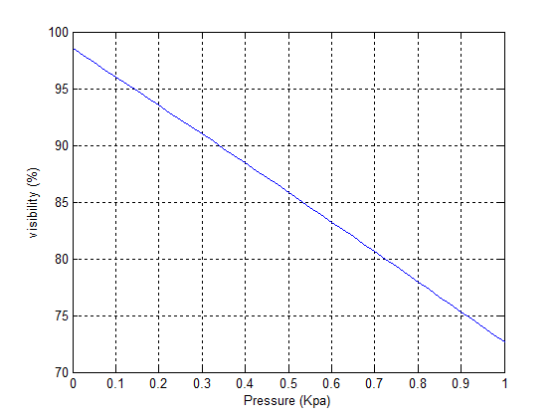

**Fig. (7):** The effect pressure on the visibility of MZIM (323 K) (0 - 40 Kpa)

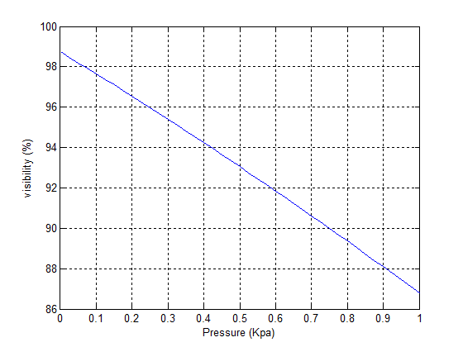

**Fig. (8):** The effect pressure on the visibility of MZIM (293 K) (0 - 40 Kpa)

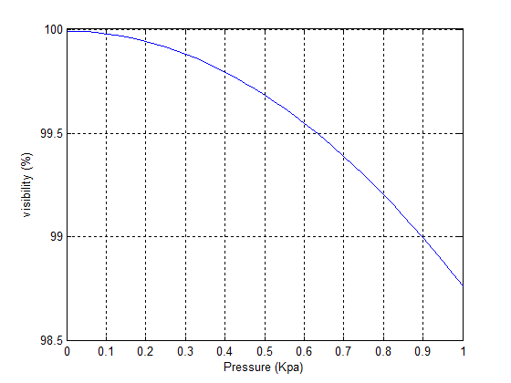

**Fig. (9):** The effect pressure on the visibility of MZIM (248 K) (0 - 40 Kpa)

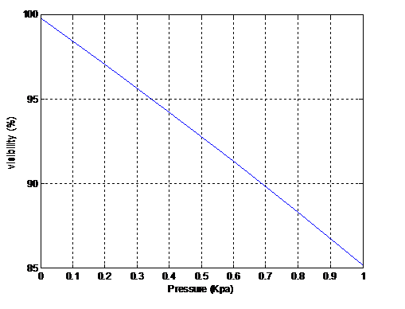

**Fig. (10):** The effect pressure on the visibility of MZIM (223 K) (0 - 40 Kpa)

**تصميم موديل رياضي يقيم التأثيرات البيئية على مضمن التداخل البصري**

**صادق عدنان حبيب**

كلية الهندسة، جامعة ديالى

**الخلاصة:**

في هذا البحث تم اقتراح موديل رياضي يبين التأثيرات البيئية على الرؤية لمقياس التداخل البصري باستخدام برنامج ماتلاب (7). بالأضافة إلى ذلك استعملت قيم مختلفة لدرجات الحرارة وضمن الأجواء العراقية لمعرفة مدى تأثر الرؤية تحت هذه الحالة وبالتالي يتم تحسين قيم الرؤية. كذلك يتم الحصول على قيم مختلفة للرؤية لمقياس التداخل البصري ناتجة من تأثير الضغط والإجهاد وذلك لمعرفة مدى تأثرها بالإجهاد والضغط تحت تأثير درجات الحرارة.