ISSN 1999-8716

**Diyala Journal**

**of Engineering Sciences**

Printed in Iraq

Vol. 08, No. 03, pp. 38-62, September 2015

**FLOW AND DEFORMATION ANALYSIS OF ZONED EARTH DAM BY THE FINITE ELEMENT METHOD**

**Qutaiba G. Majeed**

Assistant Lecturer,Civil Engineering Department, University of Diyala

(Received: 10/04/2012; Accepted: 29/09/2014)

**ABSTRACT: -** A finite element method is practical and applicable for many fields including for geotechnical engineering structures. Seepage through earth dam is difficult to analyze especially dams with multiple zones. The problem becomes complex if it requires deformation analysis taking into account seismic conditions. Therefore, finite element is the best tool for analyzing seepage flow in an earth fill dam. The main objective of the paper is to simulate the seepage flow through an earth fill dam. Hassan Kanosh Dam which is located in the north eastern part of Iraq is chosen as a case study.

There are three periods in the life of a dam which may be critical from the standpoint of shear failure and which must be analyzed; during construction condition, full reservoir condition, and rapid drawdown condition. The program SIGMA/W which is a finite element software coupled with SEEP/W, (another GEO-SLOPE software product) to analyze the dam.

The stability analysis performed showed that all parts of the dam are safe within the prescribed rang of factors of safety for the possible loading and operation cases. It is recommended, however, that close control of the quality of the works during construction must be maintained to realize the shearing strengths necessary to fulfill the assumed strength and even more. It is recommended to check routinely the foundation conditions during excavation to realize the same end results.

**Keywords:** Stability, deformation, earth dam, drawdown, flow.

**1. INTRODUCTION**

As with most civil engineering structures, the design of an earth dam is based both on precedent and analytical studies. The personal experience and preferences of the individual designer, however, play a larger role in earth dams than in the design of most other structures. At a given site, it is usually possible to build a variety of dams which would be both safe and economical, and there are many examples where competent engineers have proposed widely different designs for the same reservoir.

In addition, the characteristics of the particular site have a greater influence on the design of an earth dam than they do on many other engineering structures.

Huang (1996) described a numerical procedure for performing stability analysis of an earth dam after the filling of a reservoir. Firstly, the piezometric heads at different points in an earth dam after the filling of a reservoir are obtained with a trial-and-error procedure. Then, the numerical analysis of the dam is performed using the finite element method, with a cap model used for representing soil behaviors. A special technique to handle the effect of steady state seepage is introduced. An example of a reservoir completed recently in Taiwan is illustrated. The results indicate that the factor of safety against stability failure of the dam is adequate.

Kasim and Fei (2002) tried to simulate the seepage flow through an earthfill dam. Three sets of steady state numerical modeling are presented in the paper. Two sets of parametric studies on long-term steady state flow were conducted using homogeneous and zoned earthfill dams for studying the behaviour of seepage in the dams. The third set of the simulations is a case study, which is analysis of steady state seepage condition for Kuala Yong Dam, the main part of Pergau

Hydroelectric Project, Tenaga Nasional Berhad (TNB). The seepage quantity at the core and the downstream section were determined for the steady state flow condition. The results of the parametric simulations show that the total fluxes at downstream changes with the coefficient of permeability value. The flux quantity changes linearly with maximum seepage velocity. Significant differences can be observed in the case study, for the analysis using the coefficient of permeability function (varies with matric suction) versus analysis using a constant coefficient of permeability. Relationship between flux quantity at downstream and maximum seepage velocity is non-linear when hydraulic conductivity function is introduced in seepage analysis.

An optimal hydraulic design problem regarding an earth dam cross section is formulated as an inverse pro blem for the steady model of saturated–unsaturated seepage flows in porous media. In the problem formulation, the choice of soil material to be used in each point of the dam cross sectional domain is considered as the control variable to be identified. The performance index used to evaluate the appropriateness of the design is defined as the sum of two square integral norms, which represent reducing the saturated zone and minimizing material costs. It is also shown that the first norm bounds the total seepage discharge through the earth dam.

Since the governing variational boundary value problem as well as the adjoint problem is well-posed, a deterministic approach is taken. A numerical scheme including pseudo-unsteady terms is developed to calculate the optimal solution in an ideal earth dam cross section to be designed utilizing two different types of soil material. The results show that an inclined clay core of less hydraulic conductivity should be located on the upstream side of the cross section. The unsaturated zone turns out to play an important role in the flow field and the optimal design (Xu et al., 2003).

Analytical solutions are not available for determining the length of the filtered drainage blanket and downstream slope cover, though graphical solutions are available for them. Explicit equations have been obtained by Chahar (2004) for calculating the downstream slope cover and the length of the downstream horizontal drain in homogeneous isotropic and anisotropic earth dams. Similar equations have also been obtained for maximum downstream slope cover and minimum and maximum effective length of the filtered drainage. These equations are nonlinear and representative graphs have been plotted for them covering all the practical ranges of the dam geometry. The numerical example demonstrates that the proposed equations are simple to use, hence the designers may find these equations as an additional check to their design by the conventional flownet method.

The two-dimensional problem of the consolidation of an earth dam–subsoil system under body forces was presented by Strzelecki and Kostecki (2008). A certain loading scenario of the action (in proper time instants) of the subsoill’s, the dam’s and, subsequently, the reservoir water’s deadweight and the seepage flow of groundwater arising thereof was assumed. Calculations for the Biot–Darcy poroelasticity model were performed using the finite element method. The results are presented as displacement and seepage velocity fields at selected moments in time. Also the possibility of critical water velocity gradients arising, which would lead to the loss of seepage stability by the earth dam–subsoil system, was analyzed. A comparison of the numerical simulation results for the seepage of an incompressible fluid through a deformable medium with the results obtained for a non-deformable medium shows no significant discrepancies between the hydraulic head, water pressure or velocity field values. This means that for the linear Biot model applied the consolidation process (after appropriately long time) has no impact on the seepage problem solution. In other words, for the assumptions made in this paper it is possible to determine the seepage using the classic seepage flow theory based on Laplace’s equation.

Noori and Ismaeel (2009) used a finite element method through a computer program, named SEEP2D to determine the free surface seepage line, the quantity of seepage through the dam, the pore water pressure distribution, the total head measurements and the effect of anisotropy of the core materials of Duhok zoned earth dam. First, the accuracy of the program was tested via the data of experimental dam and the results showed an acceptable accuracy of the program. The effect of the ratio of the permeability in the horizontal direction to that in the vertical direction (Kx/Ky) on seepage was tested and results indicated an increase in seepage quantity as this ratio increased. The stability of Duhok zoned earth dam was analyzed using a slope stability computer program, named STABIL2.3. The program is verified through a dam example of known factor of safety (solved by hand calculations). The results of the verification indicated a good accuracy of the program. The slope stability analysis results showed that the factor of safety decreases with the increase of Kx/Ky ratio. The analysis of the results of this study showed that Duhok zoned earth dam is safe against the danger of piping and slope sloughing under the present operation levels. Also, the present study showed that the field piezometers readings of the dam are not accurate.

Based on the experimental work previously presented for earth dam with internal core, Rezk and Senoon (2011) developed an analytical solution for the same problem and comparisons between two solutions are presented. Effect of relative permeability of core (kc/kd) on each relative seepage discharge (Q1/Q) and relative drop of phreatic surface (d/h1) due to core is investigated. Phreatic surface is drawn according to both experimental work and the analytical solution given by the authors.

This paper presents the results of numerical calculations for the seepage of water through the foundation zoned earth dam soil in addition to deformation and stability analysis taking into account seismic stability.

**Location of the Dam:**

Hassan Kanosh Dam is located in the north eastern part of Iraq, Kurdistan Region, about 50 km in the southwestern of Sulaimaniya city, 13 km. to the south of Sangau Sub – District, and 0.75 km. to the north of Hassan Kanosh village. The dam site is located in latitude 350 09' 57" and longitude 450 09' 41" in the Hassan Kanosh Valley, which is located very close to the Hassan Kanosh khwaru Village. The tributary of this valley is started from Sarqala village lands, crest of the Ajrakh Anticline; and crest of Fatka Anticline.

The catchment area of Hassan Kanosh Dam is surrounded by agricultural lands of Sarqala village from the north, in the east by Ajrakh anticline, in the west by Fatka Anticline, and from the south by the agricultural land of Hassan Kanosh. The catchment area of Hassan Kanosh Dam is 40.2935 Km2. The slope of the catchment is steep in the crest of the anticlines (slope angle from the crest of Ajrakh Anticline to the Hassan Kanosh valley about 90) while in the valley will be gentle near to the proposal Dam site (slope angle about 1-20), that mean the slope of the topography of the catchment is variable so the marital (clay, silt, sand and conglomerate) of the high land area easily transported in to the downward of the valley during rain seasonal, so the soil conservation projects must be construct after implementing the dam for protection. Elevation of the catchments started from 1220m from SL (crest of Ajrakh Anticline) up to 600m from SL (proposed dam site). The upper part of Hassan Kanosh valley is seasonal and temporary type (from May to end of October) but the downward of the valley near the proposal dam is permanent valley. The drainage pattern is dendritic type but has a small number of branches.

**Geological Setting of the Site of the Dam:**

The areas surround Hasan Kanosh Valley (dam site) are composed of Rhythmic alternation between thin bedded calcareous silty sandstone with red or green claystone of Upper Fars Formation. The thickness of the clay layers are more than the Sandstone Layers. General attitude of the layers is 124/24 SW, therefore the direction of the dip is comparable to direction of the valley (consequent valley). The alluvial deposit (about 1-2 m thickness) appeared along the Hassan Kanosh Valley particularly in the downward of the catchments. Generally, there are three sets of joints. In spit of finding many set of joints near the Dam site in the sandstone layers, but these didn’t affect the body of the dam and storage catchments.

Depending on the physical and chemical properties of the layers surrounding the Hassan Kanosh Dam catchment, one can realize that (Final Report of Hassan Kanosh Dam, 2010):

* The infiltration of the water in storage water area of the dam is very rare due to the impervious layers, so it is useful for storing water for long period.
* The rhythmic layer of the area is composed of clay and sandstone and it is proper for constructing Dam on it if geomorphology accepted.

**Construction Materials:**

Borrow areas for clayey material and coarse aggregates required for dam construction were selected in locations close to the dam site.

Cohesive soil is the essential material for constructing the earth dam because it uses for constructing the core of the dam. Depending on the field investigation around the area, three locations were identified to use as a cohesive material quarries. Approximately each quarry can provide 1500 to 2000 m3 of the cohesive soil, the majority size of the cohesive in these quarries is clay.

Many alluvial deposits are available in that area which can be possible to use as a shell materials. But depending on the quantity and quality there are two locations which can be used to extract the shell materials from them.

The best rock type that can be used for riprap of the dam is non weathered limestone, so those argillaceous limestone layers in Lower Fars Formation that expose in the surface can be used as rock quarry. After investigation, four places have been identified to extract the rock pitching from them.

The permeability coefficients of the site soil were found to be in the range (1.62 – 6.49) x 10-5 cm/sec.

**The Dam Section:**

For the great majority of earth dams, the embankment is constructed with the same design section (the same zoning and slopes) over the whole length. At some sites, however, dams have been divided into two or more sections and a different design is used in each. For dams of relatively short length, there is usually little or reason for changing the design, but for long dams several circumstances may make different sections available.

**Choosing the Dam Section:**

The dimensions of the dam were selected to overcome the storage requirements. The height of the dam is about 14.7 at elevation 641 m at current point. The design water level is about 637+ which is made the for the core height of 640+ (the height of water at maximum water is 10 m at section 100 of the dam, see figure 1). Figure (1) shows the cross – section of the dam showing the storage level and dam sections, and Figure (2) shows one of the preliminary sections suggested for the embankment. These sections are subjected to several changes after making detailed analysis of seepage and stability.

At site where impervious soil is scarce, the feasibility of constructing a dam with a thin earth core may depend to a large degree on the minimum thickness of impervious core which can be used safely. The problem of determining the minimum safe thickness is not amenable to theoretical treatment, and no definite rules can be given. It is governed for practical purposes by the following factors:

1. The tolerable seepage loses.
2. The minimum width which will permit proper construction.
3. The type of material available for the core and shells.
4. The design of the proposed filter layers.
5. Precedent on similar projects.

Due to the uncertainties in the properties of the foundation materials, a vertical core is used to reduce the amount of seepage. The crest width of the core is (2) m and the side slopes are (1:0.75).

The principal merit of the upstream sloping core that the main downstream portion of the embankment can be constructed first and the core placed later. For a sloping core dam, the foundation grouting can be carried out while the embankment is being placed. Another advantage of the sloping core is that the filter layers between the core and the upstream and downstream pervious zones can be made thinner with less difficulty in construction than the filter layers for vertical core dams.

One disadvantage of the sloping core which can be important at some sites results from the fact that the area of contact between the core and the foundation depends on the depth of foundation excavation, i.e., when the excavation is carried deeper, the contact area moves upstream. In some cases the depth of excavation required to get down to a suitable contact between earth core and foundation cannot be determined reliably in advance and must be chosen during construction (Sherard et al., 1963).

**Embankment Side Slopes:**

No specific rules can be given for selecting the inclination of the outside slopes of the embankment. The general procedure is to make a first estimate on the basis of experience with similar dams and then to modify the estimate as required after making theoretical analyses.

Except where there are large quantities of material available from required excavations, the most economical dam is obtained with the minimum embankment volume and therefore with maximum slope steepness consistent with stability. For a given dam, the allowable steepness depends generally on the internal zoning and on the strengths of the foundation and the embankment materials. In special cases, the steepness may also be influenced by the width of the reservoir and the rate of dam construction. A preliminary selection of the upstream and downstream slope is (2.5 H: 1 V).

A berm has to be made in the upstream and downstream for functional requirements of the dam in addition to increasing the factor of safety.

The downstream slope of a dam consisting of quarried rock or pervious granular soil with a central earth core on a rock foundation is commonly chosen on the basis of precedent in the range between 1.6:1 and 1.8:1. precedent is the main factor for the choosing the downstream slope in such a dam because of the possibility that, while the dam may have ample computed safety factor against shearing failure, the crest may deflect by an excessive amount in the downstream direction (US Bureau of Reclamation, 1987).

**Control of Seepage through the Dam:**

The amount of water seeping through and under an earth dam, together with the distribution of the water pressure, can be estimated by using the theory of flow through porous media. This theory is one of the most valuable analytical tools available to the engineer.

The computed amount of seepage is useful in estimating the loss of water from the reservoir. The estimated distribution of pressure in the pore water is used primarily in the analysis of stability against shear failure and also occasionally to study the hydraulic gradient at the point of seepage discharge which gives a rough idea of the piping potential.

Control of seepage in the core is done by providing two zones of filters, one in the upstream side of the core, and another in downstream of the core. The upstream zones of filters will help in draining the core during rapid drawdown and increasing its stability in such an event. These filters are not decided until detailed stability analysis is carried out.

The downstream filters, 0.8 m thick, will drain the core during normal operation. This process will also protect the core from any possibility of piping or internal erosion. The criteria suggested by Terzaghi for the filter material has to be maintained.

The percolating water through the downstream filters is led down wards, decreasing the phreatic surface and, therefore, increasing the downwards stability.

These zones of filters are connected to a drainage blanket at the dam base to lead the water safely outside the downstream slope of the dam.

To maintain seepage analysis, permeability tests have to be conducted on the compacted clay core materials. Both vertical and horizontal permeability are required. In most cases, the clay material of the core is anisotropic.

**Dam Stability**

To evaluate the various factors of safety of dam stability, the input data for this analysis must be selected and loading cases shall also be defined. Material properties of the dam body are derived from the accumulated test results carried out during the investigation phase. So is the case for the foundation materials. Loading cases under which the dam is likely to be subjected to during its life time are defined.

Seepage analysis also serve to define the phreatic surface shape for the steady seepage conditions while a study of the drawdown parameters helps in the rapid drawdown analysis.

The trace of the shape of the failure surface on the dam cross selection may be circle, a series of straight lines, or any arbitrary curve. The portion of the dam embankment and foundation lying above the assumed failure surface is called "the trail sliding mass'.

For the evaluation of Hassan Kanosh stability, Bishop's simplified method of slices is used. A computer program capable of dealing with different geometries and material properties and loading conditions is adopted.

A number of cross selections has been chosen for this analysis to include the range of dam geometries, materials and foundation conditions.

Both theory and experience with failures show clearly that there are three period in the life of a dam which may be critical from the standpoint of shear failure and which must be analyzed:

1. During construction condition.
2. Full reservoir condition.
3. Rapid drawdown condition.

The cases for which stability analysis are performed are shown in Table (1).

When an earthquake condition is considered, the maximum credible earthquake with seismic factor of (0.17) is taken based on Iraqi seismic map (Iraqi Seismic Code, 1997).

**Drawdown Conditions:**

This analysis is related to the upstream slope only.

The following operational cases are anticipated:

1. Drawdown from El. +637 to El +627 m (which represents the emergency emptying of the reservoir). Total stress analysis with no earthquake condition is used.
2. Drawdown from El. +637 to El. +627 m (which represents the emergency emptying of the reservoir during earthquake conditions). A seismic factor of (0.17) is considered.

**Stability Analysis of the Dam:**

Most earth dam failures occur along curved surface of sliding. However, care must be exercised in selecting the seepage and pore pressure conditions, noting in particular that upstream and downstream slope may have their lowest factor of safety at different stages. In most cases the stability of downstream slope is critical at end of construction and steady seepage. On the other hand, the upstream slope may have its critical factor of safety at end of construction and during rapid drawdown.

If an earth dam has a shearing strength greater than of its foundation it may be necessary to investigate the stability along a surface of sliding passing through the foundation of the dam in addition to the usual studies for possible failure within the dam itself.

The danger of liquefaction failure in dams of granular material must be eliminated by avoiding void ratios greater than the critical (Seed, 1973). This is achieved by proper site selection followed by adequate compaction control of the fill material and adoption of soil stabilization procedures where necessary. The higher the relative density, the lower the danger of a liquefaction failure. It should, however, be noted that the critical void ratio of any material depends on a number of factors such as stress level, stress path, strain level and rate of strain.

Fill slopes involving compacted soils include embankment and earth dams. The engineering properties of materials used in these structures are controlled by the method of construction and the degree of compaction. The analysis of embankment does not involve the same difficulties and uncertainties as does the stability of natural slopes and cuts. However, independent analyses are required for the following critical conditions:

1. End of construction for the upstream and downstream slopes.
2. Long-term condition for the downstream slope.
3. Rapid drawdown for the upstream slopes.
4. Seismic disturbance.

It is often necessary to consider the stability of an embankment-foundation system rather than that of an embankment alone. In major projects, it is often economically feasible to conduct comprehensive and detailed investigations of foundation conditions.

To evaluate the various factors of safety of dam stability, the input data for this analysis must be selected and loading cases shall also be defined.

Material properties of the dam body are derived from the accumulated test results carried out during the investigation phase, so is the case for the foundation material. Loading cases under which the dam is likely to be subjected to during its lifetime are defined.

Seepage analysis also serves to define the phreatic surface shape for the steady seepage conditions while a study of the drawdown parameters helps in the rapid drawdown analysis.

A number of cross sections had been chosen for this analysis to include the range of dam geometries, materials and foundation conditions.

Both theory and experience with failures show clearly that there are three periods in the life of a dam which may be critical from the standpoint of shear failure and which must be analyzed:

1. During construction condition. The factor of safety for either the upstream or downstream slope may be lowest during construction.
2. Full reservoir condition. When the reservoir has been full long enough for seepage water to percolate all the way through the embankment, the pressure in the pore water in the downstream portion reaches its highest values. Under this condition the downstream slope may have its lowest factor of safety against sliding.
3. Rapid drawdown condition. After the reservoir had been operating for some time and seepage water has penetrated the embankment, the upstream slope may fail by sliding after the reservoir is lowered.

According to the seismic investigation analysis of the Hassan Kanosh dam region, it was found that the most reprehensive values of PGA are 0.17 g for MDE. When an earthquake condition is considered, the maximum credible earthquake with seismic factor of 0.17g is taken.

The cases of drained condition must be carried out using effective stress analysis when detailed strength parameters are available.

**Soil parameters:**

The soil parameters for the core material are listed in Table (2) while the soil used in the shell zones has the properties given in Table (3).

**Stability Condition during** **Construction:**

Slides of rolled-earth dams during construction have not occurred as frequently as slides during the operation of the reservoir and not resulted in failures of the catastrophic type. Nevertheless, as the pore pressures which develop in the embankment or foundation during construction may be higher than at any subsequent time, and this usually advisable to analyses the stability of the embankment for this condition. The construction condition is especially likely to be critical for dams on soft foundations.

**Total Stress Analysis:**

In the total stress method of analysis, the results of undrained shear tests on unsaturated samples are used to determine the shear strength. The results of the laboratory tests are greatly influenced by the water content at which the samples are compacted. Several sets of laboratory tests on samples compacted and tests to different densities and water contents simulating the conditions anticipated in the dam should be performed.

**Influence of Reservoir Level:**

For a homogeneous dam, the most critical drawdown condition exists theoretically after the reservoir has been completely emptied. However, there is only a minor decrease in the factor of safety after the reservoir has been lowered to mid-height of the dam. For a dam with a large upstream zone of pervious soil or rock, calculations often indicate that the safety factor is actually lower when the reservoir is partially full than when the reservoir is empty. This is due to the fact that, when the reservoir is partially, full, the shear strength of the upstream pervious zone at the upstream toe, which provides the primary resistance to movement, is dependent on the buoyant weight of the material, whereas when the reservoir is empty, the strength is dependent on the full weight. For this reason, it is advisable to calculate the stability of the upstream slope for several assumed reservoir levels, including at and below mid-height of the dam, as well as for complete drawdown.

**Minimum Tolerable Safety Factor:**

Since shear movement or an actual slide during construction will not cause loss of life or great property damage under the worst conceivable circumstances, we are justified in accepting lower safety factors than would be considered reasonable when there is water in the reservoir. Because of this and the fact that the numerical result of the stability analysis greatly depends on the type of analysis used, it is not feasible to establish here minimum tolerable safety factors for the construction conditions.

**Control of Seepage through the Dam and its Draining**

In Hassan Kanosh dam, the pore pressure in the foundation can be estimated through seepage analysis, and hence the factor of safety against heave is estimated. It was found that this factor is never less than 1.768 for all sections of the dam.

**Programs**

**1. SIGMA/W**

SIGMA/W is a finite element software product that can be used to perform stress and deformation analyses of earth structures. Its comprehensive formulation makes it possible to analyze both simple and highly complex problems. For example, you can perform a simple linear elastic deformation analysis or a highly sophisticated nonlinear elastic-plastic effective stress analysis. When coupled with SEEP/W, (another GEO-SLOPE software product), it can also model the pore-water pressure generation and dissipation in a soil structure in response to external loads.

**2. SEEP/W**

SEEP/W can readily handle unconfined flow problems because it is formulated to compute both saturated and unsaturated flow. With SEEP/W you discretize your entire flow domain into a finite .element mesh. After achieving a converged solution, the zero-water pressure contour within the mesh is the phreatic surface. The phreatic surface is not a flow boundary, but simply a line of zero pore-water pressure. Not only does this simplify the analyses of unconfined flow, but it includes the flow in the capillary zone above the phreatic surface, which is a real and significant component of the total flow. Another large class of problems that can be analyzed using SEEP/W is transient seepage. SEEP/W can account for the drainage of water from soil pores, or water filling soil pores, and the changes in hydraulic conductivity that occur in a transient seepage flow system.

**3. SLOPE/W**

SLOPE/W is a software product that uses limit equilibrium theory to compute the factor of safety of earth and rock slopes. The comprehensive formulation of SLOPE/W makes it possible to easily analyze both simple and complex slope stability problems using a variety of methods to calculate the factor of safety.

SLOPE/W has application in the analysis and design for geotechnical, civil, and mining engineering projects. The common "look and feel" of Windows applications makes it easy to learn how to use SLOPE/W, especially if you are already familiar with the Windows environment. SLOPE/W is a powerful slope stability analysis program. Using limit equilibrium, it has the ability to model heterogeneous soil types, complex stratigraphic and slip surface geometry, and variable pore water pressure conditions using a large selection of soil models.

**ANALYSIS RESULT:**

Table (4) presents the results of slope stability analysis for the cases mentioned in Table (1). All the values of the factor of safety of static conditions are greater than the minimum accepted value (1.5).

Figure (3) shows a typical slip surface for the minimum factor of safety for one case in the stability analysis. Figure (3) also presents the process of searching for the critical slip surface by the computer program SLOPE/W. The points represent the locations of the center of slip surface.

It can be shown that the factors of safety obtained from the stability analysis for all parts of the dam are accepted for all loading conditions, except during earthquakes.

It is important to mention that the seismic coefficients adopted in the analysis are very high. In this severe earthquake condition, it is important to ensure geometric stability of the dam, i.e., small deformations as possible, rather than higher safety factors.

**Results of Stability Analysis:**

The results of slope stability analysis on the dam sections for different cases are summarized in Table (4). The slip surfaces for these cases are shown in Figures (4) to (6).

**Results of Seepage Analysis:**

The flow rates are calculated at the clay core in addition to the outlet drain. The values of flow rates are listed in Table (5). The flow lines and the hydraulic gradients for different dam sections are shown in Figures (7) to (11). It is noticed that all the critical slip surfaces pass through the dam shell which indicates that this zone represents the weaker zone within the dam which has to be especially treated.

The upstream shell affords stability against end of construction, rapid drawdown, earthquake, and other loading conditions. The downstream shell acts as a drain that controls the line of seepage and provides stability under high reservoir levels and during earthquakes. For the most effective control of through seepage and seepage during reservoir drawdown, the permeability should increase progressively from the core out toward each slope. Therefore, a transient zone of filters is strongly recommended to overcome this rapid change in permeability.

**Results of Deformation and Stress Analysis:**

The finite element results of settlement, deviatoric stress (1 - 3), vertical effective stress and horizontal effective stress are shown in Figures (12) to (16). It can be noticed that the stresses within the dam body (core and shells) are lower that shear strength of these materials which means that no failure is expected due to loading.

During rapid drawdown, the stabilizing effect of the water on the upstream face of embankment is lost, but the pore-water pressures within the embankment may remain high. As a result, the stability of the upstream face of the dam can be much reduced. The dissipation of pore-water pressure in the embankment is largely influenced by the permeability and the storage characteristic of the embankment materials. Highly permeable materials drain quickly during rapid drawdown, but low permeability materials take a long time to drain.

The saturated weight of the slope produces the shearing stresses while the shearing resistance is decreased considerably because of the development of the pore water pressures which do not dissipate rapidly.

**CONCLUSIONS AND RECOMMENDATIONS:**

* 1. The stability analysis performed showed that all parts of the dam are safe within the prescribed rang of factors of safety for the possible loading and operation cases. It is recommended, however, that close control of the quality of the works during construction must be maintained to realize the shearing strengths necessary to fulfill the assumed strength and even more. It is recommended to check routinely the foundation conditions during excavation to realize the same end results.
  2. All the critical slip surfaces pass through the dam shell which indicates that this zone represents the weaker zone within the dam which has to be especially treated.
  3. Observations must be maintained through piezometers to check the water level continuously. Comparisons can be made with the present results to check the dam stability.

**REFERENCES**

1. Atkinson, J.H. and Bransby, P.L., (1978). “The Mechanics of Soil-An Introduction to Critical State Soil Mechanics”, McGraw Hill Book Co.
2. Bishop, A.W., (1954). “The Use of Pore Pressure Coefficients in Practice”, Geotechnique, Vol. 4, No. 4, p.p. 148-152, London.
3. Chahar, B. R., (2004), “Determination of Length of A Horizontal Drain in Homogeneous Earth Dams”, Technical Note**,** Journal of Irrigation and Drainage Engineering, ASCE, Vol. 130, No. 6, Pp. 530-536.
4. Final Report of Hassan Kanosh Dam, (2010), Unpublished Report, Scientific and Engineering Consultancy Bureau, University of Technology, Iraq.
5. Huang, T. K., (1996), “Stability Analysis of an Earth Dam under Steady State Seepage”, Computers and Structures, Vol. 58, No. 6, pp. 1075-1082, Elsevier Science Ltd.
6. Iraqi Seismic Code Requirements for Buildings – Code 2, (1997), Building Research Center, Iraq.
7. Kasim, F. and Fei, W. S., (2002), “Numerical Parametric Simulations for Seepage Flow Behaviour through an Earthfill Dam”, Jurnal Kejuruteraan Awam (Journal of Civil Engineering), Vol.14, No. 1.
8. Noori, B. M. A. and Ismaeel, K. S., (2011), “Evaluation of Seepage and Stability of Duhok Dam”, Al-Rafidain Engineering Vol. 19 No.1, pp. 42 – 58, Iraq.
9. Rezk, M. A. M. and Senoon, A. A. A., (2011), “Analytical Solution of Seepage through Earth Dam with an Internal Core”, Alexandria Engineering Journal, 50, pp. 111-115, Production and hosting by Elsevier.
10. Seed, H.B., (1973). “Stability of Earth and Rockfill Dams during Earthquakes), in “Embankment-Dam Engineering), edited by R.C. Hirchfeld and S. J. Polous, Casagrande Volume, John Wiley and Sons.
11. Skempton, A. W., (1954). “The Pore Pressure Coefficients A and B”, Geotechnique, Vol. 4, p.p. 143-147, London.
12. Sherard, J. L., Woodward, R.J., Gizienski, S.F., and Clevenger, W.A., (1963). “Earth-Rock Dams – Engineering Problems of Design and Construction”, John Wiley and Sons.
13. Strzelecki, T. and Kostecki, S., (2008), “Seepage through Dam and Deformable Soil Medium with Consolidation”, Studia Geotechnica et Mechanica, Vol. XXX, No. 3–4, pp. 71-84.
14. U.S. Bureau of Reclamation, Department of the Interior, (1987), “Design of Small Dams”, U.S. Govt. Print. Office, Washington, D.C., third edition.
15. Xu, Y. Q., Unami, K., Kawachi, T., (2003), “Optimal Hydraulic Design Of Earth Dam Cross Section Using Saturated–Unsaturated Seepage Flow Model”, Advances in Water Resources, Vol. 26, pp. 1–7, Elsevier

**Table (1):** Cases for slope stability analysis.

|  |  |
| --- | --- |
| Cases No. | Condition |
| 1 | Undrained condition (total stress analysis). Water level at +637 m (Maximum operating level) |
| 2 | Undrained condition (total stress analysis). Empty reservoir. Water level at +627 m |
| 3 | Earthquake condition. Water level at +637 m. (Maximum operating level) Horizontal acceleration= 0.17g |
| 4 | Earthquake condition. Water level at +627 m.  Horizontal acceleration= 0.17g |
| 5 | Rapid drawdown. Water level is lowered from +637 m to +627 m |
| 6 | Rapid drawdown. Water level is lowered from +637 m to +627 m. Horizontal acceleration 0.17g. |
| 7 | Rapid drawdown. Water level is lowered from +637 m to +627 m. Horizontal acceleration 0.17g. |

**Table (2):** Soil parameters for the clay core material.

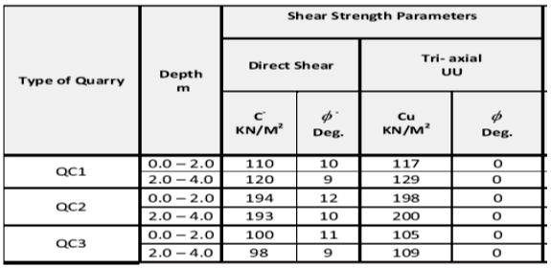

**Table (3) – Soil parameters for the shell material.**

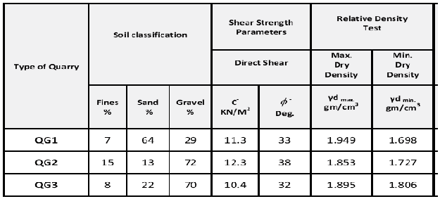

**Table (4):** Results of slope stability analysis.

|  |  |  |  |
| --- | --- | --- | --- |
| Cases No. | Minimum Factor of Safety | | |
| Section 80 m | Section 100 m | Section 140 m |
| 1 | 3.158 | 2.591 | 3.642 |
| 2 | 3.318 | 2.642 | 3.535 |
| 3 | 2.158 | 2.022 | 2.231 |
| 4 | 3.018 | 2.203 | 3.441 |
| 5 | 3.213 | 2.438 | 3.642 |
| 6 | 1.962 | 1.768 | 2.112 |
| 7 | 1.765 | 1.568 | 1.907 |

**Table (5):** Results of seepage analysis.

|  |  |  |
| --- | --- | --- |
| Dam Section | Rate of Flow (m3 / day) | |
| at clay core | at drain |
| Section 80 m | 3.939 | 4.045 |
| Section 100 m | 7.732 | 7.943 |
| Section 140 m | 2.162 | 2.224 |

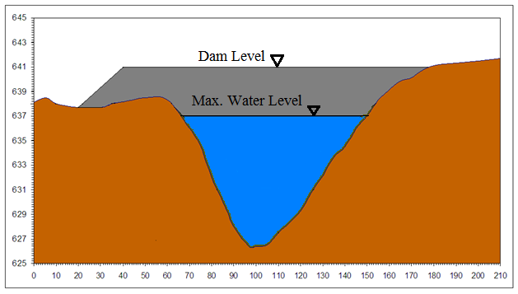

**Figure (1):** Cross – section of the dam showing the storage level and dam sections.

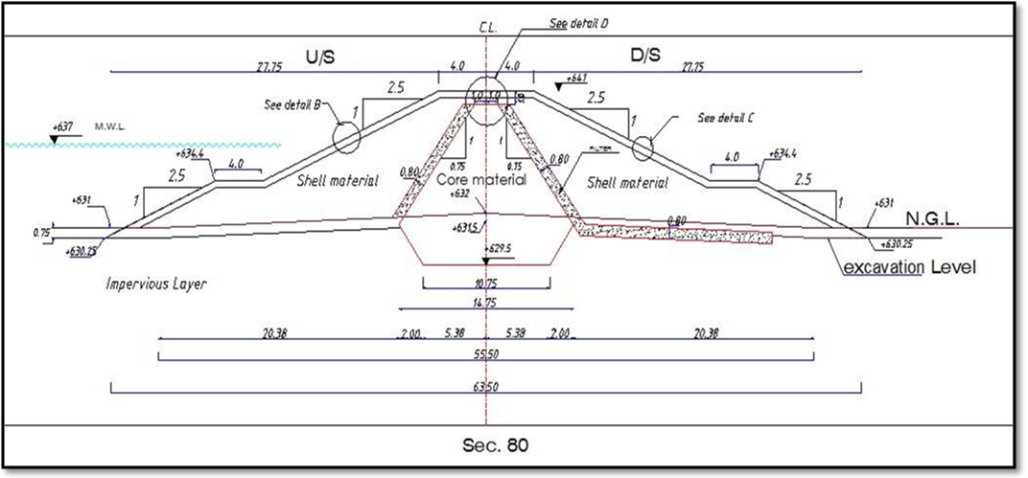

**Figure (2):** Cross – section of the dam at station 80 m.

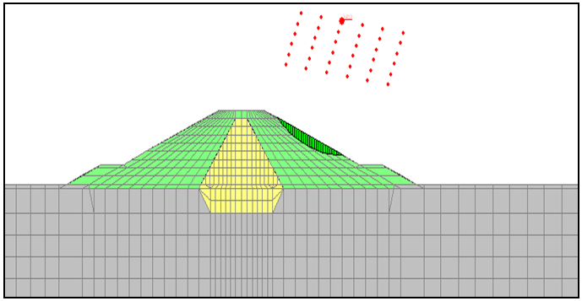

**Figure (3):** Typical slip surface.

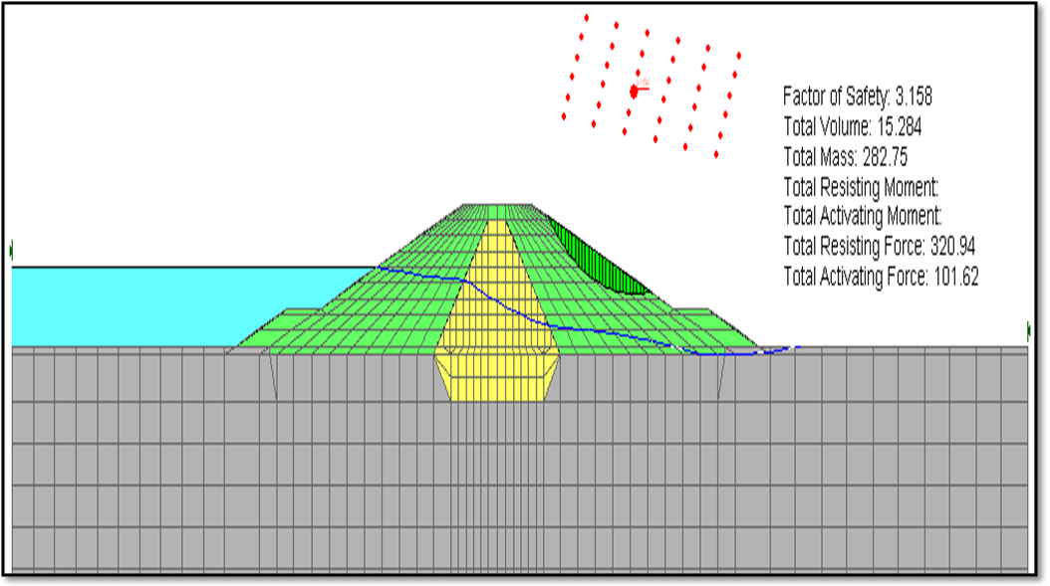

**Figure (4):** Results of stability analysis of the dam at section 80 m when the reservoir is full.

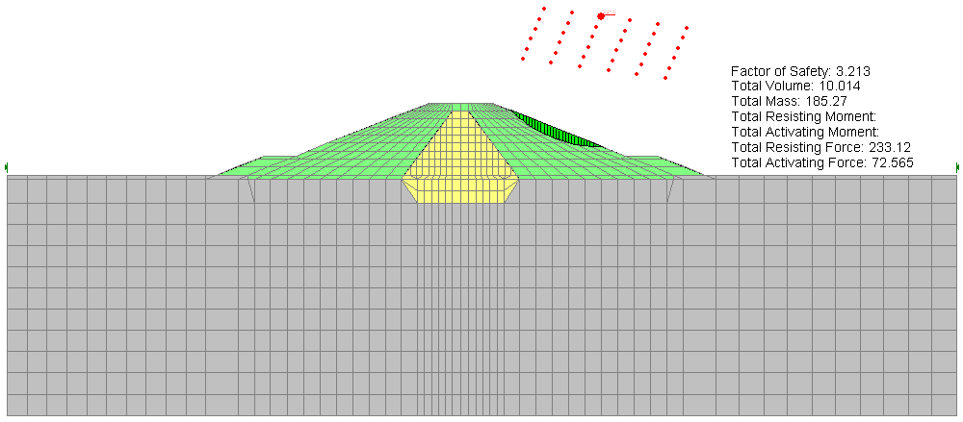

**Figure (5):** Results of stability analysis of the dam at section 80 m when the reservoir is empty.

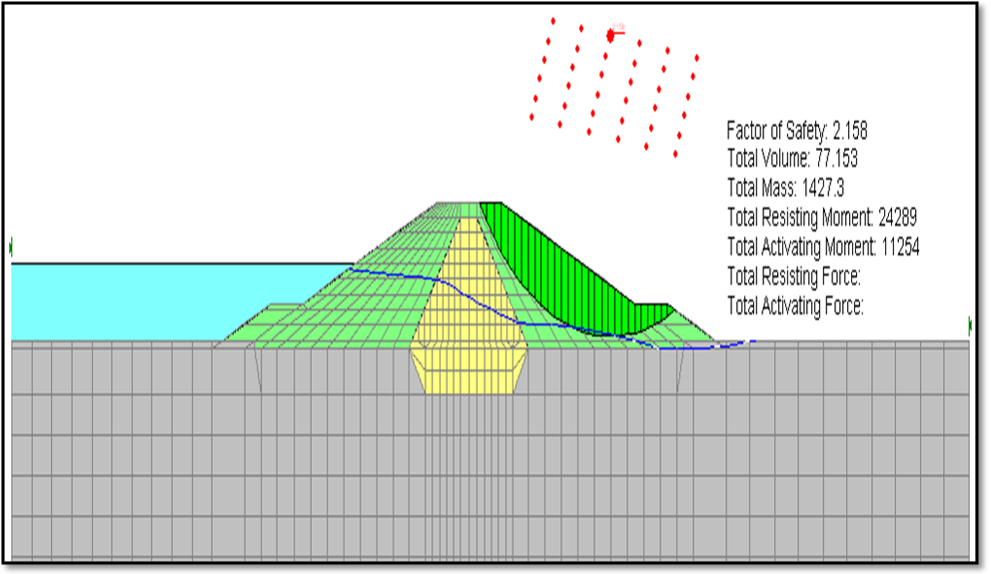

**Figure (6):** Results of stability analysis of the dam at section 80 m when the reservoir is full under the effect of earthquake.

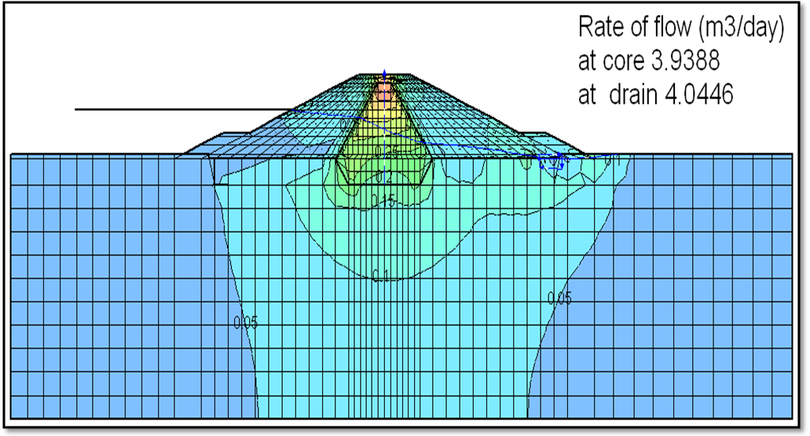

**Figure (7):** Contour lines of the hydraulic gradient showing the rate of flow at section 80 m.

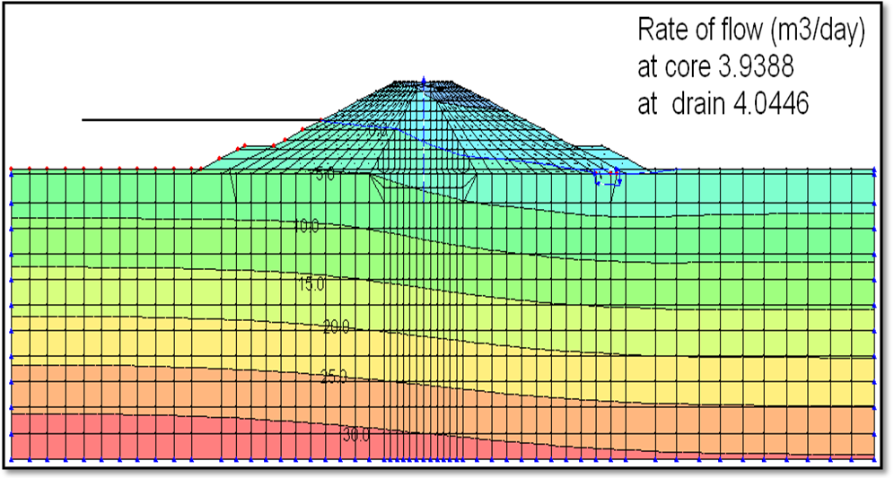

**Figure (8):** Contour lines of the pressure head (m) showing the rate of flow at section 80 m.

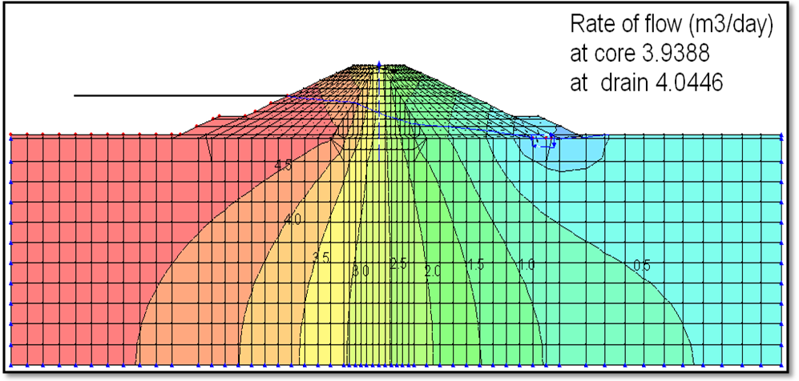

**Figure (9):** Contour lines of the total head (m) showing the rate of flow at section 80m.

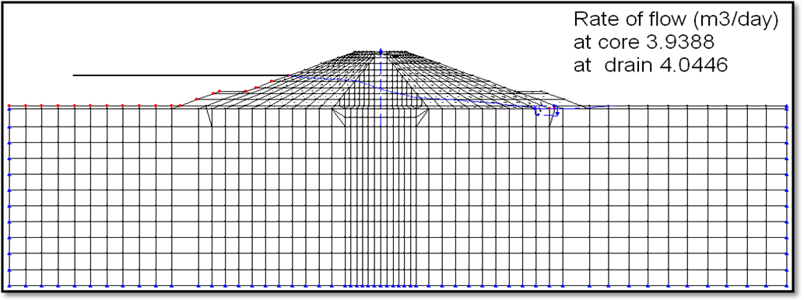

**Figure (10):** Phreatic line of flow and the rate of flow at section 80 m.

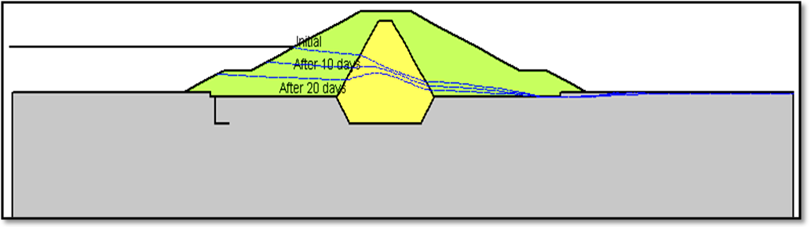

**Figure (11):** Phreatic line of flow at section 80 m predicted at different times of transient flow.

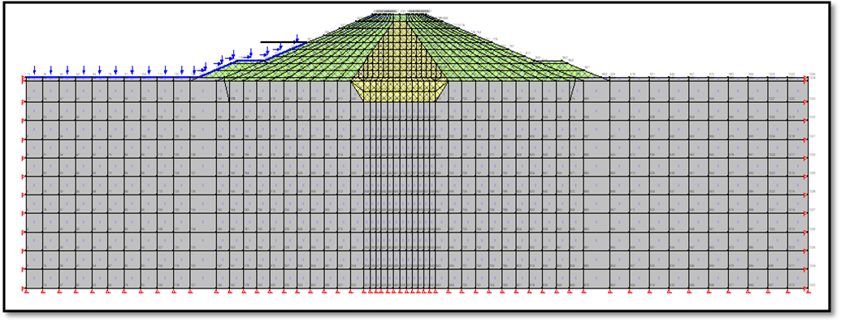

**Figure (12):** Finite element mesh of the dam and its foundation at section 80 m.

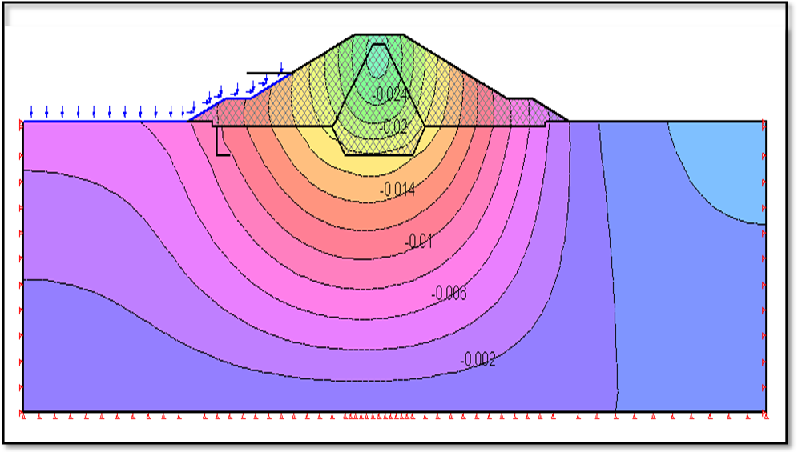

**Figure (13):** Contour lines of settlement (m) in the dam and its foundation at section 80 m.

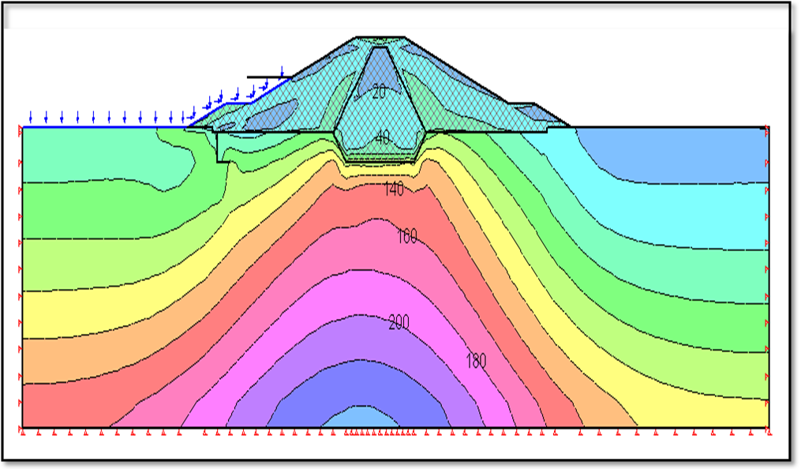

**Figure (14):** Contour lines of deviatoric stress (1 - 3) (kN/m2) in the dam and its foundation at section 80 m.

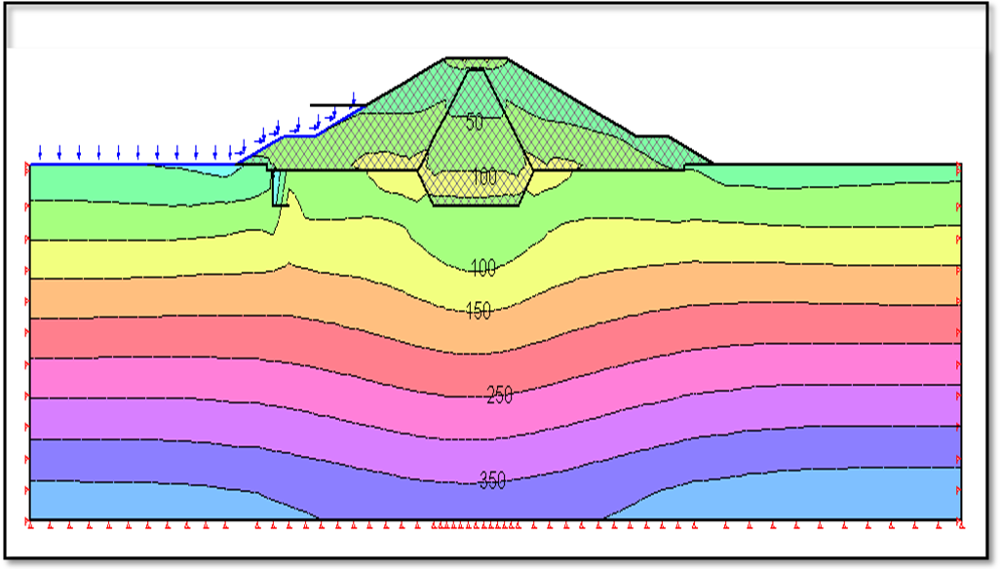

**Figure (15):** Contour lines of horizontal effective stress (kN/m2) in the dam and its foundation at section 80 m.

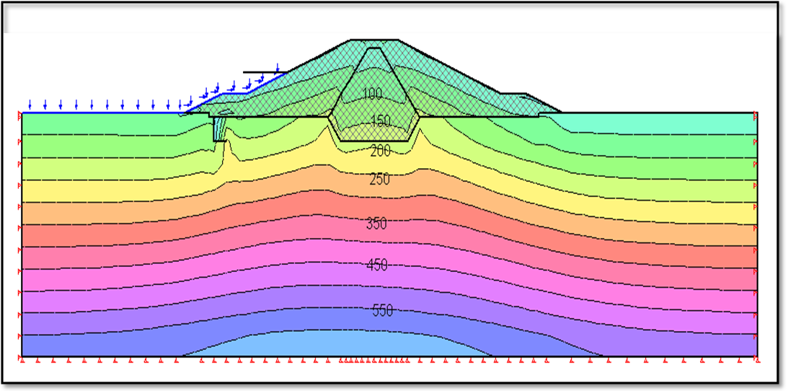

**Figure (16):** Contour lines of vertical effective stress (kN/m2) in the dam and its foundation at section 80 m.

**تحليل التسريب والترشح لسد ترابي معين باستخدام طريقة العناصر المحددة**

**قتيبة غازي مجيد**

مدرس مساعد، قسم الهندسة المدنية، كلية الهندسة، جامعة ديالى

**الخلاصة:**

ان طريقة العناصر المحددة هي طريقة عمليــة وتطبيقيــة في عــدة حقول بضمنها الهندسة الانشائيــــة والجيوتكنيكيـــة ان التســريب والترشـــح من خـــلال الســـدود الترابية مـن المواضيع الصعبــة التحليل خصوصاً في الســـدود الترابيـــة المتكونــة من عـدة طبقــات المشكلـــه حيث تكون معــقــدة اذا تطلب الامر تحليل التشــوهــات خصوصاً اذا اخذ بنظر الاعتبـــار العوامل الزلزاليـة لذلك طريقة العناصر المحددة هــي الادات الافضل لتحليل التسرب الحاصل في سـدود الاملاءات الترابيــــــة لعدة حالات مختلفة. الغرض الاساســي من هذا البحث هو محاكــات التسرب من خلال سـد ترابي. تم اختبار سد (حسن كنوش) الواقــع في شمال العراق لدراســة الحالــة هنــاك ثلاث مراحــل خلال عمر السد تكون حرجة من ناحيـــة فشـل القص والتــي يجب ان يتـم تحليـلها ودراستها وهي :خلال انشــاء السد وعندما يكـــون السد مملـوء بالكامل والحالة الثالثـــة عند التفريــغ السريع للســد .تم استخـــدام البرنامج SIGMA/W) ( الــذي هو برنامـــج يستخــدم العناصر المحددة الى جانب برنامج (SEEP/W) - برنامج اخر من برامــج GEO- SLOPE)) - لأجراء التحليل للسـد.

تحليلات ثبوتية المنحدرات التي تم اجراءها أظهرت ان كل اجراء الســد آمنـــة وضمن الحدود المنصوص عليها لكل حـــــالات التحميل المحتملــة خــلال العمـــر التشغيلـــي للسد. على أي حال يجب أن يتم مراقبــة السد خلال عمليـــة ألانشـــاء والتشغيل لأدراك الفهـــم الكامل لمقاومة القــص الازمـــة كما من الواجب أجـــراء الفحص الدوري لأساســـات السد أثناء عملية الحفر للاسس للتأكــــد من النتائـــج النهائيـــة.

**الكلمات المفتاحية:** ثبات، سد ترابي، تفريغ، جريان.