ISSN 1999-8716

**Diyala Journal**

**of Engineering Sciences**

Printed in Iraq

Vol. 08, No. 03, pp. 63-87, September 2015

**ZIG-ZAG GROUNDING TRANSFORMER MODELING FOR ZERO-SEQUNCE IMPEDANCE CALCULATION USING FINITE ELEMENT METHOD**

**Kassim Rasheed Hameed**

Lecturer, Electrical Engineering Department, Al-Mustansiriya University

(Received: 19/6/2014; Accepted: 22/10/2014)

**ABSTRACT: -** The grounding transformer is one of most important equipment in power energy system. This paper describes the modeling of zig-zag grounding transformer wound core type with varying degrees of complexity. In this paper, the Finite Element model (FEM) of zig-zag grounding transformer with non-linear magnetic characteristic for iron core is built using ANSYS software electromagnetic package. A numerical method, based on Finite Element Analysis (FEA), is presented for computing the zero-sequence impedance of grounding transformer. The analysis method is based on the two dimensions (2D) model and this model was solved by using the magnetic vector potential formulation (A).The main purpose of this paper is performing the modeling of the three-phase zig-zag grounding "wound core" transformer in 2D FEM for any capacity of transformer (100KVA- 1000KVA) and the Finite Element techniques are used for the magnetic field analysis to evaluate the magnetic field and to determine their distribution at any region inside the core window and winding.

Two types of analyses were performed, including static and transient analysis. The transient analysis in this work is simulated by direct coupling the 2D transformer model with external circuit (voltage sources) .The simulation results prove the analysis' correctness and validity, and the result of zero-sequence impedance of grounding transformer is verified by comparison with experimental result. Those measured in the Diyala transformer factory once the grounding transformer has been built. A good agreement of the computational results with experimental result by using this FEM model of zig-zag grounding transformer allowing us to know the transformer behavior before manufacturing them and, thus reducing the design time and cost.

**Keywords:** Finite Element Modeling; Grounding Transformer.

1. **INTRODUCTION**

Grounding or (Earthing) of power system is very important since the reliability, short circuit fault current withstand capability, over voltage and basic insulation levels, etc. depend on the characteristics of neutral grounding. Grounding transformers, also called Earthing transformers have been applied to ungrounded three-phase power systems to provide a source of ground fault current during line-to-ground faults (1). The sole duty of the grounding transformer primarily is to provide a neutral point for grounding purpose and to pass ground current during a ground fault (2).The desirable quantities of grounding transformer are low zero sequence impedance and low losses (no load losses). Zero sequence impedance plays a significant role in the effectiveness of grounding, and the accurate prediction of the zero sequence impedance of grounding transformer is very important for power system designers, from a cost point of view as well as a safety point of view. It is also one of the more difficult calculations for a transformer design engineer (3).The grounding transformer is usually of the wye delta or zig-zag connections(2), (4), but in this paper we shall concentrate on the zig-zag connection, with the neutrals connected to earth. Fig. (1) shows the zig-zag transformer connection and the Delta Wye connection.

There are many considerable research literatures have been attach to the study of grounding transformer which discuss on transformer technology. A number of technical publications {(1)--(6)} discuss various aspects of the purpose, application, specifications of different types of grounding transformers, and protection philosophy. The Publications (1) & (6) explain the application and specifications of grounding transformer. In Publication (2) the grounding transformer is modeled in PSCAD simulator, and simulation the phase to phase faults and in Publication (5) is modeled in MATLAB simulator. It appears that no single publication discusses all aspects of the grounding transformers .For this reason, this paper makes the analysis on special zig-zag grounding transformer wound core type.

Finite Element methods have been utilized in many Publicationsfor some time in the design, modeling and analysis of transformers (7),(8),(9).The development of finite element methods provided a detailed field calculation and enable representation of all important features of electromagnetic devices. The same methodology is now to be used in the difficult area of the prediction of zero sequence impedance.

In this paper a 250KVA, 33/0.4KV three phase grounding transformer, zig-zag / star connection wound core type (five legs) is modeled and analyzed with ANSYS software electromagnetic package. The flux density distribution and leakage flux for each winding is computed in order to calculate Zero sequence impedance. The simulation results compared with experimental result. Those measured in the Diyala transformer factory once the grounding transformer has been built.

**2-GROUNDING TRANSFORMER**

The grounding (or Earthing) transformer is a transformer primarily to provide a neutral connection point on a three-phase ungrounded power system (9).There is no difference between "earthing" and "grounding", since "earthing" is being used in Europe, whereas "grounding" is more common in the USA. Grounding transformers is one of the very important elements in the power system, and the best way to obtain the system neutral for grounding purpose in three-phase systems so the purpose of a grounding transformer is to provide a low zero sequence impedance path for zero sequence current, flow that occurs during related ground faults or unbalanced phase-to-neutral load conditions (4), (6).

**2-1. Grounding Transformer Types**

Two types of grounding transformer are in general used:

1) A Zig-Zag (Zn) connected winding with or without an auxiliary winding

2) A Wye-Delta (Ynd) connected winding with a delta connected secondary that may or may not be used to supply auxiliary power (6), (10).Fig. (1) shows the two most common grounding transformers. The zig-zag connection is the most widely used grounding transformer because the geometry of the Zig-Zag connection is useful to limit circulation of third harmonics. Furthermore, the Zig-Zag transformers are provides grounding with a smaller in size than a two winding Wye-Delta transformer providing the same zero sequence impedance (6). The impedance of all types of grounding transformers to normal three phase currents is high so that when there is no ground fault and no unbalanced phase-to-neutral load on the system, only a small magnetizing current flows in the transformer windings (2).

**2-2.Why the Grounding Transformers are Necessary**

Grounding Transformers are typically usedto

1. Provide an easy path to ground fault current during line-to-ground faults.
2. To ground the system.
3. Limit the magnitudes of transient over voltages when restriking ground faults occur.
4. Limit the current during line to ground faults.
5. Permit the circulation of unbalanced load current in the neutral.
6. Permit the connection of phase-to-neutral loads when desired (6),(9),(10)

**2-3.KVA Rating of Grounding Transformers**

The grounding transformer is of short time rating, since a grounding transformer is normally only required to carry short-circuit ground current until the circuit breakers clear the fault and de-energize the faulted circuit (2). The rating of grounding transformer is entirely different from that of a power transformer. Power transformers are designed to carry total load continuously, whilst grounding transformer carries no load, and supplies current only if one of the lines becomes grounded. Since it is almost working on no-load, dictates to have low iron losses. The KVA rating of a three phase grounding transformer is the product of normal line to neutral voltage (KV) and the neutral or ground amperes that the transformer is designed to carry current under fault conditions for a specified time.Most grounding transformers are designed to carry their ground current for a limited time only, such as 10 seconds to 1 minute. (4), (9)

**3-ZIG-ZAG GROUNDING TRANSFORMER**

A zig-zag grounding transformer is a three-phase transformer built with or without a secondary winding. These transformers have special windings, appropriate for special applications. Its applications are for the derivation of a neutral connection from an ungrounded 3-phase system and the grounding of that neutral to earth reference point. Zig-Zag transformer has six coils in which three are outer coils and three are inner coils as shown in the Fig. (2). The outer coil windings are called as Zig winding and inner coil windings are called as Zag winding. The zig winding of one phase is connected in series with the zag winding of another phase so it is called interconnected star winding. Each phase of the zig-zag transformer has two identical windings, and has the same number of windings turns but they are wound in opposite directions to give the high impedance to normal phase currents. The coils are connected as follows (6), (10): The outer coil of phase A is connected to the inner coil of phase B. The outer coil of phase B is connected to the inner coil of phase C. The outer coil of phase C is connected to the inner coil of phase A. The outer coils are connected to phases A, B, C of the existing delta system. The inner coils are connected together to form the neutral. The neutral point is then connected either directly or through a Neutral Grounding Resistor (NGR) to ground. The internal connection of this transformer is illustrated in Fig. (3) .The interconnection of windings of different phases introduces 30° (or 150°) phase shift between zig (or zag) winding. Fig. (4) shows a phasor diagram for a zigzag connection (11). The voltage relations for the zig-zag transformer are given by (2). The relations of line-to-line voltage of system (*VL-L*)and the corresponding line-to-neutral voltage (*VL-N,*).

The voltage across each the zig winding and the zag winding is 1/√3 times of line-to-neutral voltage ,

$$V_{Zag}=\frac{V_{L-L}}{3}$$

$V_{Zig}=\frac{V_{L-L}}{3}$

The zig-zag transformer has been used some years ago for creating a neutral, thereby converting a three wire distribution system to a four-wire system. Zig-zag grounding transformers are more common than a grounded wye- delta transformer because they are smaller in size. (6)

**3-1. Basic operation of zig-zg grounding transformer**

During undisturbed system operation with balanced (symmetrical) voltages and under balanced current on the systems. The three phase voltage equal in magnitude but 120° out of phase with each other, are applied to the three terminals of grounding transformer, the currents in the two windings in the same limb of the core flow in opposite directions because of the special Zigzag winding connections. As the fluxes oppose but the ampere turns in the windings cannot cancel so the zig-zag transformer takes a very small current as the magnetizing current during normal condition (2), (9) .But when single line to ground fault occurs on any phase of the system, as shown in the Fig. (5), zero sequence component of the earth fault current flows in the earth and returns to the electrical power system by way of earth star point of the grounding transformer. It gets divided equally in all the three phases. Hence, as shown in the Fig. (5), the currents in the two windings in the same limb of the core flow in opposite directions. And therefore the magnetic flux set up by these two currents will oppose and neutralize each other. As there is no increase in flux due to fault current, there is no extra (***dφ /dt***) means no extra voltage induced across the winding and no choking effect occurs to impede the flow of fault current. So it can be concluded like that, the zigzag type grounding transformer maintains the rated supply voltage at normal current as well as when a solid single line to ground fault current flows through it. The ground fault current is only limited by a Neutral Grounding Resistor (NGR), and the small reactance of the Zigzag.

For a single line-to-ground fault, zero-sequence current flows in the ground circuit allowing the protection system to act. The voltages of other two healthy line terminals are maintained at their respective line-to-neutral voltage levels. In absence of the grounded neutral, voltages of healthy phases would increase to line-to-line voltage level, stressing the insulation of connected equipment. Thus, zigzag grounding transformer not only helps in protection but also reduces the voltage stresses under asymmetrical fault conditions. a neutral grounding resistor (NGR)

Under balanced condition, the currents in three phases are equal in magnitude, with angles 120° apart. Accordingly, the vector form fluxes in three phases are 120° apart and summed to zero at the yoke. There is no need of a return path for the flux. If there is some unbalance in the terminal voltage, the residual flux, i.e., sum of the three phase fluxes, will not be zero and it has to return through a path out of the transformer magnetic core. This means the residual flux at the top yoke has to pass through a huge air gap and the tank to the bottom yoke. The path through the air gap and the tank has low permeability and, thus, high magnetic reluctance. Therefore, the zigzag winding provides an easy path for in-phase currents but does not allow the flow of currents that are 120° out of phase with each other.

The main features of Zig-zag grounding transformers are:

1. 1-Winding has much lower impedance to zero sequence currents.
2. Can be used with three phase system without secondary winding.
3. Avoidance of undesirable stresses in the insulation.
4. Can be used with either delta or star connected winding to feed desired load.
5. 6-It keeps zero sequence impedance constant even when auxiliary winding under load.
6. 7-Fault current is not reflected on to the secondary side (auxiliary winding).

From the above, it is very clear that the Zig-Zag winding can be utilized either as grounding transformer or power transformer, or in combination depending upon the requirement. **(9),**

**3-2. Representation of the Grounding Transformers configuration**

Thegrounding transformer under the study is a 250 kVA, three-phase, rated primary voltages 33 Kv, Zig-Zag connected, and rated secondary voltage 400V, Star connected, wound core type, oil-immersed. The secondary winding comprises 16 layers (per phase) of copper strip, while the each primary windings (Zig windings) or (Zag windings) consists of 1750 turns (per phase) of insulated copper wire. The transformer magnetic circuit is of wound core type five leg and is assembled from two small iron wound cores(outer core) and two large wound cores (inner core).A tank is often made of mild surrounds the active part. Fig. (6) illustrates the perspective view of the three-phase transformer active part modeled. The main design parameters and the dimensions of this transformer under the study were taken from the design documents from the manufacturing company (Diyala Company of Electrical Industries) (12**)** as shown in Table (1).

**4-BASIC EQUATIONS OF ELECTROMAGNETIC FIELD**

A general formulation of electromagnetic field problems in electrical machine has already been presented by many authors (13), (14), (15). The electromagnetic fields inside the transformer are governed by the following nonlinear equation. From of Maxwell’s equations, the differential form of the basic equations governs calculation of zero sequence reactance problem is determined.

*∇ × H= J* (Derived from Ampere law) ------ (1)

*∇ ∙ B= 0* (Derived from Gauss law) ------ (2)

$∇×E=-\frac{∂B}{∂t}$------ (3)

Where H: the magnetic field strength, J: the current density. , B: the magnetic flux density.

Assume that H is only due to source currents i.e. no permanent magnets are present, and the Current density J in equation (1) is due to current sources (current densities of the transformer's primary and/or secondary). The equations that describe the material properties are:

B=μ H ⇒ H=υ B ------- (4)

J=σE ------- (5)

Where: υ: the magnetic reflectivity (reciprocal of magnetic permeability μ),

σ: the electrical conductivity.

And the relation between magnetic vector potential (A) and magnetic flux density (B) is:

B=∇×A ------ (6)

Substitution of (6) into (1) using relation (4) gives the fundamental equation of the vector potential formulation for magnetic field equation describing the vector potential

∇× (υ∇×A =J ------- (7)

Solving equation (7), magnetic vector potential (A) can be calculated and solving equation (6), magnetic flux density (B) can be calculated.

**5-TRANSFORMER MODELLING WITH THE FINITE ELEMENT METHOD**

Finite Elements Method (FEM) is a numerical technique for finding approximate solutions of partial differential equations as well as of integral equations. (16) The basic idea of FEM is to divide the body into finite elements, often just called elements, connected by nodes and obtain an approximate solution.

The finite element model contains information about the device to be analyzed such as geometry (sub divided into finite elements), material, excitations, and constraints. The material properties, excitations and constraints can often be expressed easily but geometry is usually difficult to be described. Finite element modeling is now one of the most powerful tools available to the designer. It enables accurate computer modeling to be carried out of complex structures, whether it is required that these should represent electrical or magnetic field distributions, or both. Finite element modeling is now such an important tool to the advanced transformer designer that it is important that everyone with an interest in design should have an appreciation of the process. (FEM) is the most commonly used numerical method for reactance calculation of non-standard winding configurations and asymmetrical/ non-uniform ampere-turn distributions, which cannot be easily and accurately handled by the classical method. Many commercial 2-D and 3-D FEM software packages are now available and many manufacturers develop their own customized FEM programs for optimization and reliability of transformers. In this study, software called ANSYS is used **(17)**.

**5-1. Model detail**

In order to build the transformer model, requires measuring the dimensions of the transformer accurately. The dimensions of this transformer under the study were taken from the design documents from the Diyala transformer factory. Building the transformer model started first from Key -points, secondly connecting these Key points by lines then from these lines areas will be created. This procedure is followed as in ANSYS package. (17)

**5-1-1.Building the Coil Mode**l

Each windings at 2D was modeled as a single block area of nonmagnetic material encompassing all turns over all layers, then copy these areas on x-axis to build half of the windings model which represent the half of the actual model of the transformer winding. The element type PLANE 53 is suitable for the windings region in 2D model because these elements have the capability of coupling with the external circuit. The coil areas in 2D model are mapped meshed with quadratic elements .Fig (7) shows the 2D windings model.

**5-1-2. Building the Iron Core**

The three-phase transformer wound core consists of four units (two inner cores and two outer cores). The region core is represented by areas.AT start build the irregular areas of one outer core and one inner core then copy these areas to build half of theIron Core model at 2D.

The iron core was modeled as a single non-conducting isotropic material and a generic B-H curve for oriented core steel was used for the non-linear model. The non-linear characteristics of the electrical steel used for the iron-core was input to ANSYS manually The B-H curve of the non-linear iron-core was taken from the design documents of this transformer. The iron core areas in 2D model are freely meshed with quadratic elements because irregular areas. The element type used for iron-core is PLANE53 in 2D model. Fig (8) shows the 2D iron core model.

**5-1-3.Building the Insulation Model**

There are different types of insulation are used in transformer such as paper insulation, press board insulation, wood insulation, and oil. Because these insulations have complex shapes and irregular areas, it is very difficult to represent these insulations by areas from assigning the key points and lines. Therefore, the easiest and most favorite way of representation these insulations are to use algebra operations in ANSYS package. To build up the 2D Insulation model, using the overlap operation of areas contains the coil regions and core regions. And by same way the Insulation oil can be represented throw using the overlap operation of areas contains the active part (core + coil) areas and tank box area which surround the active part. The properties of insulation materials are represented by relative permeability (µr = 1).The suitable element type of insulation regions in 2D model is PLANE 53 and The insulation areas in 2D model are freely meshed with triangle elements . Figs (9) and (10) show the building of 2D Insulation model and Figs (11) show the complete two dimension FEM model.

**6-ZERO SEQUENCE REACTANCE CALCULATIO**N

The method of symmetrical components is commonly used in power system analysis. For a static apparatus like a transformer, positive-sequence and negative-sequence impedances (reactance’s) are equal.

Under symmetrical loading conditions, only positive-sequence reactance needs to be considered. In case of asymmetrical loading/disturbances or single-phase faults, the system response is largely decided by the zero-sequence reactance of the network .it is easy to understand and calculate positive sequence reactance but the zero-sequence reactance of a transformer may differ considerably from its positive-sequence reactance, it is depending upon the type of magnetic circuit and winding connections **(11)**.The zero phase sequence impedance is unlike the normal (positive sequence) impedance, which is derived from the transformer's leakage field because the zero phase sequence impedance is caused by the field created by the currents flowing in the same direction and rotation in all three phases**(1)** .The magnetic field produced by a zero-sequence set of currents is radically different from those produced by negative or positive sequence currents, and therefore zero sequence impedance is generally very different from positive and negative impedances, and it depends on the form of core construction and disposition of the windings (19).The zero sequence impedance is used in short circuit calculations.

The calculation of zero sequence impedance by classical methods is much more difficult, the problem with this calculation stems from the complex nature of the magnetic field set-up during a fault condition **(3)**. For a 3-limb core It can be seen that due to the currents flowing in the same direction and in phase, the flux is in the same direction for each limb as shown in Figs. (12), (13). This means that for a 3-limb core the only way of making a circuit is to return via free-space or through the tank wall, which for grounding transformers is often made of mild steel. The tank wall may saturate only very locally making inductive calculations and by classical methods almost impossible. The flux also flows through, or along the surface of, components such as clamps and other metallic structures. But For the wound core with five limb core shows in Fg. (14), the problem of local tank wall saturation does not occur since the flux flows in the two outer limbs as shown in Fig. (15).

Rough estimations of zero sequence impedance can be determined based on the positive sequence and core form of the transformer. The five-limb core type (wound core type) and shell type will have a zero sequence of ~100% the positive sequence because the flux stays in the core follows in the same path as it does for positive sequence currents. For a core type, the zero sequence will be ~80-90% typically, because the flux must travel outside the core.

In the classical method the leakage fluxcan be calculated by using the concept of equivalent magnetic circuits and this method was based upon on magnetic field calculations for simplified configurations and simplifying assumptions of the leakage field being unidirectional and without curvature.

The general formula of estimation leakage reactance for simple case of a two winding transformer shown in Fig. (16) is

$X=2πf\frac{μ_{O}.π N^{2}}{H_{eq}}×\frac{1}{3} \left(T_{1}×D_{1}\right)+\left(T_{g}×D_{g}\right)+\frac{1}{3} (T_{2}×D_{2})$----- (8)

Where:

*N* =Number of turns of primary or secondary winding

*Heq*=Equivalent height of winding

*D1* =Mean diameter ofprimary winding

*D2* =Mean diameter ofsecondary winding

*T1*, *T2*=Thickness ofprimary and secondary winding

*Dg*=Mean diameter of of gap spacing between primary and secondary winding

*Tg* =Thickness ofgap spacing between primary and secondary winding

The zero sequence reactance (*XO*) of zig-zag transformer with turn ratio equal 1 can be calculated by using the conventional equation of classical method as below **(11)**:

---- (9)

Where

*DZig* = *D1*,  *DZag* = *D2*, *Tg* = *, Dg* =

The zero sequence impedance of grounding transformer can be calculated from the following formula:

$Z_{0}=\frac{\sqrt{3} V_{L.L}}{I_{f}}$--------- (10)

Where *Zo* = zero sequence impedance / phase

*VL-L*=L ine-to-line voltage in KV

*If* = neutral current in amps

An alternative method of calculating the leakage reactance is based on energy techniques. This method is accurate and provides a simple calculation (14), (20), (21)

--------- (11)

$X_{O}=ω L=\frac{4π{ W}_{m}}{I^{2}}$---------- (12)

Where *Wm* is electromagnetic energy in the magnetic field produced by a current I flowing in a closed path. In our case this means calculating the electromagnetic energy in the windings, then dividing the electromagnetic energy by three and use the phase current to calculate the reactance per phase (?). When numerical methods like Finite Element Method are used, solution of the field is generally obtained in terms of magnetic vector potential (A), because the electromagnetic energy stored can be calculated from the product of current density (J) and magnetic vector potential (A). In 2D magnetic field, the magnetic energy that stored in window space can be calculated by using the following formula.

$W_{m}=\frac{1}{2}\iint{J.A.d_{S} }$-------- (13)

$∴$ $L=\frac{1}{I^{2}}\iint{J.A.d_{S} }$-------- (14)

Where:  ***A*** is magnetic vector potential, ***J*** is current density vector

In order to measure the zero-sequence impedance, a voltage is applied between the shorted line terminals of a zig-zag connected winding and neutral as shown in fig. (17). With reference to the test arrangement of fig. (17), the zero-sequence impedance of a zig-zag connected winding with the grounded neutral is calculated as Three-phase transformers

$Z_{O}=\frac{V}{(I/3)}=3\frac{V}{I}$--------- (15)

**7-RESULTS AND DISCUSSION**

The validity of the grounding transformer model was firstly checked during an open circuit test by finite element transient analysis, and due to the 2-D FEM grounding transformer model represented half of the actual geometry transformer, so the open circuit test is done by supplying a three phase voltage with a peak value of 8167 V, 50Hz on each zig and zag coils in primary side by coupling the 2-D FEM transformer model with external electric circuit (independent source). The possibility of coupling the magnetic field and the electric circuit equations is currently available in ANSYS software for the 2- dimensional analysis of the electromagnetic field. Table (2) shows the results of the open circuit test. From the comparison between the results of this analysis and the practical test results and the design values, the magnitudes of the obtained voltages agree with that of the practical test and the design values. Fig (18) shows the waveforms of input and output voltages. After confirming the validity of the model, the zero sequence impedance of transformer is calculated through simulations. The simulation is done by solving the model by static analysis. Under phase- to- ground fault condition, grounding transformer creates a path for the fault current and also divides the ground fault current to three in-phase, equal components.

To investigate this case, the zig-zag grounding transformer model is supplied by three in-phase, equal currents. The zero sequence reactance is calculated using energy techniques, then dividing the electromagnetic energy by three and use the phase current to calculated the per- phase reactance. The results for this transformer have been summarized in the table (3). The result shows the zero sequence impedance calculation’s is better accuracy comparing with test value.

To discuss the distribution of magnetic flux in grounding transformer, Fig.(19) and Fig (20) show the distribution of zero sequence magnetic flux in wound iron core in the form of (graphs& vector plot). It appears that the unwound parts of the iron core (outside parts of the outer core which are not surrounded by windings) offers available return path for the zero phase sequence magnetic flux. While the zero sequence magnetic flux, in the internal parts of the iron core, (which are surrounded by winding) flow in the same direction, this behavior of distribution of magnetic flux agrees with that theoretical conception.

The computation results show that along center line of X direction (length of core), the zero sequence magnetic flux in the internal parts of the iron core, (which are surrounded by winding)) are equal (1.6 tesla) while return path for the zero phase sequence magnetic flux in the unwound parts of the iron core (outside parts of the outer core which are not surrounded by windings) are equal 3.09 tesla because the maximum value of return path flux are equal approximate (3Øo / 2). The contour plot in Fig. (21) show the distribution of zero sequence magnetic flux in outside parts of the outer core(red colure region). The Fig. (22) illustrated the distribution of magnetic flux along the center line of the thickness of parts of the wound core(outside parts and internal parts). Fig. (23) Illustrated the distribution of magnetic flux along the center line of X direction (length of core) at yoke region and Fig. (24) Show the distribution of zero sequence magnetic flux along the center line of Y direction in yoke region.

We note from the distribution flux shown in figures above, it can be see that the wound core with five leg offer return path of zero sequence flux throw outer part of core that mean provided a low reluctance path to zero sequence flux, so that the zero sequence flux not return throw tank's wall or throw the frame of core so eddy currents will not develop in it and hot spots may not occur or arise. The problem of local tank wall saturation does not occur.

But under the balanced condition, the current in three phases are equal in magnitude, with angles 120 apart. Accordingly, the vector form fluxes in three phases are 120 and summed to zero at outer part of the iron core. There is no need of a return path for the flux. Fig (25) illustrates the distribution of magnetic flux in core at balanced condition

**8-CONCLUSION**

In the present paper, Finite Element techniques are used to perform the modeling of the three-phase wound-core type, Zig-Zag grounding transformer in 2D using FEM for any capacity of transformer (100KVA- 1000KVA). A simple procedure for the calculation of the zero phase sequence impedance of three phase core type Zig-Zag grounding transformer is presented in this paper. The 2D Finite Element analysis gives the ability to evaluate the magnetic field and determine their distribution at any region inside the core window.

The main conclusions of this work are:

1. The contribution of this work is describing simple technique for modeling three phase wound core type Zig-Zag grounding transformer in 2D FEM model**.**
2. 2-The result obtained for calculating the zero-sequence impedance by applying the proposed FEM model gives more accurate results, which are close to the actual measured value due to the better representation of the real transformer geometry.
3. The results show that the zero-sequence impedance obtained by the proposed model present a difference of 4% with respect to measured values and the difference between the finite element results and the empirical formulae is nearly 14% so the proposed, Zig-Zag grounding transformer model can provide accurate results (as compared with traditional design formulae) and improves transformer design.
4. The method shown here allowing transformer manufacturer to know the transformer behaviour before manufacturing them and, thus reducing the design time and cost.

**REFERENCES**

1. Martin J. Heathcote, CEng, FIEE “The J&P Transformer Book”, Twelfth edition, Newnes, Reed Educational and Professional Publishing Ltd 1998
2. M. Shen & G. Roberts “Grounding Transformer Application, Modeling, and Simulation” IEEE Transactions on Industry applications 2008: pp. 1-7
3. Roger Allcock & Scott Holland “Calculation of Zero Phase Sequence Impedance for Power Transformers using Numerical Methods” IEEE Trans. on Magn. , Vol. 31, No. 3, May 1995

4-T.A. Short “Electric power distribution handbook” book, CRC Press, Boca Raton London New York Washington, D.C, 2004

5- Hu Chenwang, Zeng Xiangjun “Fault Analysis of a Grounding Transformer” Proceedings of the 2010 International Conference on Modelling, Identification and Control, Okayama, Japan, July 17-19, 2010

6- Edson R. Detjen, and Kanu R. Shah, “Grounding Transformer Applications and Associated Protection Schemes”, IEEE TRANSACTIONS ON INDUSTRY APPLICATIONS, VOL. 28, N0.4, JULY / AUGUST 1992

7- M. Tsili1, A. Kladas, and P. Georgilakis, “Numerical Techniques for Design and Modelling of Distribution Transformers” Journal of materals processing technology 161, 2005, pp 320

8- H. Wang, K. L. Butler, "Finite Element Analysis of internal winding faults in distribution transformer "*,* IEEE trans. On, Magnetics. , vol.16, no.16, July 2001.

9-“EARTHING TRANSFORMERS FOR POWER SYSTEM” Electrical India journal, www.chetanasprojects.com

10- Pacific crest transformer “Grounding Transformers” Source, <http://www.pacificcresttrans.com/resource-center/15/Grounding-Transformers.html#top>

11- S. V. Kulkarni and S. A. Khaparde “Transformer Engineering Design and Practice”, Marcel Dekker, Inc, New York • Basel 2005.

12- “Design Calculation Sheet of 250KVA grounding r transformer” Diyala Company of Electrical Industries.

13- Pavlos S. Georgilakis “Spotlight on Modern Transformer Design” Book, Springer, 2009.

14- GUEMES-ALONSO, J. A. “A new method for calculating of leakage reactances and iron losses in transformers” - *Proceedings of the Fifth International Conference on Electrical Machines and Systems, 2001. (ICEMS 2001), Vol: 1, 18-20 Aug. 2001, pgs: 178-181*

15-S. Jamali Arand1, K. Abbaszadeh2 “The Study of Magnetic Flux Shunts Effects on the Leakage Reactance of Transformers via FEM” Majlesi Journal of Electrical Engineering Vol. 4, No. 3, September 2010.

16- Chari, M.V.K. & Silvester, P.P., “Finite Element in Electrical and magnetic field problems”, John Wily & Sons (1980).

17- Documentation for ANSYS11.

18- Willam D. Stevenson. Jr. “Elements of power system analysis”

19- Jialong Wang& Raluca Lascu “Zero Sequence Circuit of Three-legged Core Type Transformers”

20- A. Naderian Jahromi “A Fast Method for Calculation of Transformers Leakage Reactance using Energy Technique” IJE Transactions B: Applications Vol. 16, No. 1, April 2003

21- S. Jamali, M. Ardebili, and K. Abbaszadeh “Calculation of short-circuit reactance and electromagnetic forces in three-phase transformer by finite element method” - *Proceedings of the Eighth International Conference on Publication Electrical Machines and Systems, 2005. (ICEMS 2005),* pp. 1725- 1730 - Vol. 3.

**Table (1):** Design parameters of the zag-zg grounding transformer.

|  |  |
| --- | --- |
| Ratin**g** | Capacity: 250 KVA  Voltage : 33000 ±5% / 400 V  Frequency : 50 Hz  Phase : 3-Phase |
| Primary winding | Connection Type : Zig-Zag  Materials : Cu.Wire Ø 2.0 mm  No. of Turns : Zig winding 1750  Zag winding 1750 |
| Core | Type : "Wound Core"  Materials M4  Cross Section Area: 168 ×2 mm2 |
| Dimensions (mm) | Width ×Length× Hight  Primary Zig winding: 320 × 476 × 300  Primary Zag winding: 232 × 364 × 300  Secondary winding : 145 × 255 × 328  Outer core: 289 × 504 × 240  Inner core: 394 × 504 × 240  Active part (core+coil) 320 × 476 × 1381 |

**Table (2):** Results of the open circuit test.

|  |  |  |  |
| --- | --- | --- | --- |
|  | Terminal voltage (peak value) volt | | |
| Test value | Design value | FEM. Solution |
| Primary side (Input voltage) | 28291.6 | 28291.6 | 28291.6 |
| Secondary side (output voltage) | 327 | 326.6 | 327 |

**Table (3):** Comparison of Zero sequence impedance FEM result with actual test results.

|  |  |  |  |  |
| --- | --- | --- | --- | --- |
|  | Design value | FEM result | Test result | Error % |
| Zero sequence impedance  (Ohm) | 148 | 143.6 | 144 | 0.27 |

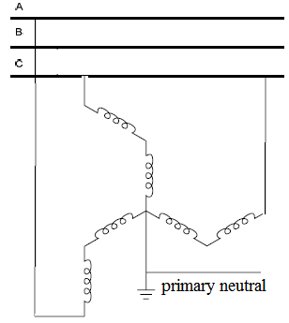

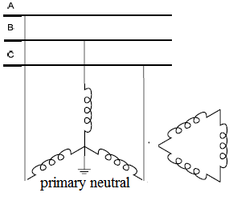

(b) Wye-delta connection

(a) Zig-Zag connection

**Fig. (1):** Grounding transformer connections.

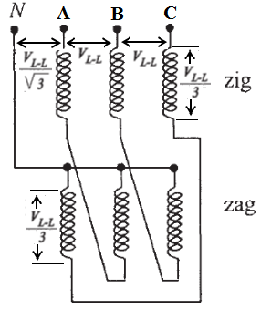

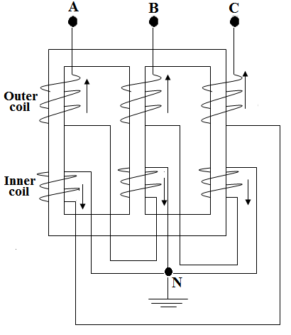

**Fig. (3):** zig-zag transformer connections.

**Fig. (2):** zig-zag transformer arrangement.

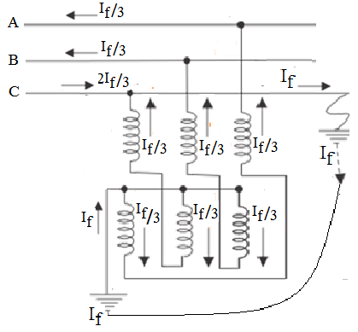

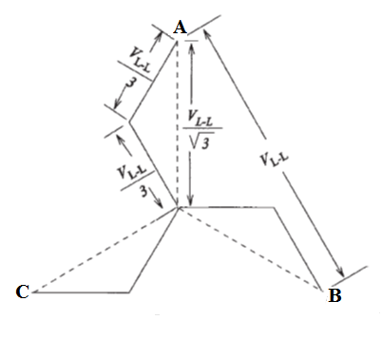

**Fig. (4):** Vector diagram of a zig-zag transformer connection.

**Fig. (5):** Earth fault current when single line to ground fault occurs on any phase of the system.

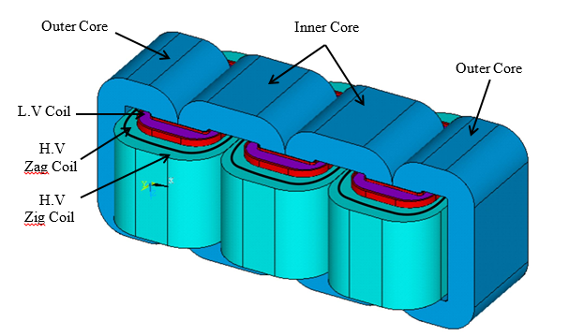

**Fig. (6):** Active part configuration of the zig-zag grounding transformer.

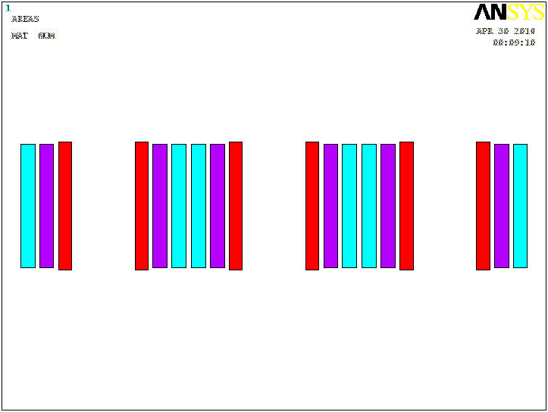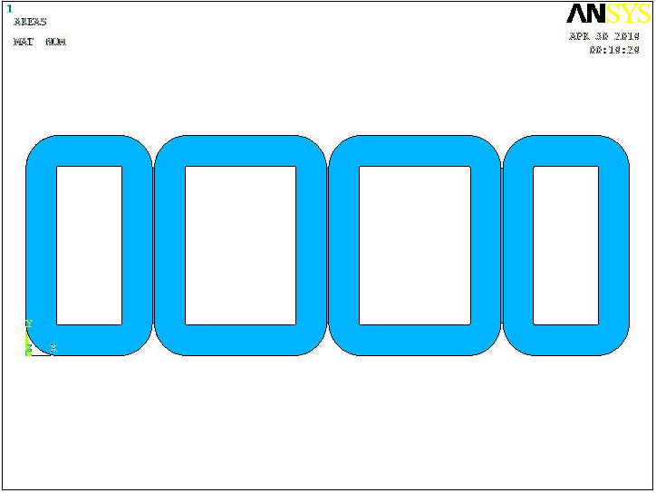

**Fig. (7):** 2D Coil model.

**Fig. (8):** 2D iron core model.

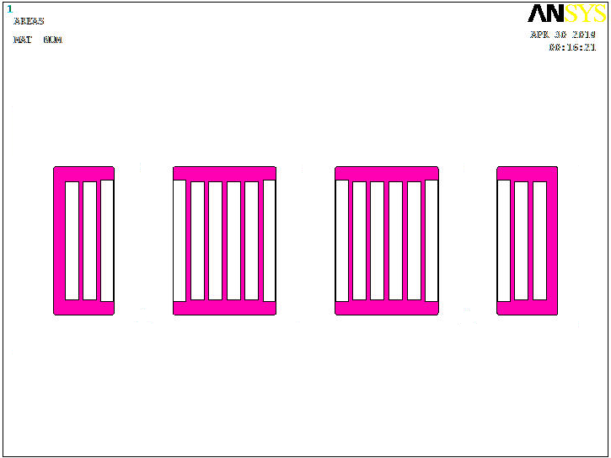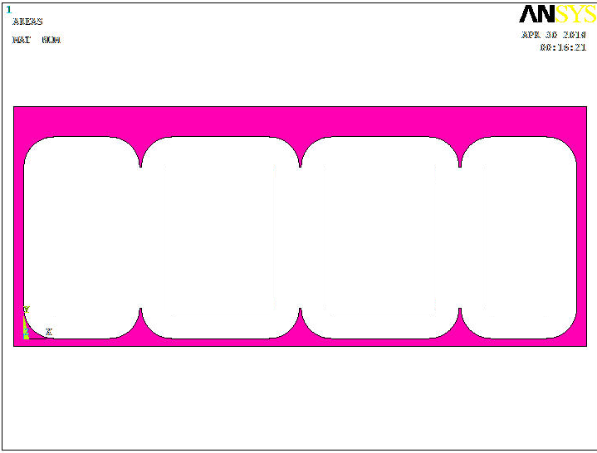

**Fig. (10):** 2D oil Insulation. model

**Fig. (9):** 2D Insulation model.

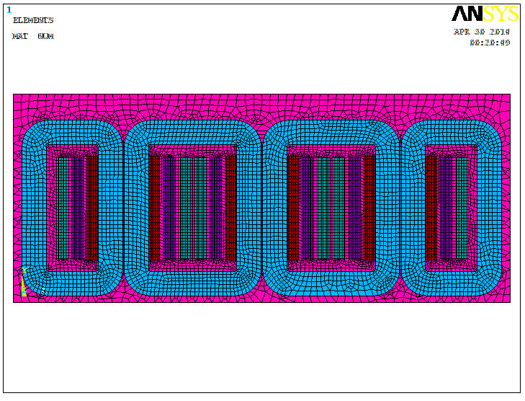

**Fig. (11):** 2D completely Model of with mesh pattern.



**Fig. (13):** three-legged core-type transformer magnetic paths

**Fig. (12):** Three-legged core-type transformer.



**Fig. (14):** Five-legged wound core-type transformer.



**Fig. (15):** of five-legged core-type transformer magnetic paths.

paths

Fig.(15) of five-legged core-type transformer magnetic paths

paths

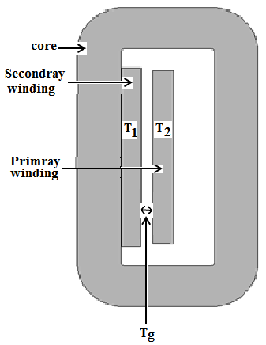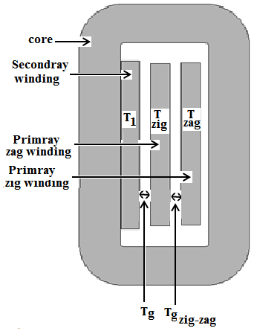

a) Zig-zag winding.

a) Two winding.

**Fig. (16):** Part sections of two winding and zig- zag transformer.

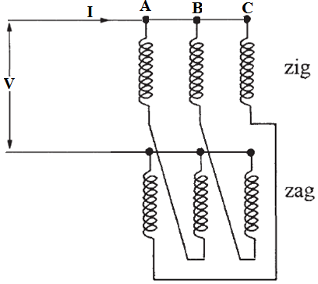

**Fig. (17):** Connection for Measurement of zero sequence impedance.

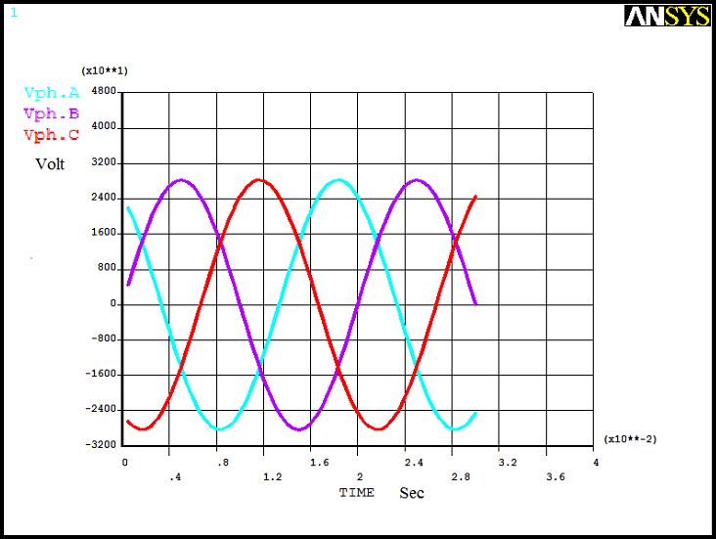

a) Input voltage waveform.

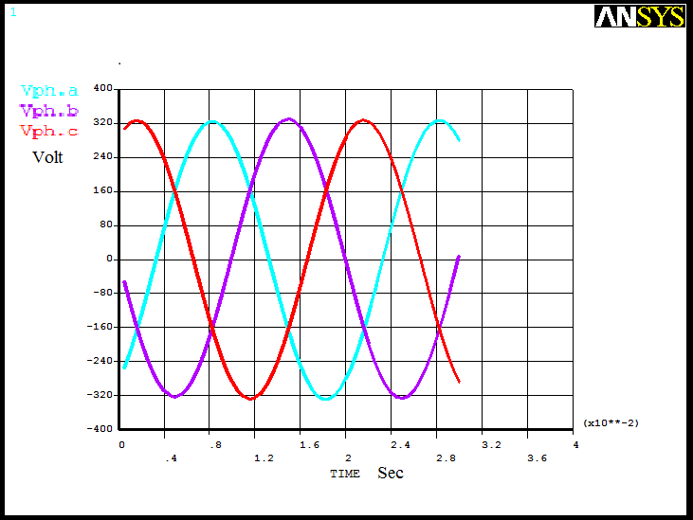

b) Output voltage waveform.

**Fig. (18):** waveforms of input and output voltages.

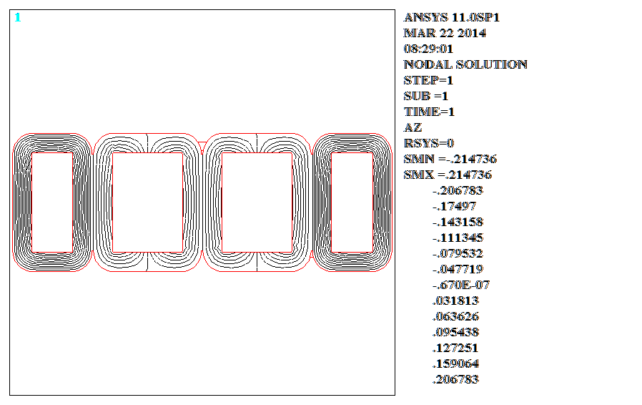

**Fig. (19):** Zero sequence flux lines distribution in iron core.

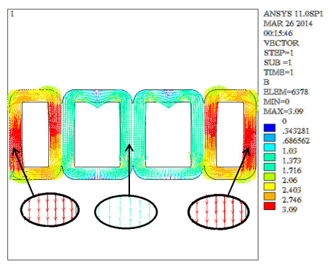

**Fig. (20):** Zero sequence flux density vectors distribution in iron core.

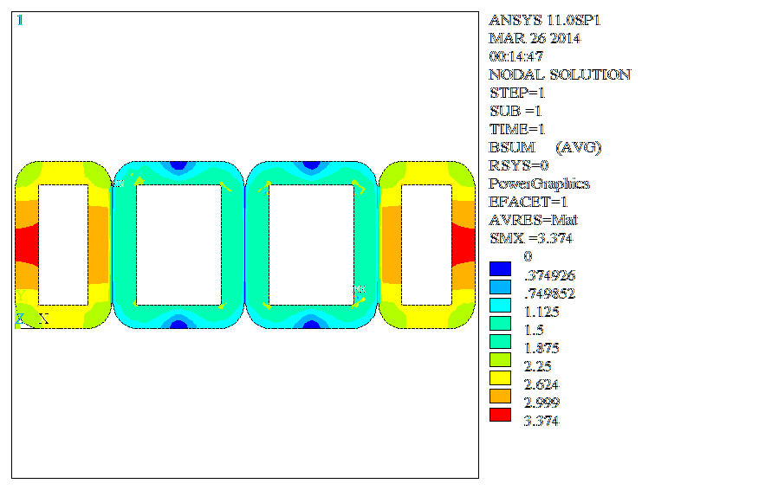

**Fig. (21):** Contour plot of zero sequence flux density distribution in iron core.

**Fig. (22):** Illustrated the distribution of magnetic flux along the center line of the thickness of wound core parts (outside parts and internal parts).

**Fig. (23):** Illustrated the distribution of magnetic flux along the center line of X direction (length of core) at yoke region.

**Fig. (24):** Illustrated the distribution of magnetic flux at width of yoke region (Y axis) region.

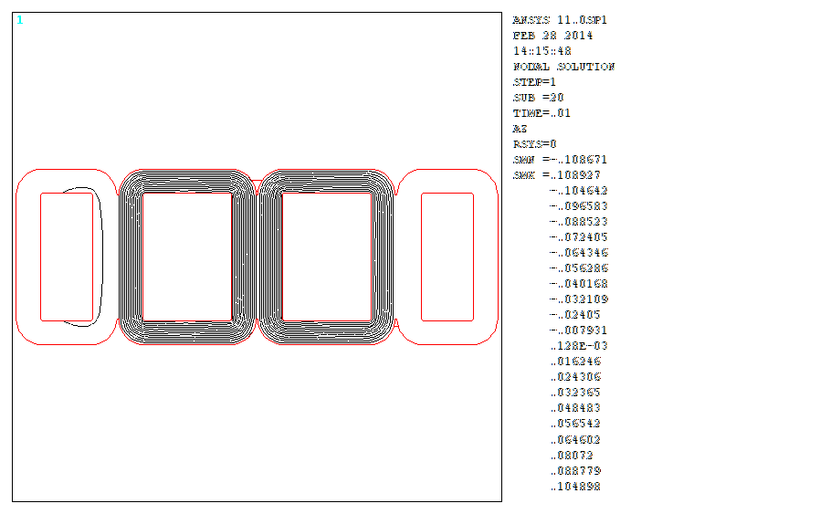

**Fig. (25):** Illustrates the distribution of magnetic flux in core at balanced condition.

**نمذجة محول تأريض ذات التوصيل النجمة المتداخل لحساب الممانعة الصفرية باستخدام طريقة العنصر المحدود**

**قاسم رشيد حميد**

مدرس / قسم الهندسة الكهربائية / الجامعة المستنصرية

**الخلاصة**

تعتبر محول التأريض واحدة من أهم العناصر في نظام القدرة الكهربائية. في هذا البحث يقدم وصف لنموذجة محول تأريض ذو القلب الحديدي الملفوف ذات توصيل النجمة المتداخل (zigzag ) وبدقة عالية للشكل الهندسي المعقد. ان أنموذج (موديل) محول التأريص ذات التوصيل النجمة المتداخل تم بنائه باستخدام برمجية (ANSYS ).

ان طريقة التحليل العددي المعتمدة على تقنية العنصر المحدود استخدمت لحساب الممانعة الصفرية لمحول التأريض.

ان التحليل تم أجرائه على أنموذج ثنائي الأبعاد لمحول التأريض وحل باستعمال صياغة الجهد المغناطيسي المتجه. ان الغرض الاساسي من هذا البحث هو بناء أنموذج لمحول التأريض ذو القلب الحديدي الملفوف ذات التوصيل النجمة المتداخل بطريقة العنصر المحدود ثنائي الابعاد بسعة (100KVA الى 1000 KVA) وان تقنية العنصر المحدود استخدمت في تحليل المجال المغناطيسي لتحديد توزيع الفيض المغناطيسي في القلب الحديدي والملفات. نوعان من التحليل تم استخدامها تتضمن التحليل الساكن والتحليل العابر, وان التحليل العابر في هذا العمل تم أجراء محاكاة للمحول من خلال تعشيق الكهربائي بين أنموذج المحول والدائرة الكهربائية الخارجية (مصدر جهد كهربائي). ان نتائج المحاكاة برهنت ان التحليل ذو صلاحية صائبة وان قيم الممانعة الصفرية لمحول التأريض تم تحقق منها بمقارنتها مع القيم العملية المقاسة في مصنع محولات ديالى المصنع لتلك المحول .وكانت قيم الممانعة الصفرية متفق بشكل جيد ودقيق مع القيم العملية. لذا ان استخدام أنموذج محول التأريض هذا يساعدنا على معرفة سلوك محول التأريض قبل تصنيعه وهذا يوفر وقت وجهد.