ISSN 1999-8716
Diyala Journal
of Engineering Sciences
Printed in Iraq

Vol. 08, No. 03, pp. 88-99, September 2015

EFFECT OF CATHODIC PROTECTION ON COATING STEEL PIPELINE IN SALINE ENVIRONMENT

Naser Korde Zedin
Assistant Lecturer, Production Eng. & Metallurgy Department, University of Technology
Naserkorde_56@yahoo.com
(Received: 13/07/2014; Accepted: 22/10/2014)

ABSTRACT: - There are two main types of cathodic protection systems: galvanic and impressed current. In this research, the effect of coatings on impressed current cathodic protection was studied. The selection of coating process for a specific application depends on several factors including the corrosion resistance that are required, the anticipated lifetime of the coated material and environmental considerations. When using cathodic protection on coated pipelines, the problems that exist if the coating disbands (loses adhesion) must be considered. Many in the oil steel pipeline industry assume cathodic protection will solve their external corrosion problems without truly understanding the relationship between the epoxy-coating and cathodic protection. Most external corrosion on oil steel pipelines is caused by disbanded epoxy-coating that shield cathodic protection. This paper will discuss the differences in cathodic protection of oil steel pipeline that coating and not coating and how cathodic protection works with these coatings (wear used epoxy (G-5470), (G-5471) and (G-5472), three types component epoxy system resistance to acid and chemical from modern paints industrials Company (in Iraq)). The aqueous corrosion properties of the coated samples in 3.5 wt % NaCl solution were studied by Tafel extrapolation measurements.
Keywords: Cathodic Protection (CP), Epoxy-coating, Corrosion Current Density (I_{corr}), Corrosion Potential E_{corr}, Tafel Extrapolation.

1. INTRODUCTION
Steel Pipelines play an extremely important role in the world as means of transporting gases and liquids over long distances from their sources to the ultimate consumers. Steel Pipelines suffer from corrosion, cracking and other problems. One of the problems face the oil steel pipeline is that most external corrosion of steel pipelines is caused by disbanded coatings which shield cathodic protection CP, because cathodic protection CP is effective when there is a route to the pipe structure ⁽¹⁾.
It is widely accepted that the application of cathodic protection to a bare structure requires large amount of cathodic protection current which is very expensive. At the same time coating on its own cannot provide full protection as it usually contain pin holes, pores, and defects resulted from the application process, transportation and mechanical damages ^{(1,2)}.
Corrosion protection of steel underground pipelines is one of the most important methods to prolong their efficient service. The reliability of the corrosion protection of steel underground pipelines depends upon the service life of the protective coatings (PC) and the Efficiency of Electrochemical Protection (ECP) ⁽²⁾.
Every coating system has finite life and eventually degrades, allowing oxygen, water, and chemicals to reach the substrate. Increasing Cathodic Protection (CP) is often considered as the best or only solution to prevent corrosion on a pipeline with poor or disbanded coatings. Increasing the cathodic protection CP may help to meet certain criteria and protect pipe exposed to the electrolyte, but it does not always protect the pipe under many types of disbanded coatings, therefore corrosion will continue unless these coatings are replaced⁽³⁾. Due to human and mechanical factors combined with long term effects of water, stress and corrosive medium in soil, coating defects such as disband, blister, etc. inevitably occur on the coating surface of oil steel pipelines underground. The category and size of the coating defects greatly influence the corrosion laws and cathodic protection effectiveness ⁾⁴⁽.
Coatings are often used in conjunction with impressed current cathodic protection (ICCP) systems to minimize the effect of corrosion on oil steel pipeline. In general, the a coating reduces the current required by an impressed current cathodic protection (ICCP) system, When corrosion does occur on the outside of the oil steel pipelines, the combination of general and localized corrosion with the high stresses in the pressurized pipelines can sometimes lead to stress corrosion cracking (SCC)⁾⁵⁽
2. CORROSION RATE (POLARIZATION TECHNIQUE)
External corrosion of steel pipelines is usually controlled by the application of various coatings augmented with cathodic protection (CP) ⁽⁵⁾. Each coating manufacturer attempts to make coatings that will not fail. The problem is all pipeline coatings fail and disband for various reasons.
Most failures occur cause of poor surface preparation, application technique, soil stress or selection of the wrong coating for the environment. However, all coatings experience disbandment and, therefore, the behavior of a disbanded coating is important in the overall performance of a coating system ⁽³⁾.
The exchange current densities of anodic and cathodic reactions are derived from the measured polarization curve in Figure (1) through the Tafel extrapolation method ^{(5, 6, 7)}. The general equations applied for determined of corrosion rate by current density in solution on the steel during electrochemical reactions are ⁽⁸⁾:
Corrosion rate (mpy) =0.13× I_{corr.} . e/D (1)
Where:
I_{corr} : Corrosion current density μA/cm².
e :Equivalent weight (for steel =25.5).
D: Density of metal (for steel =7.9 gm/ cm³).
3. EXPERIMENTAL METHODS
3.1 MATERIALS
High strength steel pipeline were used in this study was analyzed by the Specialized Institution of Engineering Industries-Baghdad. Their chemical compositions are shown in Table (1). The sample with an effective surface area of 2.25 cm² was covered by epoxy resin first.
3.2 SURFACE PREPARATION
Surface preparation is the most important step in the application of any coating, in this work, the specimens cut from the oil steel pipeline, the cutting achieved by cutting machine; it's taken from the Iraqi Oil Pipelines Company / Ministry of Oil. were The specimens prepared for coating by Mounting process with dimensions of the specimen were (1.5cm length and 1.5cm width) as shown as Figure (2), Grinding process, was carried out by using disk rotary instrument with different grades of emery papers (SiC) in sequence of (120, 180, 220, 320, 500, 800, 1000, and 1200) grit to get facing free surface.
The specimens were washed with water and alcohol and dried in the air, polished process was carried out by using special polishing cloth and alumina (Al₂O₃) solution of grain size of (0.3µm), Etching process was done by immersing the each sample in etching solution which consists of (3-5%HNO₃ and 95-97% alcohol) for (30) seconds, and Examination process by using optical microscope provided (Type, Nikon.120, Japan) with digital camera and computer.
3.3 ELECTROCHEMICAL TESTING
An electrochemical corrosion test was carried out by the potentio-dynamic anodic polarization using Potentiostat Galvanostat instrument according to the ASTM Standard G-5⁽⁹⁾. All of the electrochemical corrosion tests were performed using three-electrode electrochemical probes with electrodes made of the same material and surface area.
The first electrode was used as the working electrode, the second as the auxiliary electrode, and the third as the reference electrode. For the tests, working electrodes were made from Low Carbon Steel (AISI 1012), The reference electrode was an Ag/AgCl electrode and Auxiliary Electrode (is Rod from Platinum electrode of 10–25 mm diameter) are used in seawater .To construct the corrosion cell, three electrodes were place in an electrochemical cell with 1000 ml of 3.5%NaCl solution (Distilled water was used to prepare sodium chloride solution, the NaCl solution were taken according to the Iraqi soil which was equivalent with NaCl solution), at 25ºC and connected with Potentiostat device (Wenking LT87-Germany) as shown in Figure (3). While epoxy-coating sprayed coatings give excellent protection in themselves to steel pipeline, the metal surface is very reactive becomes good appearance due to the formation of products. Galvanized steel gives a smooth surface and is therefore not an ideal base for painting and it is normal to use an etch primer to give the necessary adhesion. The etch primer is usually based on a butyral resin and free phosphoric acid, and it leaves the epoxy-coating surface with a thin inhibitive film. In this search, three type of epoxy were used .Three component epoxy system resistance to acid and chemical from modern paints industrials Company (Mpi) (in Iraq), the coating thickness measured by using microscope type (Nikon Eclipse ME600) made in japan with digital camera type (DXMI 200F), available in the Ministry of Science and Technology, the coat type that using in this study is consist from three layers, as shown in Table (2). Is consists of:
- 1st primer (G-5470), epoxy primer is using as a primer coat on metal surface it has a high resistance to water weather chemical and mechanically resistant.
- Inter mediate primer (G-5471), this paint is mechanically and chemical resistant weather and water proof intermediate coat which applied on metal surfaces.
- Top coat (D-5472), this paint is highly weather and water proof coat and provides iron structures of any type.
After finding corrosion rates without coating and with coating the efficiency of coating (η Ca.) can be determined depending on the formula:-

η _{Ca.} $=\frac{Corrosion Rate without Ca.-Corrosion Rate with Ca.}{Corrosion Rate without Ca.} X 100$ (2)

4- RESULTS AND DISCUSSION
4-1 ELECTROCHEMICAL ASPECTS OF COATINGS
The open-circuit potential measurements provide good information about the starting of polarization curves. The polarization tests were achieved in 3.5 wt% NaCl solution for all samples: bare and coated with epoxy-coating, also bear with cathodic protection and coated epoxy-coating with cathodic protection. The potential – Log current density plots obtained for polarization of different samples in these solutions are shown in Figure (4). Corrosion current densities (I_{corr}) and corrosion potential E_{corr} are calculated by Tafel extrapolation method. All the values of corrosion parameters are shown in Table (3).
All coating applied by brush, roller, spray, not apply the primer at temperatures below 12ºC. The porosity have negative effects for all conditions, as the porosity increases the pitting corrosion resistance decreases. The porosity increases the tendency to general corrosion much higher for bare specimens compared to epoxy-coating specimens. From Table (3) (No.1 and 2) and Figure (4), the highest corrosion current density occurs in bare specimens that tested in (3.5%NaCl) solution, reaching to (9.157x10⁻¹µA/cm²), while the corrosion current density decreases to (4.005x10⁻²µA/cm²) for epoxy-coating specimens. As the porosity increases the corrosion current density increases also. Table (3) (No.3 and 4) shows that both coated and uncoated samples with cathodic protection have lower I_{corr}, E_{corr}, I_{app} values in (3.5%NaCl) solution. There are main reason why epoxy-coating is chosen as a protective coating for iron and steel. The first is the natural resistance of epoxy-coating itself against corrosion in most atmospheric conditions, and the second is the fact that epoxy-coating barrier protection (or barrier effect) provides barrier between all internal steel and their environment, the results shown its as Figure (5). Moreover, the corrosion product of the epoxy-coating normally fills the break and prevents or retards further corrosion of the exposed steel ⁽¹⁰⁾.
4-2 MICROSCOPIC ASPECTS OF COATINGS
Microscopic examinations of the steel pipeline show the substrate and layers of coating Epoxy (G-5470), (G-5471) & (D-5472) as it’s shown in Figure (6).
The electrochemical behavior of coated steel pipeline with the three layers Coating thickness 90 µm type(G-5470), (G-5471), and (G-5472) in concentration of NaCl 3.5% wt as shown Figure (4) and Figure (5), This Figures is showed the polarization curves of steel pipeline in above solution. Table (3) included the values of potential corrosion and current corrosion. The results illustrated that epoxy-coating specimens have high pitting corrosion resistance than bare specimens. The tendency to pitting corrosion for specimens in all conditions of the surface increases with the porosity increases. The results of I_{corr} for all conditions indicated that the epoxy-coating with cathodic protection will be improved the pitting corrosion resistance (were I_{corr=} 1.060x10⁻⁴ µA/cm²), but pitting corrosion resistance will be decreased at the epoxy-coating without cathodic protection (were I_{corr}= 4.005x10⁻²µA/cm²). The epoxy-coating presence cathodic protection exhibit better corrosion resistance (were efficiency 97.3%) than epoxy-coating absence cathodic (were efficiency 95.5%) with the same coating thickness, as showing in Figure (7).
Laboratory studies have shown that electrochemistry-based corrosion rate can be used to monitor the corrosion of steel pipeline in soil (that equivalent 3.5% NaCl solution). Corrosion rates were shown to that epoxy-coating can be used to decreasing the effectiveness the corrosion of steel pipelines. While there are a variety of electrochemical techniques that can be used to measure the corrosion rates of metals in soils, the effect cathodic protection will have on the corrosion rate measurements is unknown^{(11,12)}. The purpose of the research reported here is to verify the effect of coating on steel pipeline under applied cathodic protection and without applied cathodic protection. The coatings component with cathodic protection CP have shown promising results and may play an important role in increased of corrosion resistant on steel pipeline surface.

5. CONCLUSIONS
From the presented results it may be concluded:
•The performance of the CP at the coating was better than application CP without coating due to the corrosion of exposed areas with the coating film can be prevented by applying cathodic protection.
• Tafel extrapolation is an effective technique for evaluating the protective properties of the coating with and without the application of CP. Evolution of impedance corrosion current densities (I_{corr}) and corrosion potential E_{corr} clearly illustrated the effects of CP.
•Cathodic protection by (ICCP) at (I_{app}) 150.0x10⁻²µA/cm² severely affected the protective properties of the coating and CP on steel pipeline that causing the high corrosion resistance.

REFERENCES:
- Elsadig O. Eltai, J. D. Scantlebury, E.V. Koroleva, “The effects of zinc ions on the performance of epoxy coated mild steel under cathodic protection (CP)”, Elsevier, Progress in Organic Coatings 76 (2013) 548– 554, 2012.
- N. P. Glazov, “Peculiarities of the Corrosion Protection of Steel Underground Pipelines”, Protection of Metals, Vol. 40, No. 5, 2004, pp. 468–473.
- Richard Norsworthy Polyguard Products, Inc “coatings used in conjunction with cathodic protection shielding vs. non-shielding pipeline coatings” NACE, international, 2009.
- R. R. Pierre, “Handbook of Corrosion Engineering” Copyright © 2000 by the McGraw-Hill Companies, Inc.
- Sophie J. Bullard, Bernard S. Covino, Jr., Stephen D. Cramer Gordon R. Holcomb, and Małgorzata Ziomek-Moroz “soil corrosion monitoring near a pipeline under CP”, Albany Research Center, U.S. Department of Energy, 2005.
- L.L. Shreir and R.A. Jarman, “corrosion metal environment reactions” Volume I, planta tree, 1994.
- L.Y. Xu, Y.F. Cheng, “Experimental and numerical studies of effectiveness of cathodic protection at corrosion defects on pipelines”, Corrosion Science 78 (2014) 162–171.
- M. A. Sadeq, thesis “Corrosion Behavior of Biocompatible Coatings of Porous NiTi Shape Memory Alloy”, University of Technology Production Engineering and Metallurgy Department, 2013.
- Y. Lietai , “Techniques for corrosion monitoring” © 2008, Wood head Publishing Limited
- L.L. Shreir and R.A. Jarman, “Corrosion Control” Volume 2, planta tree, 1994.
- M.A. Alodan, F. Abdulaleem “Pipeline Corrosion in Soil” Research Center - College of Engineering, 2007.
- Z. Iqbala, I. Hussain, A. Rauf, M. Zakaullal, Syed Tajammul Hussain, and A ul Haq “Corrosion Protection of Commercial Steel Using Stainless Steel Coatings Deposited by Cathodic Arc Plasma Deposition Technique”, Protection of Metals and Physical Chemistry of Surfaces, 2012, Vol. 48, No. 3, pp. 371–375.

Table (1): Chemical compositions of the steels used in the tests (wt. %).
components C Si Mn Cr Ni Mo S P Fe
Steel pipeline 0.14 0.12 0.45 0.017 – 0.011 0.05 0.01 Balance

Table (2): General properties for epoxy that use in coating oil steel pipeline.
Property | Base | Thinner | Spreading rate | Film thickness | Colour
G-5470 | Epoxy resin | Thinner p-851\Mpi | 9m²\L | 35µm | Red brown
G-5471 | Epoxy resin | Thinner p-851\Mpi | 9m²\L | 30µm | Grey
D-5472 | Epoxy resin | Thinner p-851\Mpi | 7m²\L | 25µm | All uni colour

Table (3): Electrochemical Result the Corrosion of bare and epoxy Coated Steel pipeline in 3.5wt% NaCl Environment.
No. | State | Coating Type | O.C.P Mv | I_{app}, µA/cm² | E_{corr}, V | I_{corr}, µA/cm² | C.R, mpy
1 | absence of cathodic protection | Uncoated | -283 | - | –584 | 9.157x10⁻¹ | 3.8x10⁻¹
2 |  | Epoxy(90µm) | -185 | - | –286 | 4.005x10⁻² | 1.7x10⁻²
3 | presence cathodic protection | Uncoated | -169 | 150.0x10⁻² | –498 | 4.042x10⁻³ | 1.69x10⁻³
4 |  | epoxy(90µ) | -97 | 150.0x10⁻² | –175 | 1.060x10⁻⁴ | 4.45x10⁻⁵
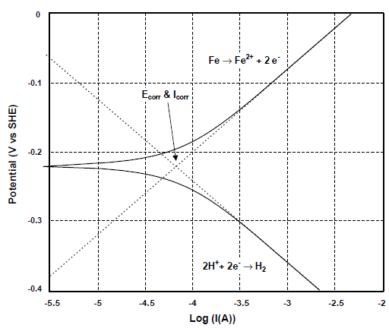

Figure: (1): The polarization curve for the iron at 25°C ⁽⁴⁾.

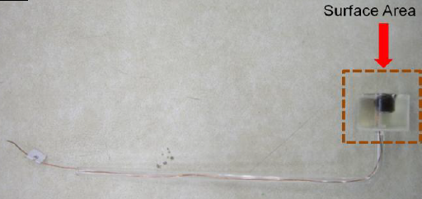
Figure (2): Photograph of Working Electrode (specimen) with Mounting and Connection of Specimen to Copper Wire.

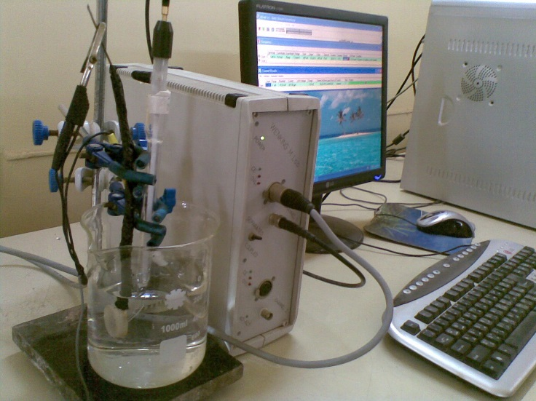

Figure (3): Potentiostat (Wenking LT87-Germany) 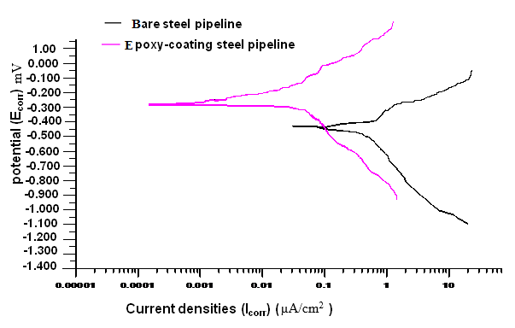
Figure (4): Polarization curves for samples in (3.5% NaCl) solution for un-coated and coated steel pipeline at 25ºC in absence of cathodic protection.

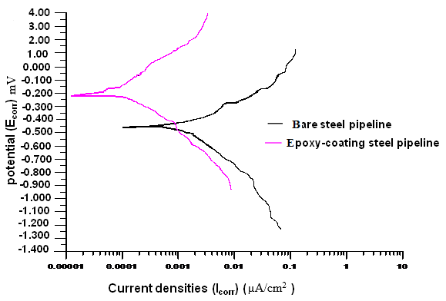
Figure (5): Polarization curves for samples having 3.5% NaCl for un-coated and coated steel pipeline at 25ºC, in presence cathodic protection.

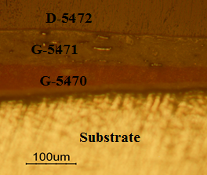
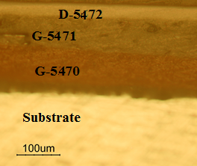
- (b)
Figure (6): Optical micrographs of the microstructures of the Substrate (LCS) Coating by Three Layers of Epoxy (G-5470), (G-5471) & (D-5472), (a) epoxy-coating presence CP (b) epoxy-coating absence CP.

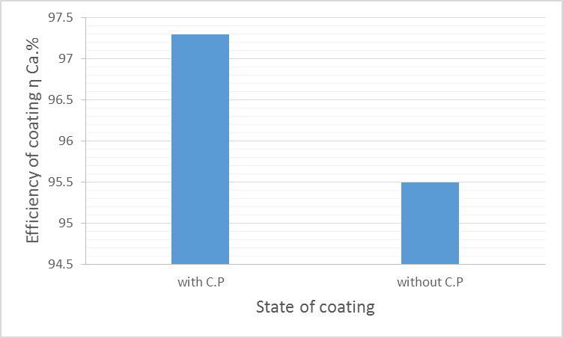
Figure (7): The efficiency of epoxy-coating presence and absence cathodic protection for steel pipeline, in 3.5% NaCl , at 25ºC.

تأثير الحماية الكاثودية على الأنابيب الفولاذية المطلية في البيئة الساكنة
ناصر كردي زيدان
مدرس مساعد، قسم هندسة الانتاج والمعادن، الجامعة التكنولوجية
الخلاصة
يوجد نوعين رئيسيين من أنظمة الحماية الكاثودية : الحماية الكاثودية بالعنصر المضحي والثانية هي الحماية الكاثودية بالتيار المسلط . في هذا البحث يتم دراسة تأثير الطلاء على الحماية الكاثودية باستخدام التيار المسلط على الأنابيب الفولاذية الناقلة للنفط . أن اختيار عملية طلاء في اغلب التطبيقات يعتمد على عدة عوامل ، بما في ذلك مقاومة المعدن للتآكل، ومقدار عمر الطلاء للمعدن المراد حمايته والظروف البيئية المحيطة بالمعدن المراد حمايته .
ان استخدام الحماية الكاثودية على خطوط الأنابيب الفولاذية المطلية ، يجب أن يؤخذ بنظر الاعتبار المشاكل القائمة فيما إذا كان الطلاء متمزق او غير متلاصق ,ومعظم التآكل الخارجي لخطوط الأنابيب الفولاذية المطلية والناقلة للنفط هو يحدث بسبب فشل في الطلاء الخارجي للأنابيب الفولاذية المطلية ويودي في النهاية إلى حدوث فشل كإرثي للأنابيب.
وأكثر البحوث المستخدمة في الصناعة تفترض بأن الحماية الكاثودية على خطوط الأنابيب الفولاذية تحل مشاكل التآكل الخارجي للأنابيب الفولاذية بدون محاولة لفهم العلاقة بين الطلاء والحماية الكاثودية نفسها.
وسيناقش هذه البحث دراسة الاختلافات في حماية الأنابيب الفولاذية الناقلة للنفط والتي تكون مطلية وأخرى عارية ودراسة هذه الطلاءات (الطلاءات المستخدمة (G-5470) و (G-5471) و(G-5472) من النوع المركب والمقاوم للتفاعلات الكيميائية والحوامض, حيث أخذت من شركة الأصباغ الحديثة العراقية) وتأثيرها على الحماية الكاثودية , وتم العمل بمحلول(3.5 wt % NaCl) ودراسة سلوك التآكل باستخدام طريقة استكمال منحني تافل.

