ISSN 1999-8716

**Diyala Journal**

**of Engineering Sciences**

Printed in Iraq

Vol. 08, No. 03, pp. 124-138, September 2015

**HYBRID PV/WIND/BATTERY/DIESEL GENERATOR ENERGY SYSTEM FOR HYDERABAD CITY, PAKISTAN**

Husham Idan Hussein 1, Ahmed Majeed Ghadhban 2

Engineering College, University of Diyala

Hh_hh200018@yahoo.com1, Asm725@yahoo.com2

(Received: 2/2/2014; Accepted: 17/11/2014)

**ABSTRACT:-**Through this paper, the optimized cost was estimated to develop a new hybrid system contains a combination of various alternative energy resources. Designing any new project requires an estimation for the minimum amount of money required for initiating it as well as the cost of operations when it is in running process. For any electric power project, the cost of electricity is very significant because it totally affects the end user or the consumer. By using HOMER simulator, these parameters were analyzed. The project was implemented in Hyderabad City, located in southern Pakistan. This city is gifted many natural resources that can produce a considerable amount of power energy for the region. This paper, highlights the average amount of all these resources that can be achieved throughout the year.

**Keyword**: Renewable Energy, Load Cast Management, Optimization Load Forecasting, Solar energy, and Wind energy.

1. **INTRODUCTION**

The increasing demand for energy, the continuous reduction of natural resources of fossil fuels and the growing concern regarding the environment pollution.(1) Determined the mankind to explore new production technologies of electrical power using non-polluting renewable sources, such as wind energy, solar energy, sea waves energy, biomass etc.(2) The renewable energy sources bear a huge potential of conversion electricity, presumably ensuring in the future a large share of all the electric power need of the planet. Among the electric power technologies using renewable sources, those based on the conversion of solar and wind energy are clean, silent and reliable, with reduced maintenance costs, and small ecological impact.(3)

The sunlight and the kinetic energy of the winds are for free, practically inexhaustible, involving no polluting residues or greenhouse gas emission. Along with these advantages, the electric power production systems using as primary sources exclusively the solar and wind energy, pose technical problems due to the uncontrollable wind speed fluctuations and due to day – night and summer – winter alternation. As a consequence, in an independent administration, the power supply stability of a local grid should be doubled by other reliable and unfluctuating sources of primary energy. (4) Such systems, dedicated to decentralize production of electric power based on the combined sources of primary energy, called hybrid systems, make the object of this paper.

The operation principle of the hybrid system proposed in this paper, Figure (1) is based on the fact that in many situations the solar and wind energy potential complements naturally each other, the parallel operation of the PV/Wind/Battery/Diesel systems determining a higher efficiency than in separate operation case. By combining several renewable energy sources (PV/Wind/Battery/Diesel), the proposed hybrid system may ensure an increased reliability of the electric power supply delivered to the consumers, at optimum quality parameters. Hybrid systems may ensure the electric power supply of a household and also other types of consumers, such as telecommunication equipment, isolated military objectives, irrigation systems, etc.

1. **CASE STUDY:- Hyderabad City**

This region is located southern province of Pakistan. It is built beside the Indus River which gets winds all across the year due to water streaming. Most importantly, it opened to its western south side that is very clear to Sea. So huge speedy wind flows throughout all seasons starting from spring to autumn (March-November). It’s also known as a windy city in the country. Along with that this region represents one of the hottest cities in Pakistan. It receives bright sun light beams all the year. Wind and solar energies are the possible clean and low cost renewable resources available in the country. The potential, for the use of alternative technologies, has not previously been fully explored in Pakistan. (4) Wind power provides opportunity to reduce dependence on imported fossil fuel and at the same time expands the power supply capacity to remote locations where grid expansion is not practical as showed in Figure (2).

Recently conducted survey of Wind Power Potential along coastal areas of the country by the Pakistan Meteorological Department (PMD), indicates that a potential exists for harvesting wind energy using currently available technologies, especially along Sindh Coast.(5) Gharo (Near Hyderabad City), as shown in Figure (3), one of the sites in Sindh where the wind data have been recorded and studied by PMD, has been selected for using the measured wind data the annual gross energy production an 18 MW wind farm consisting of thirty – 600 kW turbines will be 45 million kWh.(7)

Pakistan is fortunate to have something many other countries do not, which is high wind speeds near major centers. Near Islamabad, the wind speed is anywhere from 6.2 to 7.4 meters per second (between 13.8 and 16.5 miles per hour). Near Karachi, the range is between 6.2 and 6.9 (between 13.8 and 15.4 miles per hour). So to target this issue, we have designed a system that will utilize these alternative energies to produce electricity to cover a 50 home loads of about 830 Kilo Watt per day. It’s a huge amount of energy that will be generated by wind and solar with some economical energy generation equipment that is Diesel Generator along with some batteries as backup. (6)

1. **METHODOLOGY**

First of all, we will go through some load calculations to estimate the overall power consumption for a 50 home town with normal electrical appliances was done. Town also is under a primary & High School (College), a shopping market and a praying mosque. All the appliances power ratings were considered to estimate peak voltages during a day as well as the total load for 24 hours as showed in Tables (1-5). Later meteorological information about the region were obtained to estimate the wind and sun radiation values. Finally by using simulation software “Homer”, the optimum values for Initial cost for the System, cost of operation for overall project life and Cost of Energy (COE) for 1 kWh. were calculated.

**3.1- TOWN LOAD ESTIMATIONS**

The following load values are expected to have for all Town which may reach to an approximated about 170 kW for all appliances. But definitely all appliances can’t run at the same time. So to avoid of this issue a scheduled has been designed which can control the load balance between, all homes, as well other parts of the town The load schedule is given Table(6)(11).

1. **EQUIPMENTS AND THEIR CAPACITY**

**4.1- WIND TURBINE**

The wind turbine has a capacity of 10 kW. Its initial cost is US$ 10,000. Annual operation and maintenance (O&M) cost is US$100. Its hub and anemometer is located at 12 meter height. The turbine is estimated to last the project. The monthly wind speed is as shown in Figure (4).

From the data of Table (7) it is clear that this region is capable of producing high amount of electricity for the country. From start to end of the year, there is no wind issue. Minimum wind pressure can be found during winter and spring season from November to January.

Fluctuation in the graph shows in Figure (5) that there is certain change in wind speed on daily basis (7). This is an expected Wind speed graph for January which is considered to be very low wind month for this region. Power output Pm from a Wind Turbine Generator (WTG) is determined by (1). (8)

…………………... (1)

Where ρ is air density, A is rotor swept area, Vω is wind speed, and $Cp\left(λβ\right)$ is the power coefficient, which is the function of tip speed ratio α and pitch angle (8).

**4.2- SOLAR PV PANELS**

There are 3 PV panels with each has a capacity of 250 Watt. The initial cost of the panels is US$ 9600 for 3 panels. The lifetime of the panels will last the project. Monthly clearness index and daily radiation is as shown in Table (8).

This data is accumulated by HOMER database which retrieves all regional information from NASA. From the Table (8) we can see that this region is mostly sunny and hot. Temperature rises up to 52 degree Celsius in during summer season. So this is an ideal place to use solar energy for electricity production as shown in Figure (6). Same like the previous Wind speed, this region has solar radiation lower values during November to January. While remaining all months have very bright radiations. During November to January temperature go very low even some times below at 0 degree Celsius. During this time regions mostly covered with clouds hence can make a decrease in electric generation. The current output of the PV panel is modeled by the following three equations (2-3- 4) (8).

… (2)

………………………….......... (3)

…………........... (4)

Where

**Iph** photocurrent, **np** Number of cells in parallel, **ns** Number of cells in series, **Isat** module reverse saturation current, **q** electron charge, **A** Ideality factor, **K** boltzman constant, **T** surface temperature of the PV, **Tr** reference temperature, **Irr** reverse saturation current at Tr, **Rs** series resistance of a PV cell, **Isso** short circuit current, **Ki** SC current temperature coefficient, and **Egap** energy of band gap for silicon.

**4.3- DIESEL GENERATOR**

The two AC Diesel generators have a capacity of 30 and 10 kW. Its initial capital cost is US$ 30,000 and US$ 10,000 accordingly. The operation and maintenance is US$ 0.34/hour for each. The lifetime of both the generator is estimated at 15000 operating hours. Diesel is priced at US$ 0.78 per liter. It is expected that generator will cover all the project life time (9).

**4.4- BATTERY AND INVERTER**

Acker Drill Company’s CS-100 lead acid battery is rates at 12 V and has a capacity 200 Ah. Four batteries initially cost US$ 1600. The operation and maintenance cost add further US$ 20 to the total cost annually. There are two important parameters to represent state of a battery are terminal voltage Vb and state of charge (SOC) by following equations (5-6):

$Vb=Vo+Rb.ib-K\frac{Q}{Q+\int{ib dt}}+A.exp⁡(B \int{ib dt)}$…. (5)

$SOC=100(1+ \frac{\int{ib dt)}}{Q})$………………… (6)

Where Rb is Internal resistance of the battery, Vo is the open circuit voltage of the battery, ib is battery charging current, K is polarization voltage, Q is battery capacity, A is exponential voltage, B and is exponential capacity.

1. **HOMER SOFTWARE**

HOMER is a software application developed by the National Renewable Energy Laboratory in the United States. This software application is used to design and evaluate technically and financially the options for off-grid and on-grid power systems for remote, stand-alone and distributed generation applications. It allows you to consider a large number of technology options to account for energy resource availability and other variables. HOMER is one of the tools used for designing renewable energy base stations (10).

1. **SIMULATION BY HOMER**

After putting all raw materials to HOMER we got different optimum values that can be carried out to develop this system. Optimum values can be chosen according to load as well as Cost per unit of the electricity. Figure (7) shows a design of the propose generator system.

A daily load profile for the town during 24 hours is given in figure (8). During working hours from 0900 to 1600 o'clock the load is balanced and seems to be constant. Later there is a load drop due to close at educational institutes for a certain time. But afterward load reaches to its peak values at dusk time. As during this time sunlight goes zero and definitely all the lights glow up. This is thought to be to be family time as every home will surely turn on their TVs. This load will get a decrease in when peoples start sleeping at about 2300 o'clock. The load reaches to its minimum during this time because all appliances are mostly assumed to be turned off after midnight except Fans. The same cycle starts from 5 o’clock as people wake up again for prayers as shown in the Figure (9).

Figure (10)shows a seasonal load profile for Town. You can see a certain fluctuation in load in different months. Load may increase during March to October as this region gets hot during these months so it should be expected to use all cooling appliances i.e. Fans and air coolers and freezers. In December and January temperature gets low therefore load will reach to its minimum value may be less than 30kWh. In Figure (12) shows the flow chart of HOMER simulation design.

1. **DISCUSSION**

From beginning to end the bottom, for different combinations of systems, there is certainly change in the amount of money. But certainly a reliable will require more costly for its operation. A single Wind Turbine and a diesel generator will require a minimum amount to design this project, but due to high load this combination will not fulfill to produce the required electricity. Addition of PV array also affect the initial capital, but as its maintenance is very easy and does not require any additional source so it's good to get what energy it can produce. Use of battery will be more economical as it will be continuously providing a free energy and will need very little price for its operations. Second diesel generator cannot be avoided because it can be needed at any time when there is some reduction in wind and solar supply.

**CONCLUSION**

A computer approach is used in this simulation project. In figure (11), the simulation compares the cost of two energy supply systems (PV/WIND/BATTERY/DIESEL).The first case is the grid without the PV& Wind system installed. The result is comparable to the second case, a system with PV &Wind system installed. HOMER will perform the simulation, optimization, and analyses of several system configurations. it is that initial cost of the system as well as COE rate also rises when 2 diesel generators are used at the same time. While a single diesel generator can only operate in the case when there is no wind issue. But practically it should be kept in consideration that wind is natural and can’t be controlled so it is recommended to use two diesel generators that will work as a standby resource. The addition of the battery can also reduce the COE as it can provide a sufficient amount of electricity without having additional resource as it will be charged with the additional electricity than is not needed by the load.

**REFERENCES**

1. [Pillai, I. R.](http://libhub.sempertool.dk.tiger.sempertool.dk/libhub?func=search&query=au:%22Pillai,%20I.R.%22&language=en), [Banerjee. R,](http://libhub.sempertool.dk.tiger.sempertool.dk/libhub?func=search&query=au:%22Banerjee,%20R.%22&language=en) (2009), “[Renewable energy in India: Status and potential”](http://libhub.sempertool.dk.tiger.sempertool.dk/gmt/ivsl/elsevier/03605442_2009_34_8_970-980/S0360-5442%2808%2900292-2) Elsevier**,** Energy **Journal, Volume:** 34 **Issue**: 8 **Pages**: 970-980.
2. Arribas, L. Cano, L. Cruz, I. Mata, M. Et al. Llobet, E., (2010), “PV\wind hybrid system performance: A new approach and a case study”, Elsevier, Renewable Energy Journal, Volume 35 Issue: 1 Pages: 128-137.
3. [Ngan, M. S.](http://libhub.sempertool.dk.tiger.sempertool.dk/libhub?func=search&query=au:%22Ngan,%20M.S.%22&language=en), [Tan, C.W.](http://libhub.sempertool.dk.tiger.sempertool.dk/libhub?func=search&query=au:%22Tan,%20C.W.%22&language=en) (2012), “[Assessment of economic viability for PV/ wind/ diesel hybrid energy system in southern Peninsular Malaysia”](http://libhub.sempertool.dk.tiger.sempertool.dk/gmt/ivsl/elsevier/13640321_2012_16_1_634-647/S1364-0321%2811%2900438-2) Elsevier, Renewable and Sustainable Energy **Journal, Volume**: 16 **Issue**: 1 **Pages**: 634-647.
4. [Yang Qi](http://libhub.sempertool.dk.tiger.sempertool.dk/libhub?func=search&query=au:%22Yang%20Qi%22&language=en)., [Zhang Jianhua](http://libhub.sempertool.dk.tiger.sempertool.dk/libhub?func=search&query=au:%22Zhang%20Jianhua%22&language=en), [Liu Zifa](http://libhub.sempertool.dk.tiger.sempertool.dk/libhub?func=search&query=au:%22Liu%20Zifa%22&language=en), [Xia Shu](http://libhub.sempertool.dk.tiger.sempertool.dk/libhub?func=search&query=au:%22Xia%20Shu%22&language=en).(2008),”[A new methodology for optimizing the size of hybrid PV/wind system”,](http://libhub.sempertool.dk.tiger.sempertool.dk/gmt/ivsl/ieee/_2008___922-927/4723923/4746961/4747139/5/10.1109/ICSET.2008.4747139) IEEE International Conference on Sustainable Energy Technologies, 2008 **Pages**: 922-927.
5. *Keti Bander, Sindh*, “UNDP Off-Grid Wind Solar Hybrid Project” *-* Wind Energy Project Pakistan.
6. Tiberiu T., Alexandru M. (2008), “Optimum Design of Wind/Pv/Diesel/Batteries Hybrid System**”,**2nd International Conference on Modern Power Systems MPs, Cluj-Napoca, Romania.
7. Pakistan Meteorological Department, <http://www.pakmet.com.pk>.
8. Xiong Liu, Peng Wang, Poh Chiang Loh.2011 “A Hybrid AC/DC Micro grid and Its Coordination Control” IEEE TRANSACTIONS ON SMART GRID, VOL. 2, NO. 2. pp278-286.
9. Kshitij consultancy services, <http://www.kshitij.com/research/petrol.shtml>.
10. “HOMER user manual” ed. Golden, CO, USA: National Renewable Energy Laboratory (NREL), 2002.
11. Determine the electric load, http://tinyrevolution.us/2011/06/20/how-to-determine-the-electric-load/.

**Table (1):** For Each Home Individual Appliances and their Load.

|  |  |  |  |  |
| --- | --- | --- | --- | --- |
| Appliance Name | Quantity/home | Total Quantity | Power Ratings(W) | Total Power(W) |
| Tv | 1 | 50 | 150 | 7500 |
| Washing Machine | 1 | 50 | 1360 | 68000 |
| Freezer | 1 | 50 | 120 | 6000 |
| Saver Light | 5 | 250 | 24 | 6000 |
| Fan | 2 | 100 | 150 | 15000 |
| Laundry Iron | 1 | 50 | 1000 | 50000 |

**Table (2):** Common appliances for town.

|  |  |  |  |
| --- | --- | --- | --- |
| Appliance Name | Total Quantity | Power Ratings  (W) | Total Power  (W) |
| Electric Water Pump | 1 | 2000 | 2000 |
| Computers (Lab) | 20 | 90 | 1800 |
| Street Lights | 20 | 40 | 800 |

**Table (3):** Mosque.

|  |  |  |  |
| --- | --- | --- | --- |
| Appliance Name | Total Quantity | Power Ratings(W) | Total Power(W) |
| Fan | 10 | 150 | 1500 |
| Tube lights | 10 | 40 | 400 |

|  |  |  |  |
| --- | --- | --- | --- |
| Appliance Name | Total Quantity | Power Ratings(W) | Total Power(W) |
| Fan | 20 | 150 | 3000 |
| Saver Lights | 40 | 24 | 960 |
| Deep Freezers | 5 | 120 | 600 |

Table (4): Market

**Table (5):** Primary & high school.

ffff.png

**Table (6):** Load distribution schedule.

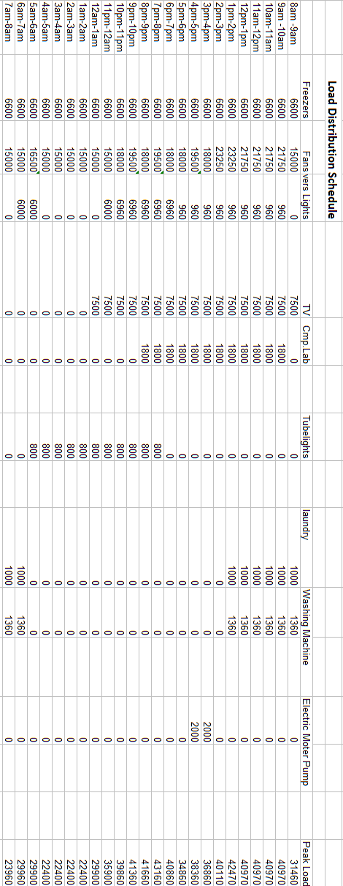

**Table (7):** Average Wind Speed for whole Year (7).

|  |  |
| --- | --- |
| Month | Wind Speed (m/s) |
| January | 3.61 |
| February | 4.17 |
| March | 4.17 |
| April | 5.0 |
| May | 8.05 |
| June | 6.9 |
| July | 7.5 |
| August | 9.44 |
| September | 6.66 |
| October | 4.17 |
| November | 3.89 |
| December | 3.055 |

**Table (8):**Average Solar Clearness and Radiation Values for whole Year (7).

|  |  |  |
| --- | --- | --- |
| Month | Clearness Index | Daily Radiation kWh/m2/d |
| January | 0.654 | 4.355 |
| February | 0.643 | 5.006 |
| March | 0.622 | 5.72 |
| April | 0.612 | 6.63 |
| May | 0.612 | 6.765 |
| June | 0.588 | 6.609 |
| July | 0.574 | 6.38 |
| August | 0.536 | 5.675 |
| September | 0.616 | 5.899 |
| October | 0.646 | 5.283 |
| November | 0.622 | 4.286 |
| December | 0.635 | 3.995 |

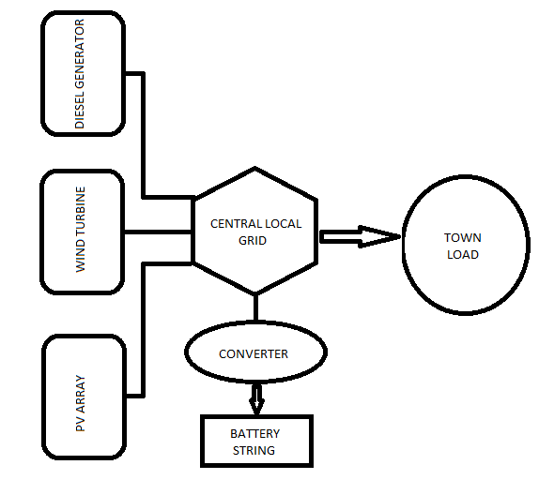

**Figure (1):** Hybrid PV/Wind/Battery/Diesel Energy System

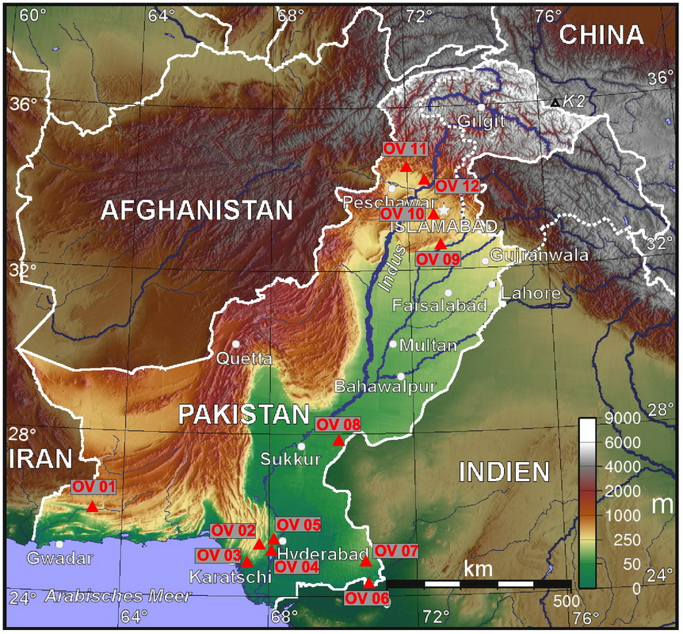

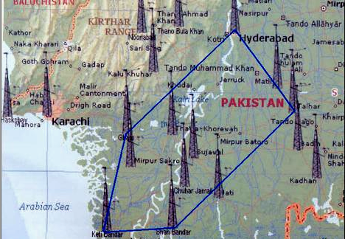**Figure (2):** Indus River Southern Province Of Pakistan (7).

**Figure (3):** Survey Area by Pakistan Meteorological Department (PMD) (7).

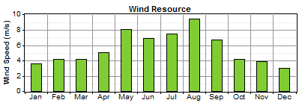

**Figure (4):** Average Wind Speed for whole Year (7).

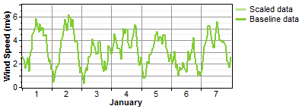

**Figure (5):** The Change in Wind Speed (7).

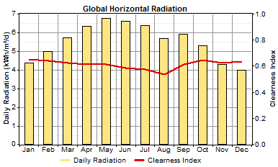

**Figure (6):** Global Horizontal Radiation (7).

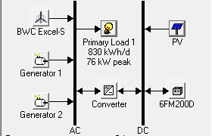

**Figure (7):** Hybrid Pv/Wind/Battery/Diesel Generator Energy System.

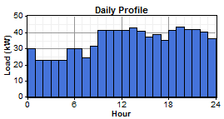

**Figure (8):** Daily Load Profile (7).

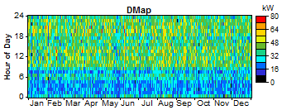

**Figure (9):** Load Variation Minimum to Peak for whole Year in KWh (7).

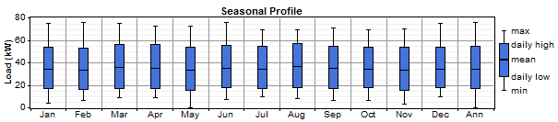

**Figure (10):** Average Load Values (7).

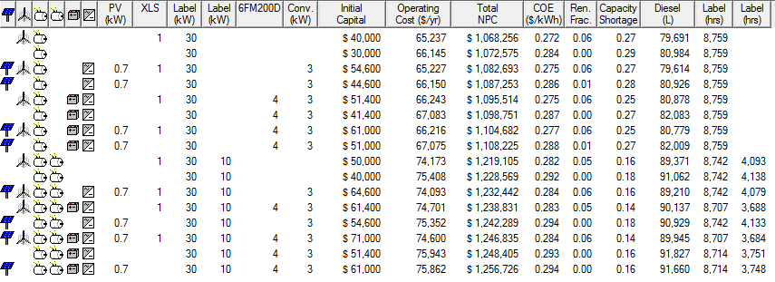

**Figure (11):** Optimum Values Generated By Homer (from HOMER Software).

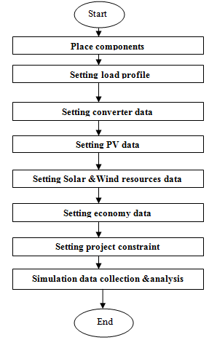

**Figure (12):** HOMER simulation design flow chart.

الخلايا الشمسية الهجينة / رياح / بطارية / نظام طاقة لمولّد ديزل لمدينةحيدر آباد،

باكستان

**هشام عيدان حسين كيطان، احمد مجيد غضبان حسين**

مدرس مساعد، قسم هندسة القدرة والمكائن الكهربائية، كلية الهندسة، جامعة ديالى

**الخلاصة :**

كلفة التشغيل تعتبر من اهم ركائز العمل لتطوير نظام القدرة الكهربائية .لتصميم نظام قدرة كهربائية جديد يعتمد على الطاقات البديلة من الخلايا الشمسية, والهواء, والبترول وكذلك على وحدة لخزن الطاقة الكهربائية متمثلة بالبطاريات كمصدر مساعد, تعتبر الكلف الكلية والتشغيلية من اهم العوامل التي تؤثر على المستهلك بشكل كامل. تقييم الكلفة الابتدائية وكلفة التشغيل للمشروع المقترح في هذا البحث تم حسابها بالاعتماد على برنامج هندسي (HOMER) متخصص في حساب الكلف لكل انواع الطاقات البديلة. هذا البحث اقترح نظام هجين يضم كل من(الخلايا الشمسية, والهواء, والبترول والبطاريات) على اساس بيانات مدينة حيدر اباد في جنوب دولة باكستان والتي تعتبر من المناطق الغنية بالطاقات البديلة. وقد تم احتساب معدل كمية هذه المصادر(البديلة) والتي يمكن ان تكفي لمدة عام كامل.